YEAR 11
HISTORY
HOME LEARNING KIT
WEEK 1
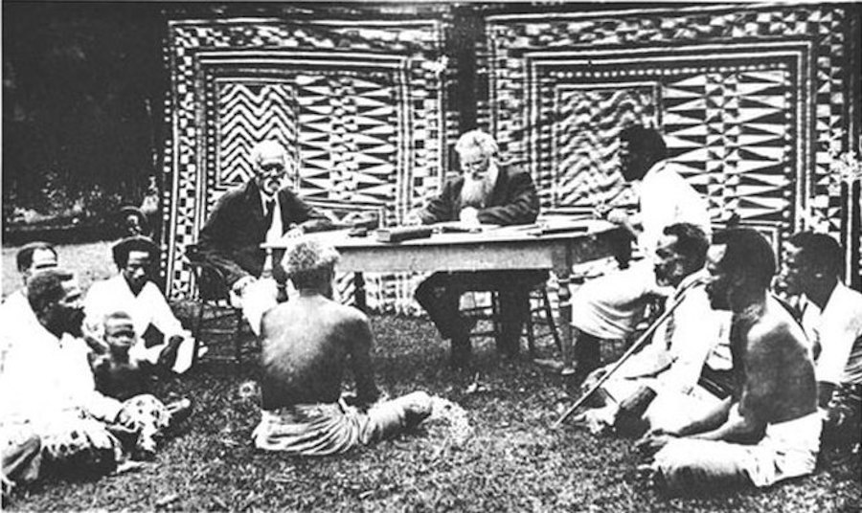 | 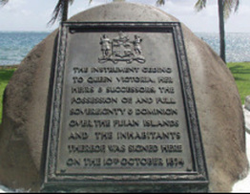

NAME
LEVEL
S/ID

GOVERNMENT AND GOVERNANCE
SUB STRAND  HY 11. 1.2  Government and Governance | SUB STRAND OUTCOME  HY 11. 1.2.1  Identify the types of government.  HY 11. 1.2.2  Explain the functions of the mechanisms of government, and how to promote good governance.  HY 11. 1.2.3  Understand the important roles played by government | ACHIVEMENT INDICATORS:  Students will be achieving these outcomes when they , for example;  - Define the types of government.  - Describe the features of governments  - Identify the important developments of the Fijian Administration  - Explain the reasons for the establishment of the Fijian Administration.  - Discuss the purpose of the co-existence of the two administration systems.  - Identify the key issues surrounding the creation of a constitution.  - Explain the reasons for changes or abrogation of a constitution.  - Define election and describe the purpose and role of elections.  - Describe the processes involved in voting.  - Analyse the importance of having a fair representation.  - Identify the political parties that existed in Fiji.  - Discuss the reasons for the establishment of political parties.  - Explain the contributions made by political parties.  - Identify the different courts and describe Fiji’s legal system.  - Discuss the roles of legal officers.  - Explain the trial process. | Suggested Content  Outcomes: Themes and Topics  - Tradition and Democracy  - Native Administration  - Constitutional Development  - Voting System  - Development of Political Parties  - Legal System in Fiji

Lesson: 29
Strand: Government and Governance
Sub-strand: types of Government
Lesson Outcome: identify the types of government
UNIT 1 - TYPES OF GOVERNMENT
(TRADTIONAL AND DEMOCARCY)
Topic | Objectives and Outcomes | Task
After completing this unit, you should be
able to:
Types of Government | - Identify the types of Government.  - Define the types of government.  - Describe the types of governments
Traditional Government | - Discuss features of traditional government.  - Discuss strengths and weaknesses of traditional government | Activity 2.1
Democratic Government | - Explain the transition from traditional to democratic government in Fiji.  - Identify factors influencing democracy in Fiji.  - Explain the differences between one party, interim and Multi-party government systems. | Activity 2.2
Other governments | - Discuss other types of governments:  - Monarchy, autocracy, dictatorship, military rule, Sharia rule. | Activity 2.3

Definitions
- Traditional Government - A governing system where the leader is determined through traditional system where the position is usually ascribed.
- Democratic Government - A group of people who are controlling the country or state through thev vote of the citizens.
- Interim Government- A group of people who are responsible for controlling a country or state in the mean while or in the mean time, waiting for an election process to decide on the permanent government.
- Multi-Party Government- A country’s system of administration which comprises of more than one party
- One-Party Government - The control of a country or state by one political party
- Military Government - The control of the country of the state by the army or the martial law.
Introduction
- Fiji is a unique nation with its own tradition and culture that governs the various chiefdoms ruling over villages, clans and sub-clans.
- Fiji was ceded to Great Britain in 1874, and made formal in the independence ceremony in 1970.
- It marked the consolidation of democratic rule in Fiji and the practice of democratic values.
- The traditional chiefdoms still exists

Types of Governments
- Governments can be classified into several types.
- Some of the more common types of governments are:

- Democratic government
- The word "democracy" literally means "rule by the people."
- In a democracy, the people govern.
- The people choose their leader through an election.

- Republic
- A state not ruled by a monarch.
- The head of state is usually a president.
- All "democracies" are really republics.

- Monarchy
- A state ruled by a monarch.
- A monarchy consists of rule by a king or queen.
- Sometimes a king is called an "emperor," especially if there is a large empire, such as China before 1911.
- There are no large monarchies today.

- Aristocracy
- A state ruled by the aristocrats.
- Aristocrats became rulers through birth and family connections.

- Dictatorship
- A dictatorship consists of rule by one person or a group of people.
- The dictator may be one person, such as Fidel Castro in Cuba or Muammar Gaddafi in Libya.
- A dictatorship can also be a group of people, such as the Communist Party in China or a group of military officers for example, the “Junta” in Chile. (Sometimes this is called authoritarian rule or totalitarian rule.)

- Democratic Republic
- It is often not democratic and not a republic. For example the democratic republic of North Korea is not democratic.
- China uses a variant, "The People's Republic of China." But most historians would not regard China as a democracy.

- Chiefdom
- A traditional form of government.
- For example, Ratu Seru Cakobau was Chief of the Kubuna confederacy. Today there are paramount Chiefs who are leaders of their province.
- A Chiefdom is led by an individual known as a Chief.

Activity

- Resource Interpretation
Study this information chain then use your knowledge to answer the following questions.

- What word commonly used in these information boxes suggests democracy?
___________________________________________________________________________
- Identify a country that was once under dictatorial rule.
___________________________________________________________________________

Lesson: 30
Strand: Government and Governance
Sub-strand: types of Government
Lesson Outcome: discuss features of traditional government

Traditional Government – Fiji
- The early Fijian society has its own unique governing system referred to as chiefdoms.
- The leader is not elected nor can be voted out since he or she has ascribed right to the position.

Turaga
Installed into the position according to ascribed status

Sau-turaga
Executive of chef who takes on the role of chief in his absence

Gonedau
carries out the fishing for the chiefly family
Matanivanua
speak on behalf of the chief and also advice the chief
Mataisau
- does all the craftwork for the chiefly family
Bete
provides spiritual guidance and strength to the chief
Bati
Warrior, protects chief and people

- Chiefdom has an authoritarian governing system where the chief directs all the welfare of the chiefdom.
- Failure to carry out commands of the chief resulted in severe punishment such as exile, banishments or even death.
- The arrival of Explorers, Traders, Whaler, Missionaries and Early European Settlers brought western ideas, materials and values that influenced the chiefdoms.
- Chiefs were empowered with guns and became affluent with modern materials.

Readings: The Rise of Ma’afu and Cakobau

Maafu
Tongans had been coming to Fiji for many years at first to collect timber for their canoes and then to cut sandalwood. Permanent settlements were established, the main one at Lakeba. Many Tongans married into the Fijian families and Tongan warriors assisted in local wars such as that between Cakobau and Tui Kilakila in 1841. The Tongans [ in Vitilevu and Vanulevu] generally enjoyed the protection of Cakobau. In 1847, King Taufa’ahau of Tonga included his cousin Ma’afu in an expedition sent to Vanua Balavu to investigate the killing of a preacher. It is uncertain why Ma’afu went on this trip, for there is little evidence to prove the legend that Taufa’ahau wanted him out of Tonga because he was a possible rival. It seems that Maafu was not given any authority over the Tongans in Fiji, but he was soon to become a powerful force.

With Wetasau, son of a former Tui Nayau, he took part in a war fought in Moala, Totoya and Matuku, establishing a reputation as an able leader and warrior. In 1853, he was appointed governor of the Tongans in Fiji by Taufa’ahau, and he immediately established himself as a power in Lau, setting himself up as the protector of the Wesleyan missionaries and taking Vanua Balavu by force after the murder of seventeen Wesleyans.

He followed this with aid to the christian Tui Bua who was in difficulties with his neighbour Ritova of Macuata and the chiefdoms of Solevu and Wainunu. Because the Tui Bua was half Tongan, he appealed to Ma’afu for help after Cakobau had failed to restore peace. Ma’afu intervened sucessfully with Cakobau’s approval.

Ma’afu now began to act in opposition to cakobau, extending his influence to Beqa and Kadavu where the chiefs accepted Christianity and placed themselves under Ma’afu’s protection. Soon his power stretched from Lakeba to the Yasawas. He was supremely confident of his ability to rule the windward islands because the majority of the island chiefs regarded Ma’afu rather than Cakobau as their overlord.

Cakobau

Meanwhile things had been going badly for Cakobau. His health was poor and his wars were not proving successful. His war with Rewa, which had broken out in 1843 had been dragging on for a long time. Although Cakobau had succeeded in capturing Rewa and placing his own King, Cokanauto, in charge of the captured part, he could not seize the Rewan chief, Qaraniqio, who had fled to the hills. When Cokanauto died in 1854, Qaraniqio returned, captured Rewa, and held off Cakobau’s attempts to win it back. A Bauan chief, Ratu Mara Kapaiwai, had great influence in Lau because he was grandson of Tui Nayau. Cakobau was suspicious that Mara might be plotting against him. When Cakobau went to Macuata in 1852 to fight Ritova, who had refused to recognise Bauan claims in Macuata, he stripped Mara of his canoe to make him less powerful. Mara fled to Rewa. Mara was also in good terms with the Europeans at Levuka who blamed Cakobau for the attacks by the Lovoni tribesmen on Levuka. At the same time, the Ovalau tribes revolted against Bau and the Americans were pressing their claim for payment for damage done to the property of American settlers. In 1854 Cakobau decided to accept Christianity and renounce his old beliefs.

This led to further trouble for many of his allies, disliking Christianity, went over to the enemy. Then came the turning point in Cakobau’s career. Qaraniqio died in 1855, and the Rewan chiefs, tired of war, sought peace. Cakobau agreed, but the rebel Bauans at Kaba disagreed. Led by Mara, they opposed Cakobau’s conversion to Christianity and were soon joined by other chiefs who were reluctant to renounce their heathen practices. Taufa’ahau of Tonga was in the Fiji island group with a large force, and it was expected that he would come to Cakobau’s aid. It is possible that Cakobau’s conversion to Christianity was partly an attempt to persuade Taufa’ahau to help him, for the latter had earlier tried to convert Cakobau. Mara’s men prepared for war. Taufa’ahau had no desire to fight, but the death of a relative at the hands of Mara’s men changed his mind and he came to Cakobau’s assistance in a combined attack against the strong fort at Kaba Point. The battle was won by unorthodox tactics of the Tongans, when the normal Fijian tactics would be to withdraw. This so confused the enemy that the fort was overrun. From this time on, Cakobau’s fortunes and his power were restored, although he was never able to forget that he relied on the Tongans. Taufa’ahau returned to Tonga, taking with him as payment Cakobau’s largest canoe and the ship which he had ordered from America. He left behind him a reformed Cakobau, now a strong supporter of Christianity. The Battle of Kaba was seen as a victory for Christianity over heathenism, a victory which led to a series of mass conversions of Fijians to Christianity. The Bauan Kingdom became the leading kingdom in Fiji. However, Cakobau owed his position to Tongan intervention and, despite his claim to be Tui Viti, was in no position to challenge the growing power of Ma’afu, who had become ruler of the northern Lau islands and controlled most of Vanua Levu.

Activity 1.2
- State one of the reasons that made the vanua of Bau powerful.
__________________________________________________________________________________________________________________________________________________________________
- Briefly state Cakobau’s main ambition.
__________________________________________________________________________________________________________________________________________________________________
- How did Christianity or missionary work influence Cakobau’s position as dominant chief?
__________________________________________________________________________________________________________________________________________________________________
- Who was Cakobau’s main rival and why?
__________________________________________________________________________________________________________________________________________________________________

Lesson: 31
Strand: Government and Governance
Sub-strand: types of Government
Lesson Outcome: explain the transition from traditional to democratic government
Democratic Government in Fiji
- Transition from traditional chiefdom to democratic government took place in the 1800s
- On 10th March, 1874 an interim colonial government was set up pending negotiations for the ceding of Fiji to Great Britain.
- Fiji was ceded to Great Britain on 10th October, 1874 at Nasova in Levuka.

The 1874 Cession at Nasova, Levuka.

Political Changes

Year | Political changes
1904 | - Constitutional changes  - governor becoming the commander in chief with enlargement of the legislative council.
1910 | - 3 electoral divisions were set up for the Legislative Council.
1914 | - Official member of the Legislative Council raised
1916 | - Legislative Council was enlarged to 12 nominated officials of whom one was an Indian.  - However both Indian and native do not have the right to vote
1929 | - Legislative Council was enlarged with one whom was an Indian.  - election based on common roll.
1937 | - Enlargement of the Legislative Council  - The colonial government began to expand its role in providing better service. From the 16 official members 3 were drafted automatically in important Government position to ensure good governance – a Colonial Secretary, Financial Secretary and Attorney General.
1954 | - Rt. Sir Lala Sukuna as the first speaker of the legislative council.
1963 | - The Legislative council was enlarged again.

Activity:

Draw a Timeline showing the important political changes in Fiji’s governement

Lesson: 32
Strand: Government and Governance
Sub-strand: types of Government
Lesson Outcome: explain and differentiate between interim and multi party

INTERIM GOVERNMENT
- Interim can mean ‘in the mean time’ or ‘mean while’.
- Is a group of people who are responsible for controlling a country or state in the mean while or in the mean time, waiting for an election process to decide on the permanent government.
- This started from 1977, after the Governor General appointed Ratu Mara to form a minority government until the September election.

1987
- The 1987 election was won by the National Federation Party-Fiji Labour Party Coalition, and they were able to form a government through the leadership of Doctor Timoci Bavadra, who was sworn in as Prime Minister on the 13th of April 1987.
- Just past a month later, on the 14th of May 1987, the Coalition government came to an end through the coups that were led by Major Sitiveni Rabuka.
- After another coup in September, an interim government was set up.

Reading: After the 1977 Election

In the recent elections, the people of Fiji did not give a clear mandate to either of the political parties. It therefore became the duty of the Governor General under the Constitution to appoint as Prime Minister the member of the House of Representatives who appear to him best able to command the support of the majority of the House. The Governor General has not been able to act sooner as it was not until this afternoon that he was informed who had been elected leader of the National Federation Party. The Governor General, after taking all the relevant circumstances into account, has come to the firm conclusion that the person best able to command support of the majority of the members is the leader of the Alliance Party, Ratu Sir Kamisese Mara. In compliance with the Constitution and acting in his own deliberate judgment, the Governor General has accordingly appointed Ratu Sir Kamisese Mara as Prime Minister. The Prime Minister is now in the process of forming a government.
(Lal, B. 1992; 239-240)

- Which two parties contested the 1977 election?
- Which party won the election?
- Why did the Governor General choose Ratu Mara to be the Prime Minister?

Lesson: 33
Strand: Government and Governance
Sub-strand: types of Government
Lesson Outcome: Discuss Multi party government

MULTI-PARTY GOVERNMENT

- A multi-party government clearly defines itself as a country’s system of administration which comprises of more than one party.
- For a multi-party government to work, it will depend on the willingness of the political parties’ leaders and members to work together.
- If they have any differences, they will have to put them aside, and work towards the good of the country.
Note:
- Laisenia Qarase and Mahendra Chaudhry tried to form a multiparty cabinet
- True statesmen are able to place the interests of their country ahead of personal ambition and petty party politics.
- Mr. Qarase and Mr. Chaudhry are indeed true statesmen.
- Israel, Germany and the minority government of Canada are three leading examples of unity government
- Minister Ratu Sir Kamisese Mara tried to form a multiparty cabinet in the 1980’s opposition of the day, the National Federation Party, derailed Mara’s efforts
- A multi-party government will provide the degree of stability
- A multi-party cabinet will allow the nation the opportunity to progress economically and socially

Activity

- What characteristics of a true statesman were displayed by the two party leaders as they agreed to form a multi-party cabinet?
___________________________________________________________________________________________________________________________________________________________________________________________________________________________________________________

- Name the Fiji leader that had earlier tried to bring about a government of national unity.
__________________________________________________________________________________________________________________________________________________________________

- Identify two countries which have been successful with the multi-party cabinet.
__________________________________________________________________________________________________________________________________________________________________

- List some of the benefits of a multi-party government.
__________________________________________________________________________________________________________________________________________________________________

