YEAR 11 HOME ECONOMICS WEEK 9
SUBSTRAND: HEC 11.2 Food planning and product development
CLO: HEC11.2.6.1 Design nutritious meals by highlighting the integration and appreciation of multicultural food
Students, please note that we have covered our coverage thus we will be doing meal planning from lesson 47-56. Note that we are learning on how to plan we are not conducting the practical aspect.
Lesson 47
Learning outcome:
- At the end of this lesson students should able to plan a nutritious meal using basic meal pattern.

- Basic meal patterns vary from culture to culture, from family to family and from person to person. They vary because of differences in family routine, likes and dislikes, ages and activities of the family members and general ideas about diet.
Basic Meal Pattern:
Meal | Basic Plan | Example one | Example 2
Breakfast | Fruit or fruit juice Cereal with milk  Main dish of protein  Bread with spread Beverage | Banana  Porridge with milk  Egg on toast  Beverage | Pawpaw  Roti with saijan  Tea with milk
Lunch | Bread/root crops/grains  Main dish  Vegetables  Fruit  Beverage | Boiled egg sandwich with lettuce and tomatoes.  Apple  Lemon juice | Cassava  Boiled fish with bele  Kavika  Lemon juice
Dinner | Bread/ root crops/ grains  Protein dish Vegetables Beverage | Dalo with steamed fish Grilled egg plant  Fresh orange juice | Cassava  Grilled /Boiled fish/seafood  Steamed leafy vegetables and tomatoes  Pineapple juice
A balanced diet includes all the five major nutrients:
These five major nutrients includes:
- carbohydrates – starchy foods(bread, rice, roti, dalo, cassava),
- fats- oil, butter, margarine,
- Protein- milk and milk products, meat, legumes and pulses,egg,
- minerals -iron(green leafy vegetables, meat), iodine(sea weeds, seafood, garlic),calcium(cheese)
- vitamin- Vitamin A(pawpaw), Vitamin B(beans), Vitamin C(mandarin), Vitamin D(fish oil), vitamin E(pork liver), Vitamin k(yogurt).
Menu- list of items to be served in a meal
Activity:
1. Plan a nutritious Lunch for a teenager using the basic meal plan. Plan three menus using the basic meal plan and choose the most suitable one, fill in the table given below.
Lunch for a Teenager
Basic meal pattern | Menu 1 | Menu 2 | Menu 3
Bread/root crops/grains
Main dish
Vegetables
Fruit
Beverage

Menu Chosen:

Meal Planning
SUBSTRAND: HEC 11.2 Food planning and product development
CLO: HEC11.2.6.1 Design nutritious meals by highlighting the integration and appreciation of multicultural food
Lesson 48
Learning outcome:
At the end of this lesson students should able to write recipes.
Recipe – instructions on how to prepare dish.
There are four parts of a recipe:
1. Name of the dish
2. Ingredients
3. Method
4. Number of Serves.
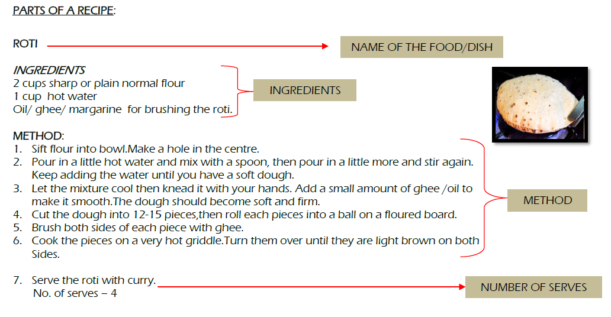
Activity:
Write a simple recipe on how to fry a fish.
- You may choose the frying method you prefer.
- In your instruction, include the following:
- The utensils/crockery/cutlery you will need
- The ingredients required
- The method of frying the fish (your instructions should be clear so that it can be followed.

Meal Planning
SUBSTRAND: HEC 11.2 Food planning and product development
CLO: HEC11.2.6.1 Design nutritious meals by highlighting the integration and appreciation of multicultural food
Lesson 49
Learning outcome:
At the end of this lesson students should able to plan nutritious meal using the skills and methods covered from lesson 42-46.
- Traditional methods of cooking practiced in Fiji:
1. Itaukei- lovo, grilling, steaming, smoking, boiling Utensils- Coconut shell, kai, leaves, strings (via and banana) bamboo, stones, pottery
2. Indian – frying, steaming, grilling Utensils – wok, girdle(tawa), Bombay pots
3. Asians – frying, steaming, grilling, boiling Utensils- wok, wooden spoons, bamboo steamer.
- Culinary skills: mixing/blending, marinating, garnishing, blanching, paring, julienne, shredding, stuffing, wrapping, rolling, fermenting.

Activity: Prepare a dinner using traditional cooking method and skills.
Using the cooking skills and methods stated above, plan three menus which are nutritious and choose the best one.
Basic meal pattern | Menu 1 | Menu 2 | Menu 3
Bread/root crops/grains
Main dish
Vegetables
Fruit
Beverage
Menu chosen:
Cooking skills used:
Cooking methods used:
Meal Planning
SUBSTRAND: HEC 11.2 Food planning and product development
CLO: HEC11.2.6.1 Design nutritious meals by highlighting the integration and appreciation of multicultural food
Lesson 50
Learning outcome:
At the end of this lesson students should able to plan nutritious meal using modern kitchen appliances.
Modern kitchen appliances include:
- Appliance with motor: Blender, cake mixer, food processor, juicer.
- Appliance with a heating element: electric frying pan/wok, rice cooker, electric pressure cooker, stove and oven, electric kettles.
- Appliance with cooling mechanism: refrigerator, freezer.
- Electromagnetic wave mechanism: microwave oven.
Activity: Preparing a meal for a family using electrical appliances.
Using the two to three kitchen appliances stated above, plan three menus which are nutritious and choose the best one.
Basic meal pattern | Menu 1 | Menu 2 | Menu 3
Bread/root crops/grains
Main dish
Vegetables
Fruit
Beverage
Menu chosen:
Cooking skills used:
Cooking methods used:

Meal Planning
SUBSTRAND: HEC 11.2 Food planning and product development
CLO: HEC11.2.6.1 Design nutritious meals by highlighting the integration and appreciation of multicultural food
Lesson 51
Learning outcome:
At the end of this lesson students should able to identify the ingredients, equipment, linen and cooking equipment and cleaning materials used in a practical.
- Ingredients- list of food items used in cooking.
- Equipment- are the utensils used in cooking.
- Linen- includes tablecloth, handtowel and dish cloths.
- Cleaning material- the items used to clean the equipments, materials and surfaces such as detergent and dish washing agent.
Activity: Lemon Juice for a family of four
For the Beverage, Lemon juice for a family of four prepare the ingredients list, identify the amount, costing, cooking and cleaning equipments that would be used. Fill in the table below.
INGREDIENTS, EQUIPMENTS, LINEN AND CLEANING MATERIALS & AGENTS
INGREDIENTS | AMOUNT | COST | COOKING & CLEANING EQUIPMENT | CLEANING MATERIAL AND AGENT

TOTAL COST:

YEAR 11 WEEKLY WORKSHEET WEEK 9
- Study the recipe given below and answer the questions that follow.
CHOCOLATE CAKE
INGREDIENTS
- 1 1/2 cups (192g) all-purpose flour
- 1/2 teaspoon baking powder
- 1 teaspoon baking soda
- 1/2 cup (1 stick, 113g) salted butter, warm but not melted
- 1/2 cup (100g) granulated sugar
- 1/2 cup (100g) packed brown sugar
- 2 large eggs, room temperature
- 1/2 cup cold coffee
- 1 teaspoon vanilla
Methods
- In a medium bowl, sift flour, baking soda, and baking powder together.
- Add 1/2 cup warm butter, sugars, eggs, cooled coffee, and vanilla to the flour mixture and mix with a hand-held mixer until fully combined. (or stir by hand)
- Add the chocolate mixture from the FIRST PART to the ingredients from the SECOND PART. Stir by hand until all ingredients are well combined.
- Pour onto a prepared (sprayed or lined with parchment) baking sheet (I used a 10x15in baking sheet). Smooth out the batter and gently tap on the counter.
- Bake in a 350°F oven for 16-22 minutes, or until the center no longer appears wet and an inserted toothpick is removed with a few crumbs.
- Allow to cool before frosting.
No of serves: 4

- Label the four parts of the recipe in the recipe shown above.
- Identify and define the different cooking skills used in the above recipe.
- Name the third part of the recipe.

