WEEK 8 YEAR 11 HOME ECONOMICS
LESSON 86
STRAND: HEC 11.3 CLOTHING AND TEXTILES
SUB-STRAND: HEC 11.3.2 CARE OF FABRICS, RENOVATING AND RECYCLING
LESSON OBJECTIVE: HEC 11.3.2.1
- discuss recycling and renovation.
- describe basic and traditional fabric decoration.
RECYCLING
 |  | RECYCLING
1 | DEFINITION | Is the process by which old clothing and other textiles are recovered for reuse or material recovery.
2 | ADVANTAGES | - provide low cost clothing  - lesser energy is consumed while processing  - provides environmental and economic benefits  - reduces the demand for dyes and fixing agents  - protecting the planet for future generation
3 | DISADVANTAGES | - high upfront capital costs  - recycling sites are always unhygienic, unsafe and unsightly  - products from recycle waste may not be durable  - might not be expensive
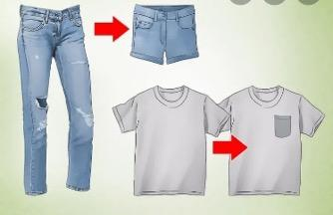
Examples of recycling:
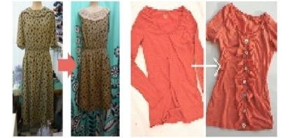

FACTORS THAT INFLUENCE RECYCLING:
Factors that influence recycling of clothing
i. Economic: Save money, the cost of buying a new garment may prove to be expensive and unnecessary. The cost of renovation would be less than buying a new outfit.
ii. Fashion and Design: Seasonal colour and style, type of fabric and fabric finishes change. A style, colour or design may become fashionable or out – of – fashion after a period of time, therefore, pre-owned garments may be recycled.
iii. Personal: Sentimental (it can be a gift), hereditary and aesthetic values. The garment could have been passed from another generation, a gift from a loved one or has an appealing/ unique style line and the fabric is in good condition.
LESSON 87
STRAND: HEC 11.3 CLOTHING AND TEXTILES
SUB-STRAND: HEC 11.3.2 CARE OF FABRICS, RENOVATING AND RECYCLING
LESSON OBJECTIVE: HEC 11.3.2.1 describe the advantages and disadvantages of renovating
RENOVATING
 |  | RENOVATING
1 | DEFINITION | - Is the process of improving an outdated garment  - Renovation can refer to making something new, or bringing something back to life and can apply in social contexts.
2 | ADVANTAGES | - Reduces the amount of waste sent to landfills and incinerators  - Conserves natural resources such as timber, water and minerals  - Increases economic security by tapping a domestic source of materials
3 | DISADVANTAGES | - More pollution and energy consumption  - Results in pollutants  - Require stricter and more stringent implementation  - Good products are not guaranteed  - Generally ineffective

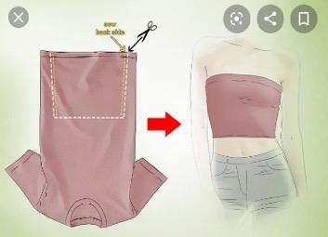
Examples of renovating:
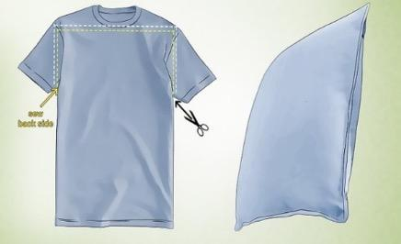

Renovating safely to protect your health and home environment
1. Design your renovations to minimise the need for hazardous products- It is most effective to consider safer renovations at the design stage when you are able to specify safer products and materials as well as ensure your design enhances natural ventilation.
2. Avoid hazardous products and materials- Rather than relying on ventilation systems to dilute pollution to ‘safe’ levels, the most effective way to reduce your exposure to hazardous chemicals during renovations is to avoid using them in the first instance.
3. Read labels and check product claims-There are a growing number of better products on the market made by companies with integrity and high standards, but be careful not to get caught out thinking you are buying a safer product only to discover later it was a clever marketing ploy. Always read labels
4. Choose zero or low emission products -Products and materials are often made with various chemical components, which can be emitted or ‘off-gas’ as chemical pollution into the indoor environment. If you choose zero or low emission products you will reduce chemical pollutants in the air. Carefully and check product claims.
5. Practice safer renovation techniques - It is very important regardless of what products and materials you are using, to practice safer renovation techniques - especially if you are living in the building that you are renovating.

ACTIVITY:
use an old clothes or unused clothes from your wardrobe to practice renovating at home. Sew something out of the old/unused clothes.

LESSON 88
HEC 11.3.3 Selection of clothing needs /consumer
HEC11.3.3.1 Explore the prevalence and importance of Fiji’s diverse cultural dressing requirements for different stages in the life cycle
- Clothing is an important part of everyday life both in function and for fashion. People’s clothing needs differ as they go through their different life stages.

LIFECYCLE | REQUIREMENT
1. Infancy (birth to 12 months) Infant clothing can be an unrewarding investment because your child will grow out of them so quickly. | It is important to look for :  - Snap or zip all the way down the front, instead of the back  - Snap or zip down both legs to make diaper changes easier  - Have loose-fitting sleeves so your hand fits underneath to push the baby‘s arm through  - Have no ribbons or strings to knot up, unravel, or wrap around the neck (which could cause choking)  - Are made of stretchy fabric (avoid tight bindings around arms, legs, or neck)
2.Childhood (12 months to 12 years) As babies grows the main concern when buying clothes will be that they are comfortable and clothing allows for easy movement.  A. Toddlers 1 – 2 ½ years Buying clothes for toddler | - Buy unisex clothes when you can. There is no reason why a girl shouldn't wear boys' clothes, and they are usually sturdier anyway.  - Brightly coloured clothes are useful if your toddler wanders off – it will be easier to spot them  - Fabrics need to be very strong but pliable – stretchfabrics are best.
B. Pre – scholars 3 – 6 years  Children at this stage are more independent and begin to make known their personal preferences in clothing. Children start to express colour, design and texture preferences.  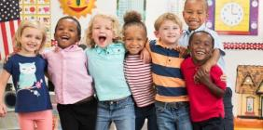 | - Fabrics should be strong and easy to wash.  - Comfort is still a dominant factor, and dressing and undressing should be simplified with easy buttoning so that the child can dress him or herself.  - Talk about the weather when you and your child are choosing clothes. Ask her whether it‘s hot or cold, raining or sunny.
C. School age 6 – 12 years  The growth rate of children is stable during these years and clothes seem to fit for longer periods of time. Children have wider social contacts and are involved in more activities  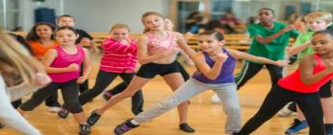 | - They require a variety of clothes.  - The most important need here is to conform in order to belong to a certain group.  - Peer group pressure can be so great that children may reject clothing which is not accepted by their peers.  - Garments should attractive, made from strong fabric and be easy to care for.  - Children prefer clothes which are comfortable for easy movement.
3. Adolescence School and beyond 12 – 15 years  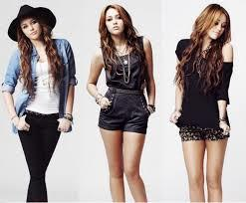 | - Peer group pressure is even stronger at this stage, and the desire to be seen wearing clothes just like the rest, is very strong.  - Everything in fashion is copied – from hairstyles, to clothing, to shoes.  - Looking very similar to friends is more important in many cases than individualism.  - This could be called the experimental period of clothing, as this age group likes to try various types of clothes, fabrics, colours, textures and designs.  - The need for strength of fabric and quality is not as important at this stage as the clothes are not worn for a long time.
4. Adulthood  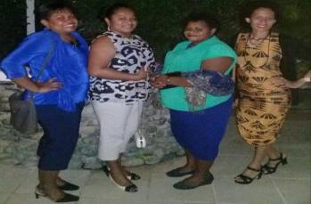 | Young adult  - Adulthood is the time when individuality is expressed.  - Most adults do not notice peer group pressure, therefore an individualistic approach to clothing is more likely to be followed.  - Changes in life style and role take place during this period which changes clothing needs.  - There is also a very high interest in personal appearance which makes decisions in selecting clothes more difficult.  - Clothes should be versatile, well-constructed, with easy to look after fabrics, designed to suit the life style of the individual.  Middle age  - Cost is not the major concern during the middle age years as most people are well established in careers.  - A general interest in clothing and appearance is maintained with preference often given to clothes that are well styled, constructed and made from durable fibers which withstand wear.
5. Pregnancy  Pregnancy is one of the beautiful phases in a woman‘s life. During this phase the body undergoes physical transformation and demands soft and comfortable clothing. The best garment for pregnant women is the one that allows the abdominal area to expand, as it is imperative for both the mother and the baby.  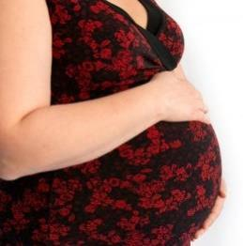 | Here are some do‘s for the expecting mother:  - Choose light and comfortable clothes; do not wear extremely snug or figure-hugging outfits.  - Choose traditional clothes that are tailored to your shape & style and is in your budget.  - Wear clothes that provide support to the stomach.  - Keep garments simple and flaunt any dress that is liked, but be confident about it.
6. Elderly  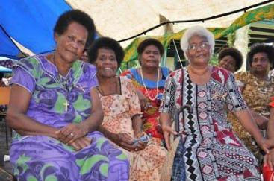 | - As people age, it is a fact that their clothing needs and fashion preferences change.  - Many factors impact the type of attire older adults might choose to wear, including the type of activities they engage in on a regular basis, as well as health factors.  - We select fabrics that are comfortable for the elderly to wear with patterns, designs and colors that are appropriate.  - We choose fabrics that are easy to launder and wear without the need for

LESSON 89
HEC 11.3.3 Selection of clothing needs / consumer
HEC11.3.3.1 Explore the prevalence and importance of Fiji’s diverse cultural dressing requirements for different stages in the life cycle
Learning outcome:
At the end of this lesson students should be able to:
- identify and explain the factors that affect the availability of clothing in Fiji.
- demonstrate appreciation of traditional costumes for the different cultures in Fiji.
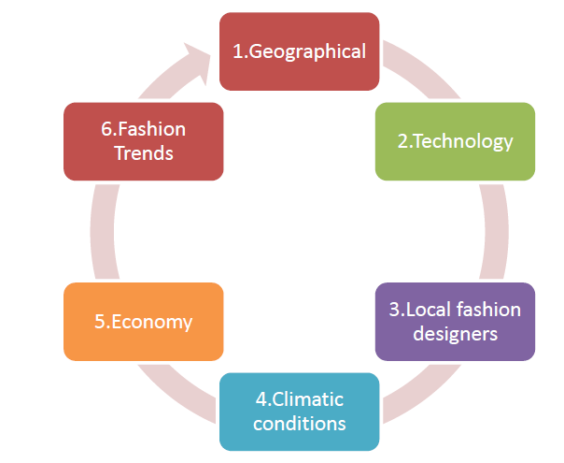
1. Geographical
- Fiji is made up of two main islands; Viti Levu and Vanua Levu and many smaller geographically isolated islands.
- This type of geographical location affects the accessibility of all types of clothing in the smaller islands where as the main land consumers have greater choice and access to the latest styles.
- They are able to fulfill their demands and wishes.
- Lack of shopping facilities and increased cost of transportation contributes to less choice and availability of clothing in the outer islands.
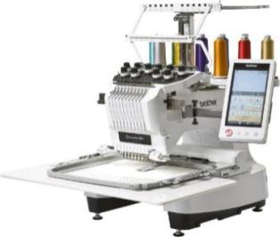
2. Technology
- New machines have been developed to sew special fabrics such as knitted fabrics.
- Computer Aided Designs (CAD) has been introduced to produce a variety of styles, nested –patterns (one design with multiple sizes); mass production- large quantities of garments are produced in a short period of time for example in Garment factories in Fiji.

3. Local fashion designers
- There is an increase in the number of local designers in Fiji.
- Their designs are based on a combination of contemporary and traditional concepts. This is very much influenced by the availability of local natural resources e.g. shells, masi, magimagi, seeds and flowers.

4. Climatic conditions
- The weather influences the type of clothing people wear. Shops display change in clothing according to the weather.
- During the cold season (May- October), warm clothing such as cardigans, jackets, shawls, socks and scarves are prominently displayed for access to the consumers.
- While during summer (November- April), cooler clothing made from cotton, linen and rayon are displayed or commonly used. Such garments include surf shorts, T-shirts, and sun dresses.

5. Economy
- Economic factors include the nature and direction of the national economy in which a company does business.
- Some major considerations include the availability of credit and the amount of disposable income in a given market.
- Both inflation and interest rates and a given country's GDP are other economic factors that can hinder or help the availability of clothing in a country.

6. Fashion Trends
- Fashion itself is a reflection of social, economic, political and cultural changes.
- It expresses modernity, symbolizing the spirit of the times.
- Home life and moral values also contribute to lifestyle trends, which in turn influence the clothes we wear.

LESSON 90
HEC 11.3.3 Selection of clothing needs / consumer
HEC11.3.3.1 Explore the prevalence and importance of Fiji’s diverse cultural dressing requirements for different stages in the life cycle
TRADITIONAL DRESSES FOR DIFFERENT CULTURES IN FIJI
1. I Taukei
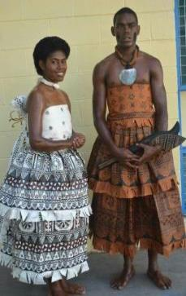
- Today, women dress more conservatively - usually wearing masi or tapa cloth for mekes or weddings. On other occasions, women often wear a dress with a sulu I ra or a chamba which is a specially made top and long sulu.
- Modern Fiji's national dress is the sulu, which resembles a skirt. It is commonly worn by both men and women.
- One type worn by both men and women is the 'sulu va Taga' pronounced sulu vah Tanga which is a wraparound piece of rectangular material which is elaborately decorated with patterns and designs of varying styles this is for more casual and informal occasions.

2. Indian Clothing is known for its colourfulness and grace. Outfits for women such as the sari bring out the essence of feminism. Mens‘ clothes are suitable for the warm climate and for comfort.
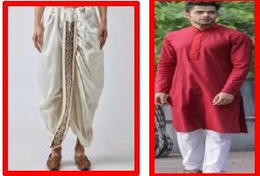
Dhoti
Dhoti kurta is the traditional Indian clothing of men. Unlike other dresses, it is an unstitched piece of cloth usually 5 yards long that is tied around the waist and legs. The knot is tied at the waist. Dhoti is known by different names at different places such as Laacha in Punjabi, dhuti in Bangla. In Fiji men wear this during prayer functions.
Kurta
- Kurta is a term used to refer to a long loose shirt, the length of which falls below or may be just above the knees of the wearer.
- In the olden times, it was primarily worn by men, but today, it has become a unisex dress that both men and women can wear.
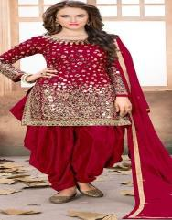
Indian Salwar Kameez
- Salwar kameez is the traditional Indian clothing for women. Due to its high popularity in the region of Punjab, salwar kameez is commonly referred to as Punjabi suit.
- The fashion of Salwar Kameez in India is not new. Since the past many few centuries, women have been wearing this wonderful attire.

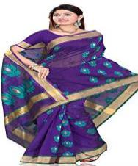
Indian Sari
- The sari is one of the most wonderful dresses worn by Indian women.
- In fact, when one thinks of a typical Indian woman, the first thing that strikes the mind is a woman clad in sari, who is wearing the solah shringar including bindi, chudi and kajal.

Gujarat
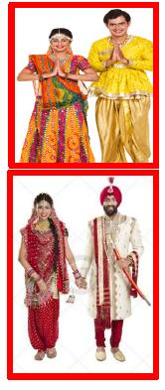
- The traditional Gujarati dresses for men include kediyu or kurta on the top and dhoti or chorno at the bottom.
- Women in Gujarat wear sarees or chaniya choli. Recently, they have started wearing salwar kameez as well.

- Traditional Dresses of Punjabi
- The traditional dress for Punjabi men is the kurta and tehmat, which is being replaced by the kurta and pajama, especially the popular muktsari style in India.
- The traditional dress for women is the salwar suit which replaced the traditional Punjabi ghagra. The patiala salwar is also very popular.
- Turban In India, one can spot many men wearing turbans. The hair turban is a headdress that basically consists of a long piece of unstitched cloth, which is wrapped around the head. A turban is tied not for the sake of fashion, but because it has a lot of significance in the lives of Indians.
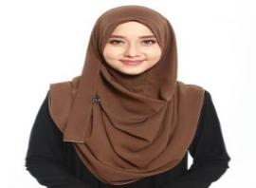
3. Muslims
- A Muslim woman may wear whatever she pleases in the presence of her husband and family or among women friends. But when she goes out or when men other than her husband or close family members are present, she is expected to wear a dress which will cover all parts of her body, and which should not reveal the figure. Women are encouraged to dress in their best clothes, new if possible, and to attend a special Eid prayer that is performed in congregation at mosques or open areas like fields and squares.

4. Chinese
Traditional Chinese clothes were an evolution of their long, loose, straight-cut jackets and pants or gowns. They are reflected traditional. Chinese aesthetics, philosophy, and social values as they changed through over 3,000 years of history.

YEAR 11 HOME ECONOMICS WEEKLY WORKSHEET 8
1. Infants‘ Clothing Requirements
Give a reason for the following statement:
(i) Always choose one size ahead of your baby‘s actual age
(ii) When sales shopping, get clothes for the coming months
(iii) If you are tempted by expensive clothing for your baby, consider whether it is good value for money.
2. Discuss two clothing for the following age groups:
(i) Toddlers
(ii) Teenagers
(iii) Elderlies
3. State one reason why caps and booties are important for infants.
4. Discuss how the following factors contribute to the type of clothing that is available in Fiji.
(i) Technology
(ii) Economy
(ii) Climate Conditions
(iv) Fashion Trends
5. Differentiate between recycling and renovating.
6. State one benefit reusing clothing items.
7. Name one item that can be made from the following
- Old pair of jeans
- Unused T-shirt
8. Explain how fashion and design can contribute to recycling
9.Explain one factor that influences recycling.

