WEEK 7 YEAR 11 HOME ECONOMICS
LESSON 81
STRAND: HEC 11.3 CLOTHING AND TEXTILES
SUB-STRAND: HEC 11.3.1 FIBRES AND FABRIC
LESSON OBJECTIVE: HEC 11.3.1.2: describe structural and surface design
STRUCTURAL AND SURFACE DESIGN
 | DESIGN | DEFINTION
1 | SURFACE DESIGN | Is any type of work [ pattern, illustration, hand lettering etc] made by a designer that is intended to be applied to a surface to enhance its virtual appearance and/or functionally
2 | STRUCTURAL DESIGN  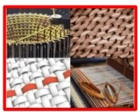 | - A woven –in pattern as opposed to one printed on a fabric  - Provides insight on different types of design used for the production of woven and knitted fabrics, highlighting the effect design has on a fabrics properties and applications

VARIOUS METHODS OF BASIC AND TRADITIONAL FABRIC DECORATION
 | METHODS OF FABRIC DECORATION | DESCRIPTION | PROCESS/METHOD
1 | DYEING  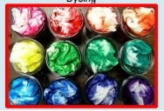 | Is the application of dyes or pigments o textile materials such as fibers, yarns, and fabrics with the objective of achieving color with desired fastness. | - Wash any finish out of cotton fabric so that dye can penetrate the fabric  - Fold or scrunch up fabric  - Tie with string/elastic bands  - Mix up dye with salt and fix  - Place in dye  - Remove from dye  - Rinse out excess dye and dry  - Take off string and press with iron
2 | PRINTING  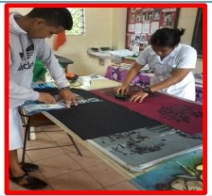 | - Is a process of decorating textile fabrics by application of pigments, dyes, or other related materials in the form of patterns.  - Although apparently developed from the hand painting of fabrics, such methods are also of great antiquity. | - Wash any finish out of cotton fabric so that dye can penetrate the fabric  - Mix up dye with salt and fix  - Apply wax onto design where you want to keep the colour  - Apply dye to fabric by painting the next layer of wax onto next colour  - Repeat stages to build up pattern  - Scratch away and apply dye  - Melt wax off the fabric by placing fabric between wallpaper and ironing

ACTIVITY
- Differentiate between surface and structural design

- Give an example of surface and structural design
3. Define the terms with examples:
a. dyeing
b. printing

LESSON 82
STRAND: HEC 11.3 CLOTHING AND TEXTILES
SUB-STRAND: HEC 11.3.1 FIBRES AND FABRIC
LESSON OBJECTIVE: HEC 11.3.1.2: Discuss various methods of basic and traditional fabric decoration.

 | METHODS | DESCRIPTION | PROCESS/METHOD
1 | EMBROIDERY  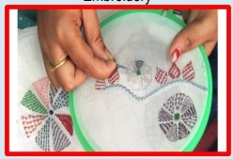 | Is the method used for decorating fabrics with a needle and a thread | - Choose the embroidery design you want to sew  - Transfer it to your embroidery machine  - Select your thread colors-use good quality thread  - Make several stitches in place to lock the thread. Stitch out the design  - Stop the design after each color and trim the jump threads-they will be easier to remove at this stage rather than trimming them all at the end  - Remove excess stabilizer
2 | BRAIDING  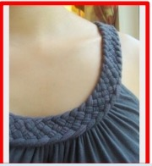 | - Is the formation of comparatively narrow fabrics or rope –like structures by diagonally interlacing three or more strands of material.  - Braids may be sewn together to make braided rugs  - Hats, handbags can also be from various braids, including plastic and straw types. | - Braiding is one pf the major fabrication methods, and produces a rope-like material by interweaving three or more strands, strips or lengths in a diagonally overlapping pattern  - It can be classified into two –and three dimensional braiding
3 | SEQUINS  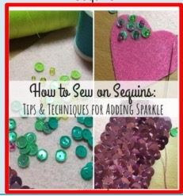 | - Are small shiny disc sewn on to clothing for decorations  - Are commonly used on clothing, jewelry, bags, shoes and many other accessories | - Begin with fine, long needle and suitable thread  - Place the sequin with care on the top side of the fabric, sitting I the position that you want it to be  - Bring the needle up through the fabric  - Return to the backside of the fabric i.e the ends of the thread together on the back side to create secure knot.  - Move on to the next sequin
4 | BEADS  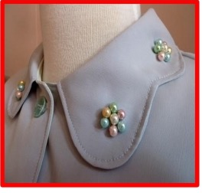 | Are small piece of glass, stone, or similar material that is threaded with others to make a necklace or rosary or sewn on to fabric | - Can be worked from a spots, with one part, bead or sequin sewn on singly or as rows  - The spots can have sequins and beads together as one unit  - They can be placed in all over design or used singly, for example the centre of a flower motif  - Rows are sued as outline design or to fill the design
5 | APPLIQUE  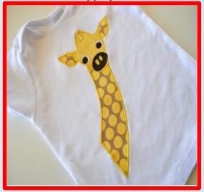 | - Is ornamental needlework in which pieces of fabric are sewn or stuck on to a larger piece to form a picture or pattern  - Are made with ribbons, cords, beads sequins or any other materials.  - Can be made with a sewing machine | - Trace the applique design piece[s] from the template on the paper side of fusible webbing, leaving about ½ inch between each piece  - Cut out the pieces roughly leaving about ¼ inch of webbing  - Place the fusible webbing piece[s] onto the wrong side of chosen fabric, then fuse for a few seconds with a dry iron around the tracing lines  - Cut out applique piece[s] neatly on the lines  - Peel off paper backing, then position applique pieces on project [webbing side down], layering the pieces as indicated on placement guide  - To machine applique you need a basic machine capable of doing zigzag stitch

LESSON 83
STRAND: HEC 11.3 CLOTHING AND TEXTILES
SUB-STRAND: HEC 11.3.1 FIBRES AND FABRIC
LESSON OBJECTIVE: HEC 11.3.1.2: Discuss various methods of basic and traditional fabric decoration.
6 | SHELLS  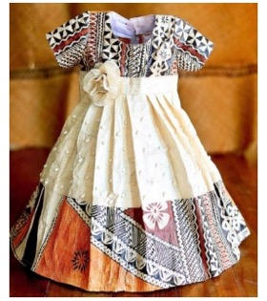 | - Are special forms of decorations that uses a needle and thread to stitch to a surface of fabric.  - Are embellishment does not form an essential part of a textiles structure  - Mostly used on clothing and decorative textiles | - Select the properly cleaned shells, needle and thread. Select a needle that is small enough to fit through the shells  - Lock thread in the fabric by tying a knot in the end and insert the shell through the 2 holes made  - Sew through the thread under the shell and make a knot to secure it and move the needle under the fabric to where the next shell
7 | MAGIMAGI  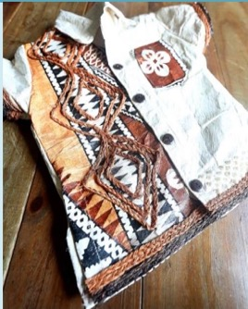 | - In FIJI, the fibre of the coconut husk is made into magimagi.  - This can be very coarse like rope or extremely fine like string  - Nowadays it is mostly used as decorative features on wedding attires, bags, belt buckles and other clothing accessories | - Mark a line directly onto the fabric where magimagi is intended to sit and use a straight stitch form the machine or glue it in place in the desired pattern  - With right sides together, get ready to stitch your seam. Use a pin to secure magimagi in place if necessary  - Sew or glue accordingly onto your fabric

DYES AND PIGMENT
- Are substance that impart color to a material
- Dyes are usually soluble or can be made to be soluble, in water
- Pigments are not soluble in water, oil or other common solvents
- Once a dye is dissolved in water, the aterial to be dyed can be immersed in dye solution

NB: to apply pigments to a material they have to be first ground into fine powder and thoroughly mixed with some liuquid, called the dispersing agent or vehicle.

ACTIVITY
Explain the methods of decoration below:
- Embroidery
- Sequins
- Applique
LESSON 84
STRAND: HEC 11.3 CLOTHING AND TEXTILES
SUB-STRAND: HEC 11.3.1 FIBRES AND FABRIC
LESSON OBJECTIVE: HEC 11.3.1.2: Discuss methods of applying color on fabrics
METHODS OF APPLYING COLOR TO FABRICS:
NO. | METHODS |  | DESCRIPTION
1 | FIBER DYEING | 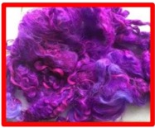 | Is the method of dyeing before blending woth other colors to give fancy yarn or fabrics
2 | YARN DYEING | 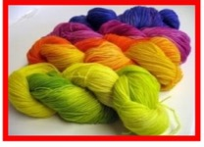 | Method of dyeing yarns in fprms of hanks or packages dyeing
3 | FABRIC DYEING | 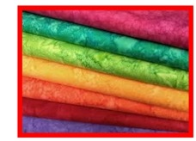 | Is the method after weaving, knitting our non-woven to make fabrics
MORDANT
- Is a chemical binding agent that adheres well both the fibres and the dye
- Is a substance used to set dyes on fabrics by forming a coordination complex with the dye which then attached to the fabric
- Is always a polyvalent metal ion
Importance of mordant dyes
- Are done for getting the binding action of the chrome
- They are mostly used for wool which gets a good color fastness after treatment with mordant dyes
- Also used for cotton, linen, silk, rayon and nylon but are less effective for them
- It requires less time
- Has high production
- Has easier shades matchig and dyeing is carried in one stage
LESSON 85
STRAND: HEC 11.3 CLOTHING AND TEXTILES
SUB-STRAND: HEC 11.3.1 FIBRES AND FABRIC
LESSON OBJECTIVE: HEC 11.3.1.2: Identify and discuss the different types of printing and explain their advantages and disadvantage.
PRINTED FABRICS
- Are defined as fabrics that have been decorated by a motif, pattern or design applied to the surfaces opf the fabric after it has been constructed.
- A form of applying colour decoration to a fabric after it has otherwise been finished
TYPES OF PRINTING
 | TYPES | DESCRIPTION | ADVANTAGES
1 | SCREEN PRINTING  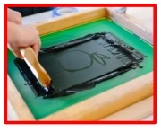 | - Method in which ink is applied directly to the surface to be printed [substrate]  - The ink is wiped across the screen to pass through the unblocked pores and reach the substrate.  - For each color to be printed a separate screen is prepared and the process is repeated  - It is more suitable for curved shapes [such as bottles and cups], non-porous surfaces [such as ceramics and metals], and short print runs  - Also called as sengraphy | - Colours can be produced in brighter, cleaner shades than are possible woth roller printing  - Designs to be repeated can be much larger than in roller printing  - Rotary metal screens are lightweight in contrast to heavy copper rollers in roller printing
2 | STENCIL PRINTING  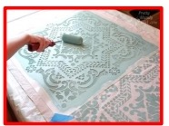 | - The pattern is cut out of a sheet of stout paper or thin metal with a sharp pointed tool, the uncut portions representing the part that is to be left uncolored.  - The sheet is laid on the material to be decorated and colour is brushed through its open spaces.
3 | BLOCK PRINTING  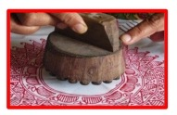 | - The blocks are usually made of wood and the design is hand carved, so that it strands out in relief against the background surface.  - The print paste is applied to the design surface on the block and the block then pressed against the fabric  - The process is repeated with different designs and colours until pattern is complete

YEAR 11 HOME ECONOMICS WEEKLY WORKSHEET 7
- Differentiate between surface design and structural design.

- Write down one factor to remember when using the following decoration
- Stencil printing

- Embroidery

- Applique

- Discuss two advantages of screen printing.

- Describe the three methods of applying colour to fabric.

- Discuss the term Mordant.

- Discuss two importance of Mordant in fabrics

