WEEK 6 YEAR 11 HOME ECONOMICS
LESSON 76
STRAND: HEC 11.3 CLOTHING AND TEXTILES
SUB-STRAND: HEC 11.3.1 FIBRES AND FABRIC
LEARNING OUTCOME: HEC 11.3.4.1 discuss special fibers and classify their properties.
- Fibre Fibres are small hair like structure that either grows naturally on animals or plants.
- Yarn: Yarn is a long, continuous thread made from twisted or spun fibres.
- Fabric A thin, pliable, sheet like material made from woven, knitted or knotted yarns, or felted or bonded textile fibres.
SPECIAL FIBRES
FIBRES | SOURCES | PROPERTIES | USES
Metallic  Includes manufactured fibres composed of metal, metal-coated plastic.  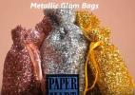 | - Metallic fibres are produced in various ways including solid-state manufacturing and melt-state manufacturing, since metals can be cut, deformed and melt-procesed. | - Lightweight  - High Strength  - High Stiffness  - Durable  - Versatile  - Shiny, adds decoration to garments  - Magnetic | - Used as upholstery fabric and textiles such as lame and brocade.  - Party and evening wear to club clothing, cold weather and survival clothing, and every day wear.
Elastomeric  Elastomeric fibers are those fibers that possess extremely high elongations at break and that recover fully from high elongations up to their breaking point.  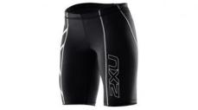 | - Elastomeric fibers are produced with natural and synthetic polymers. | - Fiber is more elastic and durable than rubber.  - The fiber is quite weak.  - Dry-cleanable, the fiber is heat-sensitive and must be pressed with cool iron.  - Hydrophobic, therefore it dries quickly because it‘s not comfortable and it‘s advisable to wear absorbent apparel over it. | - Use for texturized yarns and knitted structures and are used in waistbands, sock tops, foundation garments, and exercise wear.
MICRO-FIBERS  The term "Microfiber" is short for "Micro denier" fiber, that is, ultrafine fibers that are less than 1 denier in size.  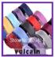 | - Microfiber Fabrics can be made from polyester, nylon, rayon, acetate or a combination of those fibers. | Microfibers are usually:  - Very Drape able yet not flimsy;  - Soft with luxurious hand;  - Washable. Dry cleanable;  - Shrink- resistant  - High Strength(except Rayon)  - Resist ‗Pilling‖ and Clinging; | - Used to make mats, knits, and weaves for apparel, upholstery, industrial filters, and cleaning products.  - Athletic wear, such as cycling jerseys.
ACTIVITY
- Write the sources for the following special fibres.
- Metallic
- Elastomeric
2. List two properties of
a. metallic fibres
b. microfibers

LESSON 77
STRAND: HEC 11.3 CLOTHING AND TEXTILES
SUB-STRAND: HEC 11.3.1 FIBRES AND FABRIC
LESSON OBJECTIVE: HEC 11.3.1.1: Examine the principles in the construction of fibers, yarn, fabric.
BASIC PRINCIPLES INVOLVED IN THE PRODUCTION OF: FIBERS [CARDING, HACKLING, COMBING]
1. Carding
- Cotton, wool, waste silk, and man-made staple are subjected to carding, a process of separating individual fibres and causing many of them to lie parallel and also removing most of the remaining impurities.
- Carding produces a thin sheet of uniform thickness that is then condensed to form a thick, continuous, untwisted strand called sliver.
- When very fine yarns are desired, carding is followed by combing, a process that removes short fibres, leaving a sliver composed entirely of long fibres, all laid parallel, and both smoother and more lustrous than uncombed types.
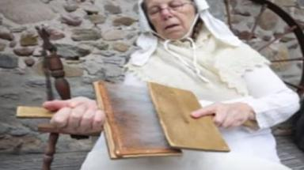

2. Hackling
- Hackling is the disentangling of fibres and combing them out, laying the fibres smooth and parallel, and splitting these into ultimate filaments.
- The fibres are then combed on hackles to produce long line fibres that can be spun, called line flax.
- The short fibres that are combed out are the hackle tow or flax tow and are carded and spun into coarse yarns and thread.
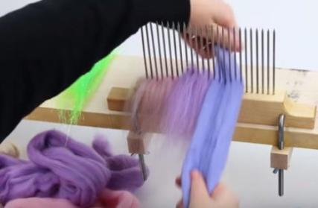
3. Combing
- Combing is a technique whereby fibres (usually cotton or wool) are passed through a series of straight, metal teeth in order to lay the fibres parallel to one another.
- The fibres are then placed together in a long line (combed sliver‘), which is used to spin a smooth, even thread.
- In this process, long fibres are separated from shorter ones (noils) and tangles are removed.
- At the same time, practically all remaining foreign matter is removed from the fibres.
- In general, combed fibres are cleaner, finer, stronger and more lustrous than carded ones.
- Combed fibres are generally used for producing worsted threads.
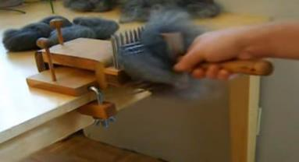

ACTIVITY
- Explain the following principles:
i. Carding
ii. Hackling
iii.Combing
LESSON 78
STRAND: HEC 11.3 CLOTHING AND TEXTILES
SUB-STRAND: HEC 11.3.1 FIBRES AND FABRIC
LESSON OBJECTIVE: HEC 11.3.1.1: Examine the principles in the construction of fibers, yarn, fabric.
PRINCIPLES INVOLVED IN THE PRODUCTION OF SPUN, FILAMENT YARN, YARN TWIST – ‘S’ AND ‘Z’
TWISTING
- Twisting in yarn and rope production, process that binds fibers or yarns together in a continuous strand, accomplished in spinning or playing operations.
- The direction of the twist may be to the right, described as Z twist, or to the left, described as S twist.
- Single yarn is formed by twisting fibers or filaments in one direction.
- Ply yarn is made by twisting two or more single yarns together, usually by combining singles twisted in one direction with a ply twist in the opposite direction.
- “Z” Twist- spinning to the right(clockwise) produces a “Z” twist
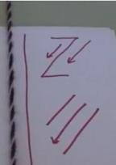
- “S” Twist- spinning to the left(counter clockwise) produces an “S” twist
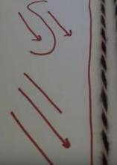
Types of yarn
Classification based on number of strands.
Yarns can be described as single, textured or novelty.
1. Single Yarn
- Single yarns are single strands composed of fibres held together by at least a small amount of twist.
- Single yarns of the spun type, composed of many short fibres, require twist to hold them together and may be made with either S-twist or Z-twist.
- Single yarns are used to make the greatest variety of fabrics.

2. Textured Yarn
- Texturizing processes were originally applied to man-made fibres to reduce such characteristics as transparency, slipperiness, and the possibility of pilling (formation of small fibre tangles on a fabric surface).
- Texturizing processes make yarns more opaque, improve appearance and texture, and increase warmth and absorbency.
3. Novelty
- Novelty yarns include a wide variety of yarns made with such special effects as slubs, produced by intentionally including small lumps in the yarn structure, and man-made yarns with varying thickness introduced during production.
- Natural fibers, including some linens, wools to be woven into tweed, and the uneven filaments of some types of silk cloth are allowed to retain their normal irregularities, producing the characteristic uneven surface of the finished fabric.
- Man-made fibres, which can be modified during production, are especially adaptable for special effects such as crimping and texturizing.

ACTIVITY

- Explain the process of twisting.
- Differentiate between S-twist and Z- twist.
- Describe the following yarns:
i. Novelty yarn.
ii.Textured yarn.
iii. Single yarn.

LESSON 79
STRAND: HEC 11.3 CLOTHING AND TEXTILES
SUB-STRAND: HEC 11.3.1 FIBRES AND FABRIC
LESSON OBJECTIVE: HEC 11.3.1.1: Examine the principles in the construction of fibers, yarn, fabric.
PRODUCTION OF FABRICS
Weaving
- Weaving is a method of textile production in which two distinct sets of yarns or threads are interlaced at right angles to form a fabric or cloth. Most fabrics are presently produced by some method of interlacing, such as weaving or knitting.
Weaving Patterns Decoded
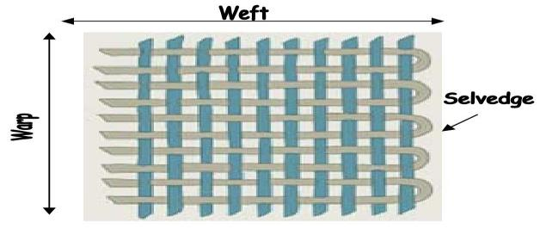
- Weft: The horizontal yarns are called weft yarns.
- Warp: Warp yarns run vertically the length of the fabric, known as the grain.
- Selvedge: The weft yarns are wrapped around the warp yarns to create an edge to the fabric, known as the Selvedge.
- Bias: the diagonal or cross grain of a woven fabric.
- Grain: runs the length of the fabric.

TYPE OF WEAVE | METHOD | USES
Plain Weave-it is the simplest weave  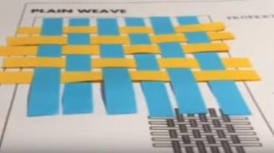 | In plain weave, each weft thread (Filling) passes alternatively over and under each ways yarn in a square pattern. | Plain weave produces a firm woven fabric.
Twill Weave: produces a strong, sturdy fabric like jeans.  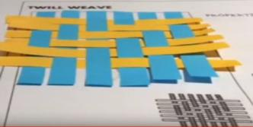 | In a twill weave, the weft passes over two or several warp threads to produce a diagonal pattern. | Denim, tweed, chino, gabardine, drill, covert, and serge.
Satin Weave will produce smooth, luxurious cloth.  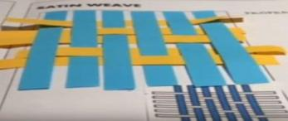 | The weft can pass as many as 12 warp threads so that the diagonal lines cannot be seen. | Womens‘ lingerie, nightgowns, blouses, and evening gowns, but also in boxer shorts, shirts and neckties.

Knitting
- Knitting is done by set of connected loops from a series of yarn in warp or weft direction. Knitted fabrics are divided into two main types; they are:
1. Warp knitting
2. Weft knitting

TYPE | METHOD | USES
Weft Knitting  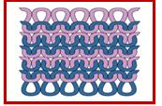 | - In weft knitting, the loops are formed across width of the fabrics.  - Each weft thread is fed, more or less at right angles to direction in which the fabric is produced.  - In this method the fabric is produced by simple up and down movement of the needles, which is provided by the profile of a cam system. | - Single jersey or plain fabric  - Purl Fabric  - Rib Fabric  - Interlock Fabric
Warp Knitting  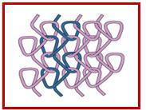 | - In a warp knitted structure each loop in the horizontal direction is made from different thread.  - Elasticity of the warp knitted fabrics is less than weft knitting. | - Inner wears (brassieres, panties, camisoles, girdles, sleep wear, hook & eye tape.)  - Apparel (sportswear lining, track suits, leisure wear and safety reflective vests.)

Activity
1. Differentiate between weaving and knitting.
LESSON 80
STRAND: HEC 11.3 CLOTHING AND TEXTILES
SUB-STRAND: HEC 11.3.1 FIBRES AND FABRIC
LESSON OBJECTIVE: HEC 11.3.1.1: differentiate the characteristics of woven and fabrics
Characteristics of Woven and Knitted Fabric
Knitted fabric | Woven fabric
Lengthwise stitches are called ribs and the crosswise stitches are called course or cross grain | Lengthwise stitches are called grain and the crosswise stitches are called cross grains
The most stretch is either in the cross grain or the bias | The most stretch is always on the bias (diagonal stretch)
Generally have more stretch and natural give | Require ease when sewing
Mold and fit the contours of the body better | Look good with pleats and sharp corners
Cool and breathable | Thick and wind resistant
Wrinkle resistant | Holds a crease well
Edges curl and some knits run (think nylon panty hose) | Edges are prone to ravel
No seam finish is required, although optional | Requires seam finishing, like serging, to prevent ravel
- The easiest way to tell whether a fabric is knit or woven is to look close to the fibers. If there are loops, it is a knit fabric, but if it resembles more of a checkerboard, it is woven as seen below:
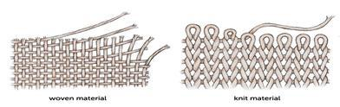
Activity
- Explain the process of knitting.
- List two characteristics of woven fabrics and knitted fabrics.
YEAR 11 HOME ECONOMICS WEEKLY WORKSHEET 6

- Define the following terms:
- Yarn
- Fibre
- Fabric
- In the space provided in your books, demonstrate how ‘Z’ and ‘S’ yarn twist is done and explain brielfy on each.
- Differentiate between the following terms below:
- Textured and novelty yarn.
- Warp and weft knitting.
- Identify two characteristics of woven and knitted fabric.
- Define the following terms:
  - spinning.
(ii) textured yarn.
6. Study the picture below and answer the following questions.

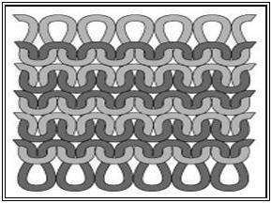

 | (i) | Identify the type of knitting illustrated in the picture.
 | (ii) | State two properties of knitted fabrics that make it a popular wear.

