**HOME ECONOMICS**

**LESSON NOTES YEAR 11**

**WEEK 4**

**LESSON 66:**

STRAND: HEC 11.3 CLOTHING AND TEXTILES

SUB-STRAND: HEC 11.3.6 TECHNIQUES AND PROCESSES

LEARNING OUTCOME: construct a garment using selected processes and techniques

**HAND STITCHES**

|  |  |  |
| --- | --- | --- |
|  | TYPES | DESCRIPTION |
| 1 | HEMMING | Is a decorative drawn thread work hand sewing technique for neatening the hem of clothing or household linen.  Contrasting colours are used to be noticeable |
| 2 | SLIP-HEMMING | Is a finish stitch  Use it to hem the garments with regular fold-up hems and for attaching the bias to the inside of necklines, waist, edges, and sleeves/skirt/pant hems  The hem is pressed up and small stitches tack the fold to the fabric. |

ACTIVITY:

1. Differentiate between hemming and slip hemming.

2. Identify the hemming shown below.

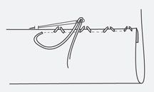

**LESSON 67**

STRAND: HEC 11.3 CLOTHING AND TEXTILES

SUB-STRAND: HEC 11.3.6 TECHNIQUES AND PROCESSES

LEARNING OUTCOME: construct a garment using selected processes and techniques

**DISPOSAL OF FULLNESS:**

|  |  |  |
| --- | --- | --- |
|  | **TYPES** | **DECRIPTION** |
| 1 | DARTS | * Are fold and sewn into fabirc to take in ease and provide shape to a garment, especiaaly for a womans bust * They are used frequently in all sorts of clothing to tailor the garment to the wearers shape, or to make an innovative shape in the garment. |
| 2 | PLEATS | A double or multiple fold in a garment or other item made of cloth, held by stitching the top or side |
| 3 | GATHERS | * Is used to draw up fullness in piece of fabric. * Two rows of machine stitches is used and the bobbin thread drawn up and fullness distributed evenly. |
| 4 | TUCKS | * A tuck is a fold or pleat in fabric that is sewn in place * May be used to decorate clothing or household items. |

ACTIVITY:

Identify the method of disposable shown below in the garments below.

|  |  |
| --- | --- |
| i. Adding in pin tucks tutorial - Guthrie &amp; Ghani |  |
| ii.  Buy Taavi Women Blue Indigo A-Line Top with Gathers online | Looksgud.in |  |
| iii.  Pleated Maxi Skirt in Black - Roman Originals UK |  |
| iv. |  |

**LESSON 68: FASTENERS**

STRAND: HEC 11.3 CLOTHING AND TEXTILES

SUB-STRAND: HEC 11.3.6 TECHNIQUES AND PROCESSES

LEARNING OUTCOME: construct a garment using selected processes and techniques

|  |  |  |
| --- | --- | --- |
|  | **TYPES** | **DECRIPTION** |
| 1 | ZIPPER | * Are commonly used at the center front or center back of dresses, skirts and trousers * They are strong fasteners and are most often used to fasten garments at pints where there is likely to be strain. |
| 2 | VELCRO | * It consists of two parts –a with covered with small loops and the other with hooks. * When the two parts are pressed together, the loops and hooks interlock. * The strips of tape can be machined or sewn with fine hemming stitches around all four edges to keep them in place. * The tape can be cut to any required length. |
| 3 | BUTTONS/BUTTON HOLE | * There is an art to sewing on buttons so that the closing edge will lie flat * This depends on the buttons being located accurately and being sewed on in the correct way for the type of button been used |

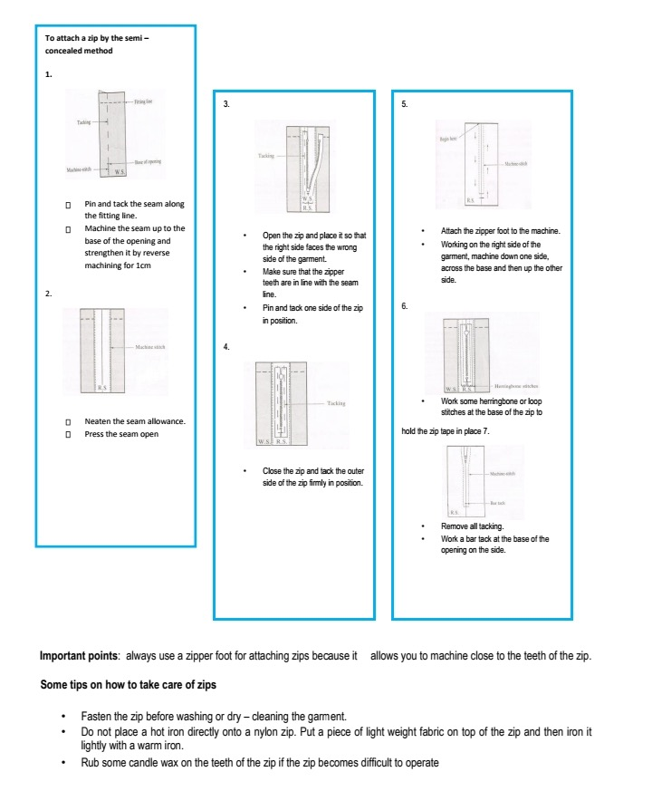

ACTIVITY:

1. Differentiate between a zipper and velcro.

2. Explain the steps in attaching a zipper.

**LESSON 69:**

STRAND: HEC 11.3 CLOTHING AND TEXTILES

SUB-STRAND: HEC 11.3.6 TECHNIQUES AND PROCESSES

LEARNING OUTCOME: construct a garment using selected processes and techniques

**EDGE FINISHES**

|  |  |  |
| --- | --- | --- |
|  | Types | Description |
| 1 | Facing | A piece of material sewn on the inside of a garment, especiaaly at the neck and armholes, to strengthen it. |
| 2 | Binding | Used to finish a seam or hem of a garment, usually by rolling or pressing then stitching on an edging or trim [sewing] |

**TECHNIQUE [REMOVING BULK]**

|  |  |  |
| --- | --- | --- |
|  | **TYPES** | **DESCRIPTION** |
| 1 | CLIPPING | Is done on curve-convex or outward curves so that the edges are allowed to spread  Cuts are made at frequent intervals, atmost up to the line of stitching |
| 2 | NOTCHING | is done on concave or inward curves, notching is recommended so that space is opened by the removal of fabric, allowing the edge to be drawn in small ‘V’ shapes are cut out at regular intervals |
| 3 | TRIMMING | To make something neater or more even by cutting a small amount off.  Cutting to remove a small of fabric/thread from an area in the case of an enclosed seam, both seam allowances are cut back an equal distance. |
| 4 | LAYERING | Is the cutting of seam allowances to different widths.  The seam allowance that will be next to the garment side is cut the widest.  The end result is a seam that lies flat without causing a bulky edge. |
| 5 | TOPSTITCH | Is a sewing technique  It is most often on garment edges such as necklines and hems, where it helps facings to stay in place and gives a crisp edge  Decorative topstitching is designed to show, and may be done in a fancy thread or with a special type of stitch.  Otherwise, topstitching is generally done using a straight stitch with a thread matches the fashion fabric |

ACTIVITY:

1. Differentiate between the following processes:

1. Clipping and notching.
2. Trimming and layering.
3. Facing and binding.

2. Identify two garments where top-stich is used.

**LESSON 70**

STRAND: HEC 11.3 CLOTHING AND TEXTILES

SUB-STRAND: HEC 11.3.6 TECHNIQUES AND PROCESSES

LEARNING OUTCOME: construct a garment using selected processes and techniques

**TECHNIQUE [REMOVING BULK]**

|  |  |  |
| --- | --- | --- |
|  | TECHNIQUE | DESCRIPTION |
| 1 | UNDERSTITCH | Used to keep a facing and its seem line on the wrong side of the garment  After seam allowances have been trimmed and graded, cliper or notched, stitch through the facing and seam allowances, very close to the seam line. |
| 2 | STAY STITCH | Is an important way to maintain the size and shape of garment pieces as you work with them.  It is done along the curved areas of each garment piece to keep the edges from stretching and to hold the grain in place.  Regular machine stitching is used on a single piece of fabric. |
| 3 | PRESSING | Pressing is what you do when youre making something out of fabric and it isnt finshed yet  When you press your own sewn pieces, you lift the iron and place it gently down over the area [usually a seam], then lift it and move it again. |
| 4 | MITRE | Mitered corner is a neat way of finishing the corner of a fabric edge I such a way of finishing the corner of fabric edge in such a way that there is no bulk in the corners when the fabric is turned under to finish the edges. |

ACTIVITY:

1. Differentiate between pressing and ironing.

2. State the purpose of stay stitch.

3. What is the function of under stitch and where is it used?

**YEAR 11 HOME ECONOMICS WEEKLY WORKSHEET 4**

STRAND: HEC 11.3 CLOTHING AND TEXTILES

SUB-STRAND: HEC 11.3.6 TECHNIQUES AND PROCESSES

ACTIVITY

A. Define and describe the following types of techniques.

1. Mitreing 2. Snipping

3. Layering

B. Explain the following processes with one example.

1. Fastening 2. Seams

3. Controlling Fullness

C. Identify the following techniques.

|  |  |
| --- | --- |
| **A** | **B** |
| http://www.blueradish.com.au/wp-content/uploads/2015/07/Sewing-Curves-3.jpg | http://seekatesew.com/wp-content/uploads/2014/05/easing-sleeves.jpg  Set- in -sleeve in the arm hole. |

D. Identify the following techniques.

|  |  |
| --- | --- |
| **A** | **B** |
|  |  |