HOME ECONOMICS

LESSON NOTES YEAR 11
WEEK 3
LESSON 61
STRAND: HEC 11.3 CLOTHING AND TEXTILES
SUBSTRAND: HEC 11.3.5 PATTERNS/DESIGN
LEARNING OUTCOME: CREATE PATTERNS USING FREE HAND DRAFTING TECHNIQUE
BASIC BLOCK PATTERN:
- is a foundation pattern which involves moving a template to change the position of darting, add extra fullness, take fullness out and change the shape of the basic block.
- The basic principle is to move your original basic pattern on certain pivot points to gain new styles.
- It is important that a correct block is selected for the design, this is not only saves time during adaptation but can affect the final shape.
- There is no seam allowance added to the blocks.
- These are added after the pattern is constructed.

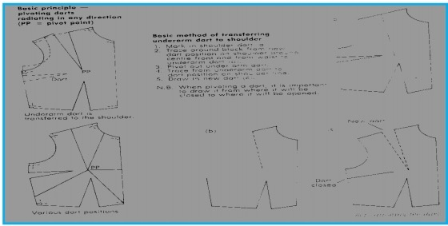
ACTIVITY:
DRAW AND COLOUR YOUR SCHOOL UNIFORM IN YOUR ACTIVITY BOOK.
LESSON 62
STRAND: HEC 11.3 CLOTHING AND TEXTILES
SUB-STRAND: HEC 11.3.6 TECHNIQUES AND PROCESSES
LEARNING OUTCOME: DEVELOP COMPETENCY IN GARMENT CINSTRUCTION TECHNIQUES AND PROCESS TO CONSTRUCT A GARMENT.
PATTERN MARKINGS:
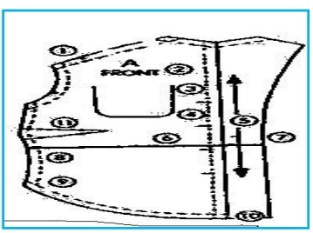
- Each pattern piece contains written directions and symbols such as dots and arrows-a-kind of shorthand that’s easy to learn and speeds your sewing because it shows you which edges to match and where to position details.

1 | Notches | Are diamond shaped symbol located on the cutting lines
2 | Letters or numbers | Identify each pattern piece
3 | Solid lines | Show where to position pockets, buttonholes, the waistline, centre front and centre back, or where to fold the fabric
4 | Center lines | A broken line that appears on some pattern pieces
5 | Grain line arrow | Is used for positioning pattern piece on the correct fabric grain
6 | Lengthen or shorten here lines | Are two parallel lines which indicate where to make the pattern piece longer or shorter
7 | Cutting lines | Are broken lines along the outer edge. Follow the line while cutting
8 | Seam lines | Are broken lines, usually 5/8 “[1.5cm] from the cutting line
9 | Dots | Are circles which mark points to be matched before stitching and the placement of details, such as darts, tabs and belt loops.
10 | Seam allowance | Is the area between the seam line and cutting line
11 | Darts | Are usually shown as V-Shaped broken and solid lines with dots.
12 | Tuck lines | Is usually a combination of solid and broken lines
13 | pleats | Solid and broken lines with double –headed arrows between
14 | Hemline | The recommended amount to turn up for hem
15 | Straight line arrows | Indicate pieces that must be placed parallel to the edge of your fabric
16 | Curved grainline arrows | Indicate pieces that are placed along folded fabric edges
17 | Gathering or ease lines | Show where the to sew the gathering or easing stitches
18 | Clip arrow | Show where to clip into seam allowance to make it easier to sew
19 | Directional stitching arrows | Are located on the seam line and how you which direction to stitch seams so the fabric doesn’t stretch.

ACTIVITY:
Identify the pattern markings below:
 | MARKINGS | NAME
1
2 | ---------------------------------------
3
4
5 | --------------------------------

LESSON 63
STRAND: HEC 11.3 CLOTHING AND TEXTILES
SUB-STRAND: HEC 11.3.6 TECHNIQUES AND PROCESSES
LEARNING OUTCOME: construct a garment using selected processes and techniques
CARE LABEL
- Care label symbols give consumers and retailers information on how best to wash, dry or clean their clothes.
- Following the correct care labelling can help keep clothes in the best shape possible.
- Help reduce the number of complaints and returns.
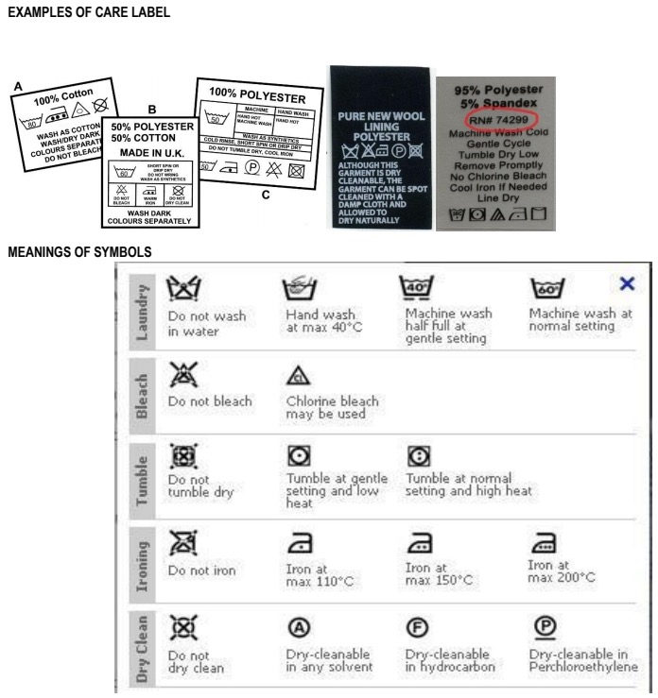
NB: [draw them in your book]

PRE-SHRINKING:
DEFINITION: wash and dry the fabric- fabric is put through a shrinking process to prevent further shrinking after washing or cleaning.
DIRECTIONS:
- Your fabric is necessary, and make sure the grains is straight.
- Do this by tearing across the grain at the ends of your fabric piece [if it is firmly woven], pulling a thread across the width of the fabric at the ends, or cutting along a dominant line in the pattern or weave.
- Fold lengthwise, matching selvages, to see whether the ends now match
- If they don’t and the fabric needs to be straightened, gently pull on the fabrics length from opposite corner.
ACTIVITY:
- Take out an old garment that is not used -[no need to buy], wash it in the sink then dry it under the sun or in the shed. –example of pre-shrinking that can be done at home.

- Take out the care labels from the old garments and paste it in the box given below.

LESSON 64
STRAND: HEC 11.3 CLOTHING AND TEXTILES
SUB-STRAND: HEC 11.3.6 TECHNIQUES AND PROCESSES
LEARNING OUTCOME: Develop competence in garment construction techniques and processes.
SEAMS
NO | TYPES | DESCRIPTION | DIRECTION
1 | PLAIN | Suitable for any type of fabric, whether its woven or knit, soft or crisp, lightweight or heavier weight. | With right sides together, stitch along the seamline, which is usually 5/8”[1.5cm] from the cut of the edge, with a regulation –length.  Open the fabric and the seam allowance, so that the right sides of your fabric are no longer together; press the seam open.
2 | FRENCH | Adds a courture look to the inside of garments made from sheers and lightweight silks.  The finished seam, which should be very narrow, completely encloses the raw edges of the seam allowances. | - With the wrong side together, stitch a 1cm plain seam  - Trim the seam allowances to 3mm  - Open the fabric and seam allowance, so that the right sides of your fabric are no longer together, press the seam and seam allowances open  - Fold the fabric tight sides together along the stitching line, then press.  - The 3mm trimmed seam allowance should be now encased inside this fold.
3 | FLAT FELL | Used on sportwear, mens wear and reversible garments | With the wrong sides of the fabric together, stitch a plain seam.  Open the fabric so that the wrong sides are no longer together  Press the seam allowances to one side, so that one seam allowance lays on of the other  - Trim the underneath seam allowance to 1/8”[3mm]  - Turn under 6mm of the top seam allowance and baste it in place over the trimmed edge  - Edge stitch close to the fold
4 | LAPPED | Is frequently used non-woven fabrics, such as synthetic suede and leather, as well as real suede and leather, because their edges do not fray. | - Trim away the seam allowance on one of your squares. This will be the upper section of the seam.  - Lap the upper section over the second fabric square, placing the trimmed edge along the lower squares seam lime; hold it in place with hand basting, double – faced basting tape, glue stick or fuse basting  - Edge stitch along the trimmed edge, going through both upper and lower layers.  - Top stitch on the overlap 6mm away from the first stitching line, again going through both layers of fabric.

ACTIVITY
Identify the following types of seam
 | TYPES | NAMES
1 | 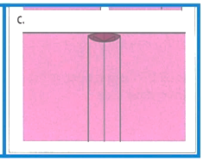
2
3
4

LESSON 65:
STRAND: HEC 11.3 CLOTHING AND TEXTILES
SUB-STRAND: HEC 11.3.6 TECHNIQUES AND PROCESSES
LEARNING OUTCOME: construct a garment using selected processes and techniques
SLEEVES: SET-IN
- Is a sleeve cut and stitched into armhole of a finished bodice so that there is a comfortable sleeve cap ease for better fitting.
- The set in sleeve fits the armhole smoothly without puckers.
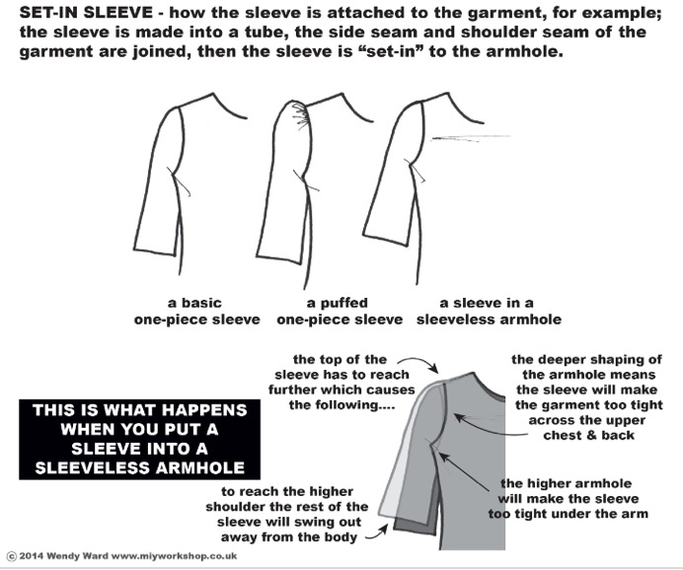

ACTIVITY
Draw/ collect pictures of the different types of sleeves in the space given below.

YEAR 11 HOME ECONOMICS WEEKLY WORKSHEET 3
STRAND: HEC 11.3 CLOTHING AND TEXTILES
SUBSTRAND: HEC 11.3.5 PATTERNS/DESIGN
LEARNING OUTCOME: CREATE PATTERNS USING FREE HAND DRAFTING TECHNIQUE
- SELECT ANY THREE DESIGNS BELOW AND DRAFT THEM IN YOUR EXERCISE/ ACTIVITY BOOK.

- DRAW WITH PENCIL AND USE COLORS TO ENLIGHTEN YOUR DESIGN
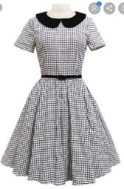 | 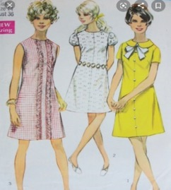 | 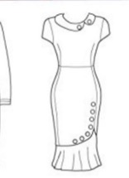 | 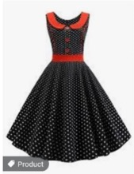
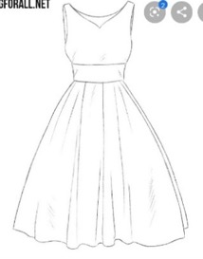 | 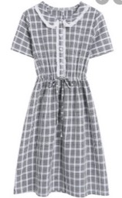 | 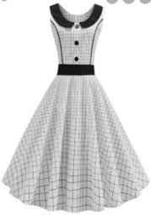 | 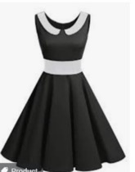
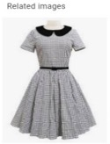 | 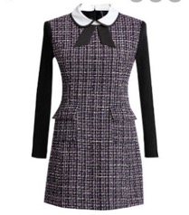 | 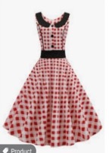 | 