YEAR ELEVEN
GEOGRAPHY
HOME LEARNING KIT
Week 10
Strand: Human Geography
Sub strand: Population and Settlement

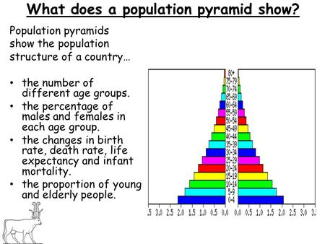

Name :
Year:
Index no:
LESSON 81
Strand: Human Geography
Sub Strand: Population (INDIA)
Learning Outcome: Analyze ways of minimizing impacts
Ways of minimizing impacts from increasing population
- Afforestation/reforestation
- Minimize the burning of fossil fuels
- Control logging
- Sustainable development

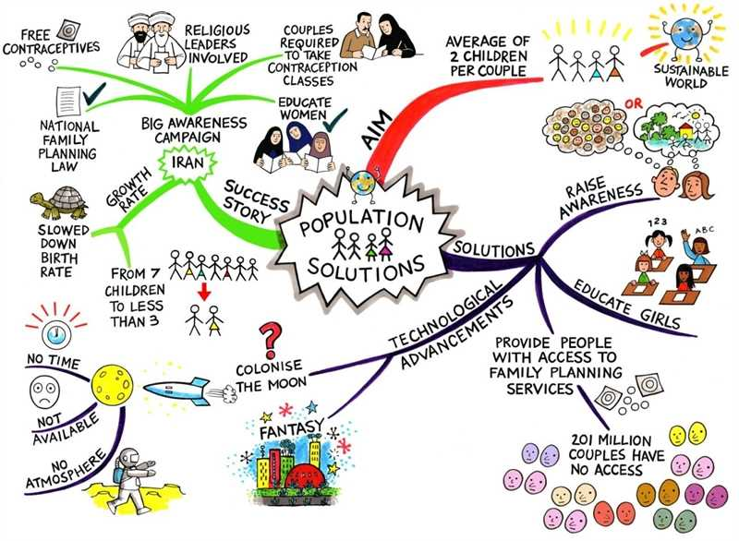

Activity
- Discuss four effect of climate change on population distribution.

Lesson # 82
Strand: Human Geography
Sub Strand: Population (INDIA)
Learning Outcome: Describe the types of external migration

Voluntary – is internal and external migration
Compulsory- is internal and external migration
Voluntary – people either choose to migrate (there is strong pull factors)
Compulsory – people are made to or forced to migrate (involuntary) (there is strong push factors)
Types of external migration
Immigration – (migration into the country)
Immigrants- people who come into the country
Emigration- migration out of the country
Emigrants – people who go out of the country to another country
Activity
Show the example of internal and external migration on the map of Fiji
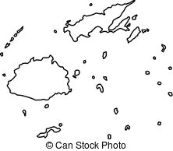

Short Answers
- Discuss two reasons for urban to urban migration
- Why the government needs to control rural urban migration
- State one problem faced due to excess emigration.
- How can the government control emigration.
Lesson # 83
Strand: Human Geography
Sub Strand: Population (INDIA)
Learning Outcome: Analyze push and pull factors
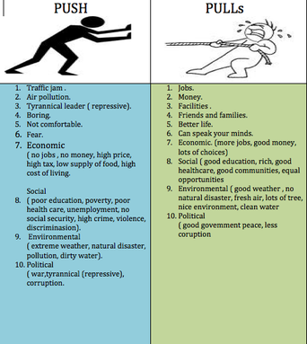

Activity
- State two pull factors common in Fiji.
- Discuss how the government can improve on push factors.
- State two problems that would be faced by an area losing population and an area gaining population.

Lesson # 84
Strand: Human Geography
Sub Strand: Population (INDIA)
Learning Outcome: Analyze and examine the positive and negative impacts of migration.
LOSING COUNTRY |  | HOST COUNTRY
Positive impacts | Negative impacts | Positive impacts | Negative impacts
- Decrease population  - More space  - More opportunities  - Less competition | - Less labor  Force  - Brain drain  - Less developed | - More labor/better expertise  - New ides/ new tech  - New developments  - New investments | - Increase population  - Depletion of resources  - Destruction of habitats  - Decrease in land space due to development

SHORT ANSWERS
- State two environmental impacts to the host country.
- Describe how population growth has a negative impact to economy.
- Suggest to ways control losing population from an area.

Lesson # 85
Strand: Human Geography
Sub Strand: Population (INDIA)
Learning Outcome: Analyze the impacts of population change
Impact of population change

Increasing population
Increase in depletion and exploitation of resources
Require more resources

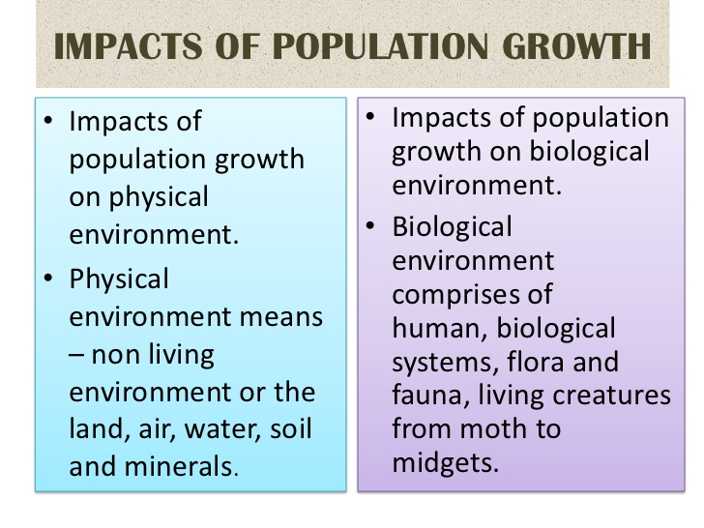

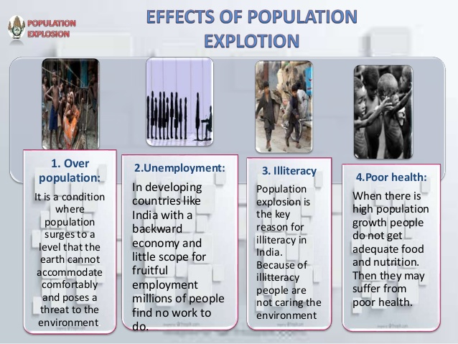

Activity
- State two environmental impacts from population growth.

- Describe one way to reduce the impact in (1) above.

- State two economic impacts from population growth.

- Describe one way to reduce the impact in (1) above.

