YEAR ELEVEN
GEOGRAPHY
HOME LEARNING KIT
Week 9
Strand: Human Geography
Sub strand: Population and Settlement

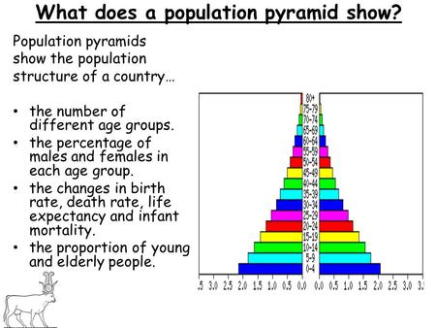

Name :
Year:
Index no:
Lesson # 76
Strand: Human Geography
Sub Strand: Population (INDIA)
Learning Outcome: describe and analyse push and pull factors
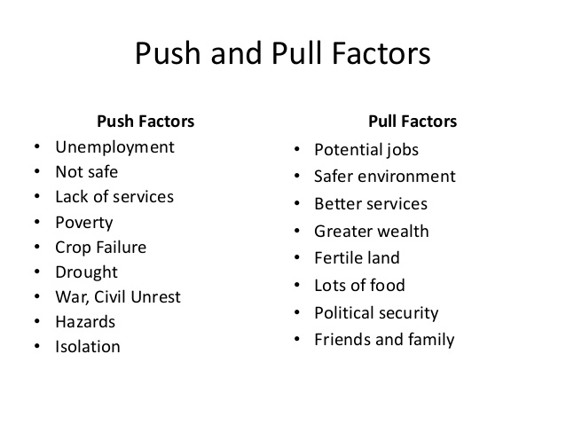

Activity
Fill in the table below
Reasons for Immigration Reasons for Emigration
pull | push | pull | push

Activity
- State two pull factors common in Fiji
- Discuss how the government can improve on push factors.
- State two problems that would be faced by an area losing population and an area gaining population.

Lesson # 77
Strand: Human Geography
Sub Strand: Population (INDIA)
Learning Outcome: Analyze and examine the positive and negative impacts of migration.
Positive and negative impacts of host and losing in migration
Losing country Host country
Positive impacts | Negative impacts | Positive impact | Negative impact
Decrease population | Less labor force | More labor | Increase population
More space | Brain drain | Better expertise | HOTCUPS
More opportunities | Less development | New ideas | Depletion of resources
Less competition |  | New technology | Destruction of habitats
 |  | New developments | Decrease in land space due to development
 |  | New investment

Activity
Essay
With reference to specific case studies discuss four main causes of migration and its impacts to the host country/area. (Environmental, economic and social)

Lesson # 78
Strand: Human Geography
Sub Strand: Population (INDIA)
Learning Outcome: Analyze the impact of population change
Impact of population change
REQUIRE MORE RESOURCES
INCREASE IN DEPLETION AND EXPLOITATION
INCRESING POPULATION

NEGATIVE ENVIRONMENTAL IMPACTS
- Pollution (air, water, noise and land)
- Depletion of resources (land and marine)
- Deforestation
- Destructions of habitats/organisms
- Degradation of drinking water
- Soil degradation
- Over grazing and over cropping to meet demands – desertification
- Loss of biodiversity
- Environmental stress
NEGATIVE ECONOMIC IMPACTS
- Poverty
- Inflation
- More government expenditures
- Reduce per capita income
- Increase in Unemployment
- Low investment child’s education
- High trade deficit
- High cost of living

Activity
Short Answers
- Describe one environmental impact of increasing population
- Suggest two ways to solve economic impacts

Lesson # 79
Strand: Human Geography
Sub Strand: Population (INDIA)
Learning Outcome: Analyze the impact of climate change on population
Impact of climate change on population distribution
Climate change has become a contemporary issue of modern era as it is major threat to planet earth.
The small island of south pacific experience the most of it and it contributes to massive population distribution.
Climate change due to human activities | Changes experienced | Negative impacts
Air pollution  deforestation | Increase temperature  Changes in wind patterns  Changes in precipitation | Rise in sea level  Drought  Excessive rainfall

Activity
- State two ways in which you have contributed towards positive action to climate change.

- List two ways to create awareness in
- School

- Society

Lesson # 80
Strand: Human Geography
Sub Strand: Population (INDIA)
Learning Outcome: Familiarise with population pyramid
Resource study
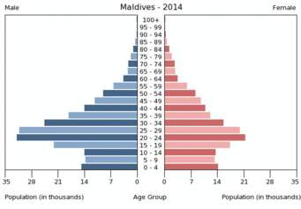

- State the data of population age group 0-4 for males and females.

- This pyramid is a good example of developed or developing nation? Why?

- Which age group belongs to workforce?

- State one advantage of more population in workforce.

- Define zero population growth.

Resource Study
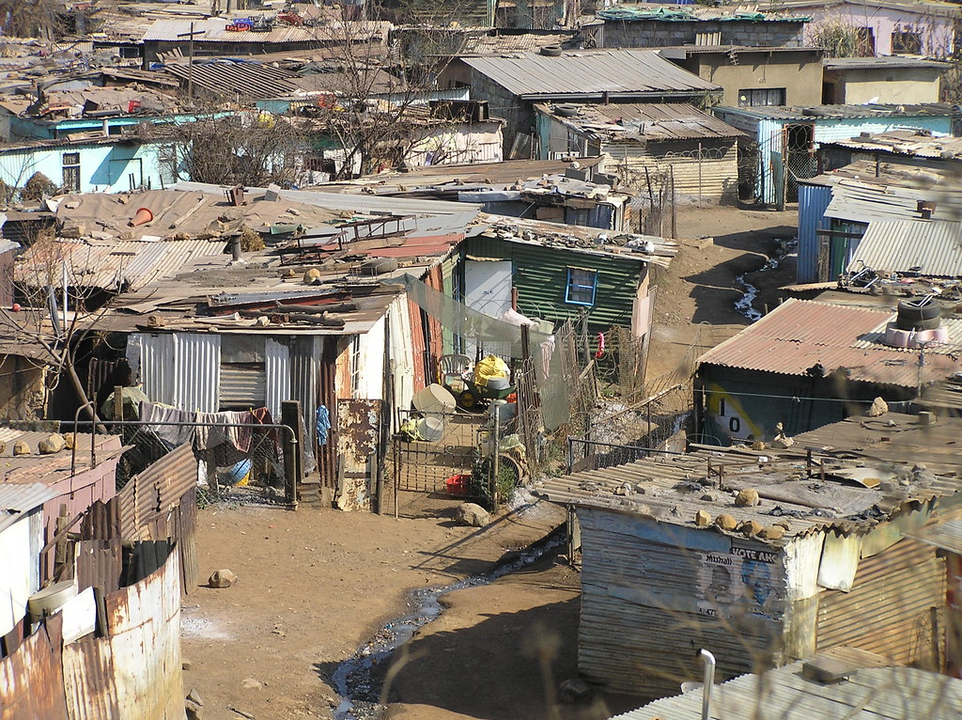

- State one factor that contributes to the formation of squatter settlements like the one shown above.
- Describe one social problem that residents living in such houses may experience.

