YEAR ELEVEN
GEOGRAPHY
HOME LEARNING KIT
Week 8
Strand: Human Geography
Sub strand: Population and Settlement

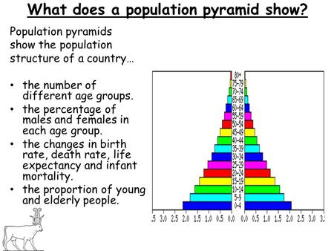

Name :
Year:
Index no:
Lesson # 71
Strand: Human Geography
Sub Strand: Population (INDIA)
Learning Outcome: Analyze the indications of pyramids

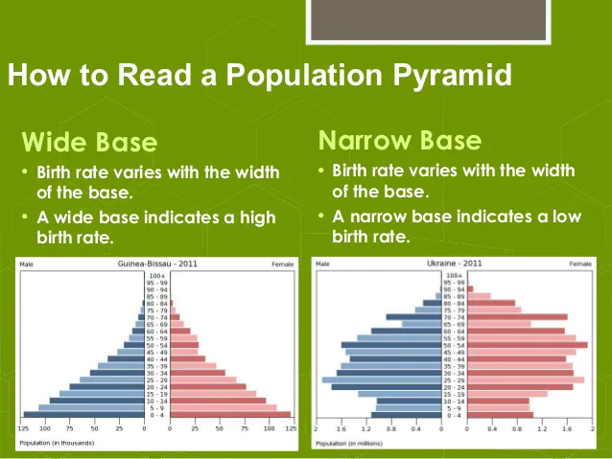

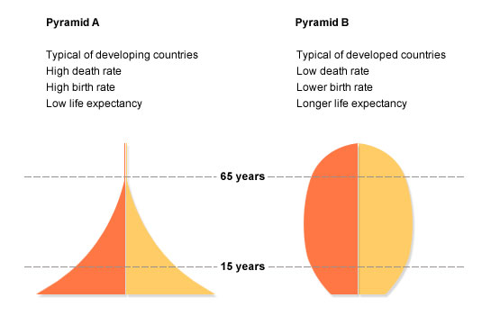

Activity

- Comment on the differences on the base of pyramid shape for developing and developed countries.

- State one reason of low death rate in pyramid B.

- State one reason of high birth rate in pyramid A.

Lesson # 72
Strand: Human Geography
Sub Strand: Population (INDIA)
Learning Outcome: Analyse and study the demographic transition model
This population graph intends to show the demographic patterns through changes in time. The graph refers to four main time in history.
Demographic transition model. The demographic transition model shows population change over time. It studies how birth rate and death rate affect the total population of a country.
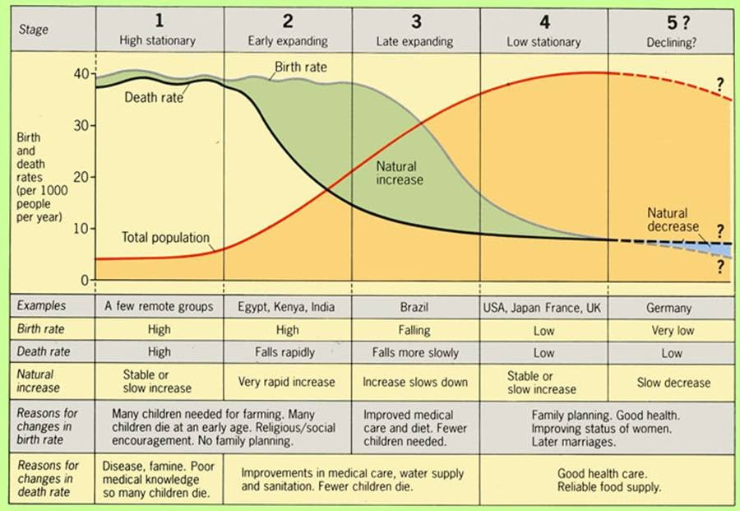

Activity
- Describe one reasons for low death rates in stage 4.

- List two plans by the government that could decrease death rate.

- Identify the reason for change in birth rate in stage 1.

- Identify the reasons for change in death rate in stage 3.
Lesson # 73
Strand: Human Geography
Sub Strand: Population (INDIA)
Learning Outcome:
Factors affecting change in a population
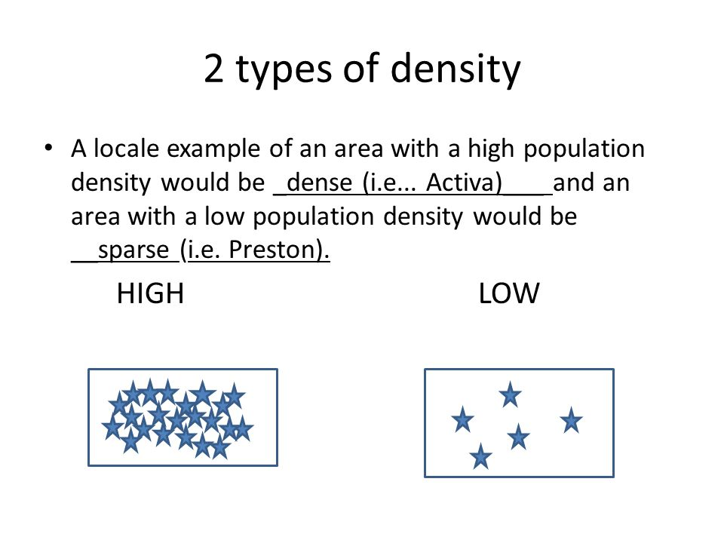
Densely populated Sparsely populated
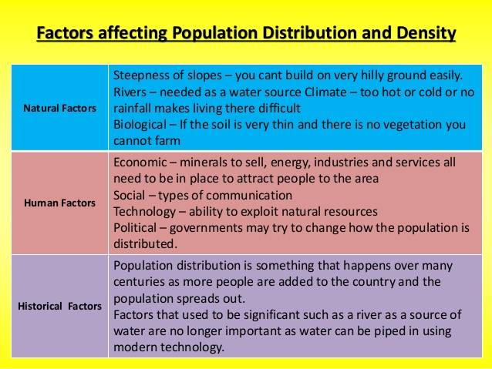

Activity
- State one way in which climate affects population distribution.

- Name an area in Fiji with sparse population. State a reason why?

- Fill in the table with a tick

Factors | Densely populated | Sparsely populated
- Even rainfall
- Infertile soil
- Lack of minerals
- Rugged mountains
- Availability of administrative service

Lesson # 74
Strand: Human Geography
Sub Strand: Population (INDIA)
Learning Outcome: Analyze types of migration
Types of migration
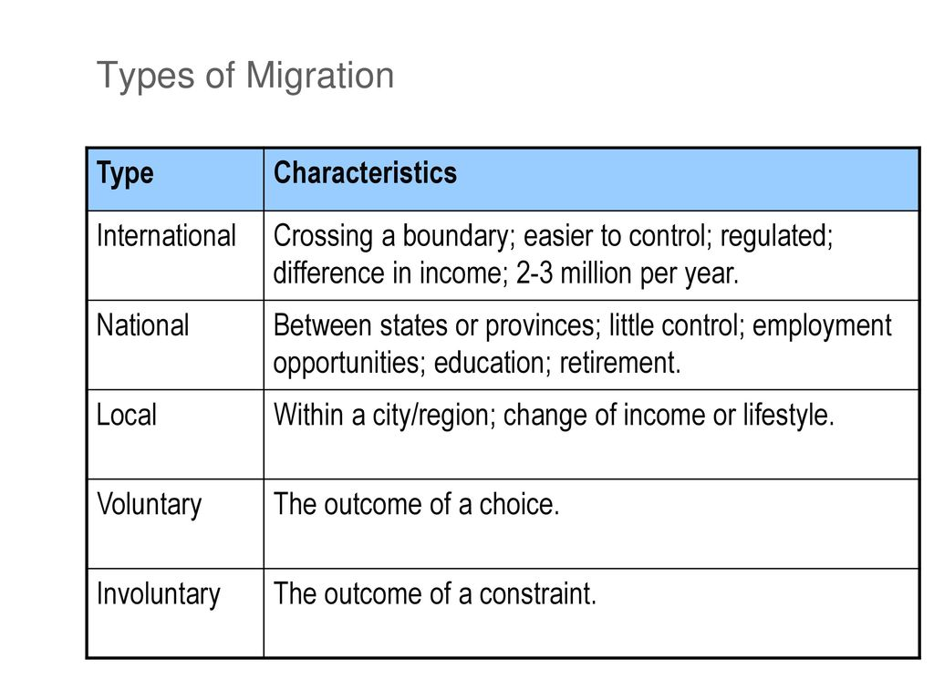

Activity
State the reason for the following types of migration in Fiji
Types of internal migration
Urban to urban | Rural to rural | Urban to rural | Rural to urban

Lesson # 75
Strand: Human Geography
Sub Strand: Population (INDIA)
Learning Outcome: Describe the types of external migration
Immigration – (migration into the country)
Immigrants – (people who come into country)
Emigration – migration out of the country)
Emigrants- (people who go out of the country)
Activity
Students are to label all the towns and cities and show the example of the following migration on the map of Fiji.
- RURAL – RURAL MIGRATION
- URBAN –URBAN MIGRATION
- EMIGRATION
- IMMIGRATION

Activity
- Discuss two reasons for urban- urban migration.

- Why the government needs to control rural – urban migration

- State one problem faced due to excess emigration.

- How can the government control emigration.

