YEAR ELEVEN
GEOGRAPHY
HOME LEARNING KIT
Week 7
Strand: Human Geography
Sub strand: Population and Settlement

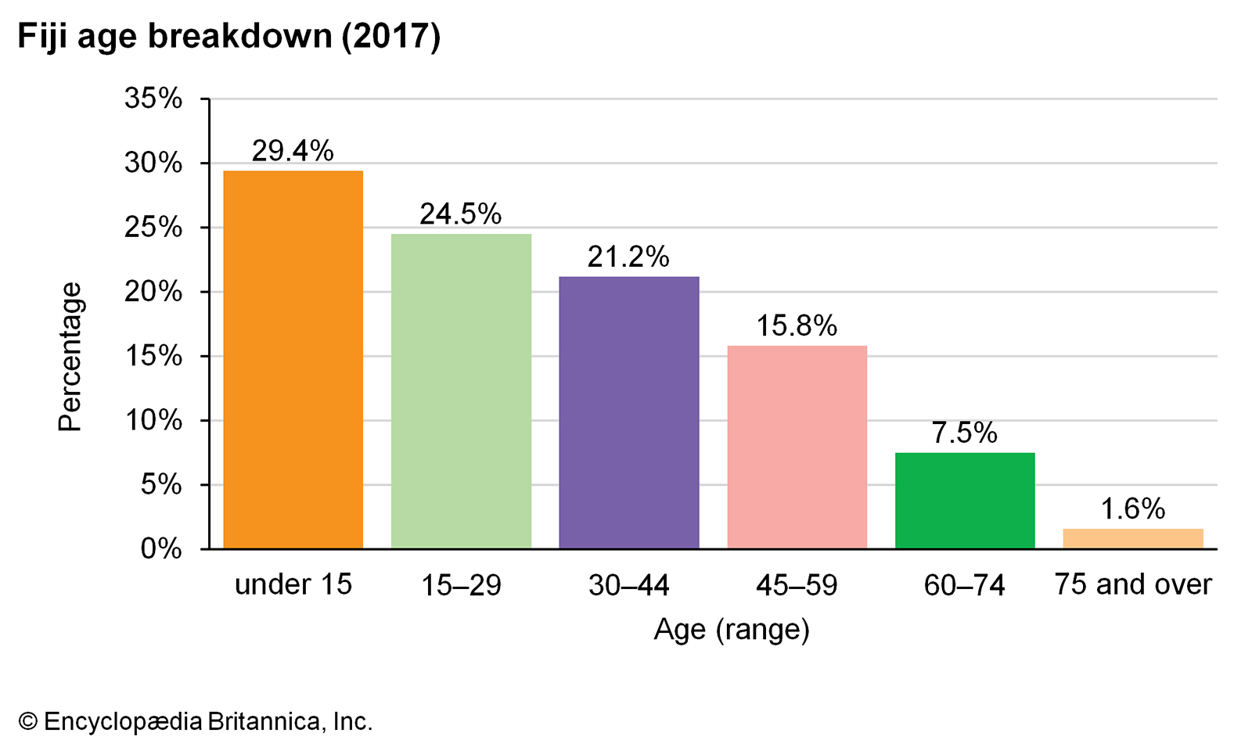

Name :
Year:
Index no:

Lesson # 66
Strand: Human Geography
Sub Strand: Population and Settlement (India and Fiji)
Learning Outcome: Examine the nature of population and characteristics
Nature of population
Population is the number of people in a particular area at a particular time.
Population has been changing for 19th – 20th century
Population increased either slowly, moderately or intensively
Demography- study of human population dynamics distributions, structures an movements constantly changing in time and space.
Population number changes and is not stagnant due to birth, death, emigration or immigration it changes in number distribution and density.

Activity
Define the following terms
- Population distribution-

- Emigration-

- Birth rate-

Lesson # 67
Strand: Human Geography
Sub Strand: Population and settlement (Fiji and India)
Learning Outcome: Examine the causes of population increase and decrease
Causes of population decrease
- Increase in death
- Decrease in birth
- Increase in emigration
- Decrease in immigration
Causes of population increase
- Decrease in emigration
- Increase in immigration
- Decree in death
- Increase in birth

Activity
State the reasons for the following:
Increase birth rate | Decrease birth rate | Increase immigration | Decrease immigration

Lesson # 68
Strand: Human Geography
Sub Strand: Population
Learning Outcome: Analyzing population equations and formulas
Population Equation
Death rate –birth rate + (emigration-immigration)=population decrease
Birth rate – death rate + (immigration – emigration )= population increase
Natural change + Net migration = Population Change
Birth rate – death rate = natural change
Immigration- emigration = net migration

Activity
Use the calculation above to calculate (approximate data)
YEAR | BR | DR | IMMI | EMI
2018 | 2500 | 2000 | 40000 | 43500
2019 | 2800 | 1000 | 45000 | 48000
2020 | 4000 | 2000 | 500 | 200
2021 | 4800 | 2500
CALCULATE
- Calculate the total BR
- Calculate the total DR
- Calculate the population increase
- Calculate the total immigration rate
- Calculation the total emigration rate
- Calculate net migration
- Comment on the Death rate of 2021.

Lesson # 69
Strand: Human Geography
Sub Strand: Population (INDIA)
Learning Outcome: Describe the characteristics of population and examine the causes of changes in population distribution and density.
Characteristics of population
Population distribution- the spread of population throughout an area
Population density- the number of people per unit area of a country as whole
Population distribution- and density are key indicators used for development planning and professional view- socio economic development.
Physical factors that affect population distribution include altitude and latitude, relief, climate, soils, vegetation, water and location of mineral and energy resources. ... However, in low latitude areas, which are otherwise hot and less favourable, high altitude provides suitable conditions for human habitation.
The following are the major reasons the high density of the population in any place.
- Availability of water.
- Industrialisation.
- Employment potential.
- Infrastructure facilities like housing, roads, proper transport facilities, health and education, communication facilities etc.

Activity
Work out the reasons
 | Population implosion | Depopulation
Define
Reasons

Lesson # 70
Strand: Human Geography
Sub Strand: Population (INDIA)
Learning Outcome: Analyze and describe population pyramid, age and sex structure
Population pyramids, age and sex structure
A population pyramid is also called an age pyramid or age and sex structure. A graphical illustration that shows the distribution of age groups and gender of a population.
The shape of pyramid helps to depict the development and planning policies.
Population pyramid : shows
- The total percentage of females and males
- The total percentage of females and males per age interval.
Activity
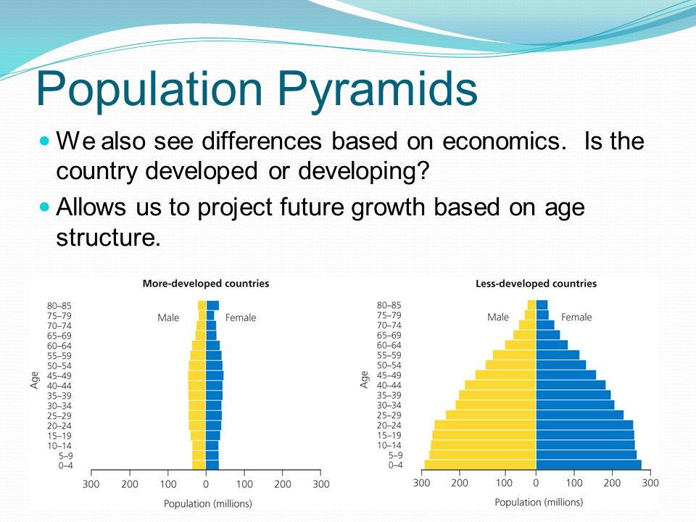

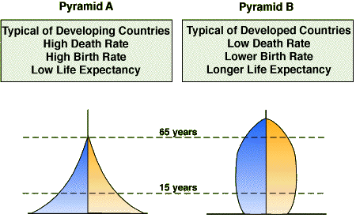
Triangular Beehive
- Comment on the birth rate and death rate in pyramid A and B.
- Define life expectancy, where would be higher life expectancy A or B.
- Who all are the dependent population?
- Which age group belongs to the independent population?

