YEAR ELEVEN
GEOGRAPHY
HOME LEARNING KIT
Week 5

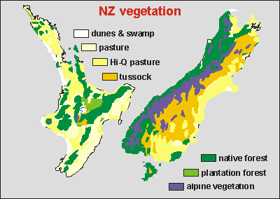

Name :
Year:
Index no:

Lesson # 61
Strand: Physical Geography
Sub Strand: Vegetation (NZ)
Learning Outcome: Factors affecting vegetation
Climate | - Amount and regularity of rainfall influences forest growth  - Windward side receive high rainfall in (warmer months) encourages tropical lowland forests Namosi, Naitasiri and Tavueni.
Soil | -the type of soil and level of fertility influences plant growth  - maintain soils- weathering – support certain plant growth
Relief | - Affected drainage which in turn influences vegetation distribution  - Steep slopes – high drainage run-off  - Flat areas- low drainage  - Rolling hill fairly good drainage support shrub growth and grassland  - Poor drainage- supports mangrove forests

ACTIVITY
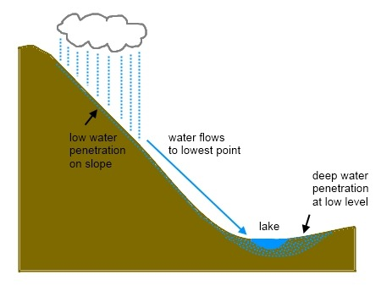
Y
X

- State where will have good and poor drainage X OR Y

- Explain the reason why in (1) above.

Lesson # 62
Strand: Physical Geography
Sub Strand: Vegetation (NZ)
Learning Outcome: Describe the Factors affecting vegetation
Importance of vegetation and sustainability
- Support biota
- Source of food, fuel and habitat
- Protects soil provides logging materials- mankind
- It serves as recreation
Problems affecting vegetation
- Deforestation
- Bush fires
- Over grazing
- Over cultivation
- Tragedy of commoners
- Mining
- Poor farming methods
- No strict laws/ regulations- deforestation
- Kiss of death (commercial over exploitation)
Activity
Conservation method research and write
1.

2

3

4

5

6

Lesson # 63
Strand: Physical Geography
Sub Strand: Vegetation (NZ)
Learning Outcome: Describe the effects of climate change on vegetation
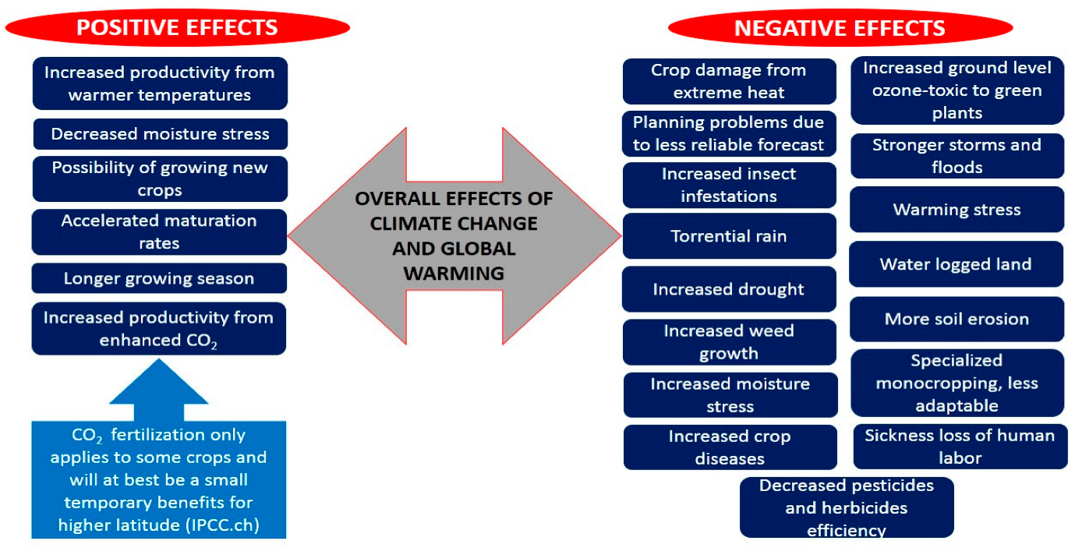
Source: https://www.google.com/search?q=effects+of+global+warming+on+plants+pdf&hl=
Activity
- State two ways in which global warming affects vegetation.

- Describe one way in which heat waves affects plant growth

- Describe one way in which torrential rain would be a disadvantage for plant growth.

Lesson # 64
Strand: Physical Geography
Sub Strand: Vegetation (NZ)
Learning Outcome: describe how vegetation affects climate
How vegetation affects climate?
The trees are the lungs of the mother nature. It purifies CO2 to O2
Trees keep a balance in the biota by maintaining the temperature, being part of evapo- transpiration process that affects rainfall and siltation of rivers and streams.
Note:
Drought – dries up vegetation and plants and restricts growth
Sea level rises- is associated with change in salinity (salt) in the coastal areas due to rise in sea level.
High saline environment affects many sea weed plants and mangroves.

Activity
Mapping page 94 text book
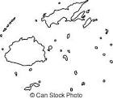

Lesson # 65
Strand: Physical Geography
Sub Strand: Vegetation (NZ)
Learning Outcome: Revision questions
Resource Interpretation
Use the resource given below and your knowledge to answer the questions that follow.
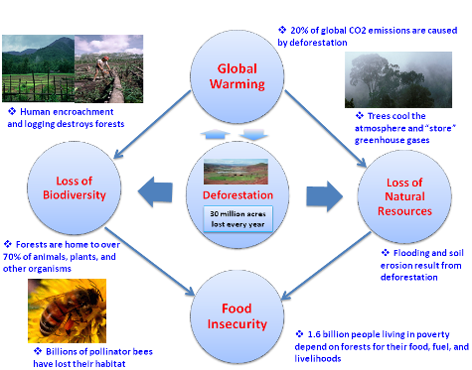

- State one effect of deforestation and one possible solutions to this problem
C. Diagram Interpretation
Use the diagram given below and your own knowledge to answer the questions that follow

- What type of vegetation will be seen in area marked B and state a reason for your answer.
- State a climatic element that influences the vegetation pattern in A.

