YEAR 11
GEOGRAPHY
HOME LEARNING KIT
Week 4

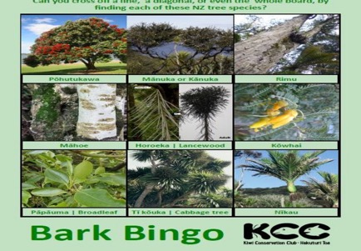

Name :
Year:
Index no:

Lesson # 51
Strand: Physical Geography
Sub Strand: Soil (Fiji)
Learning Outcome: examine the effect of human activities destroying soil.
Reference: Page 79 text
Soil erosion occurs naturally by wind or harsh climatic conditions but human activities include overgrazing, overcropping and deforestation. Overgrazing occurs when farmers stock too many animals such as sheep, cattle or goats on their land.
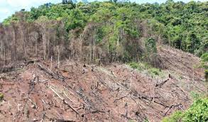 | 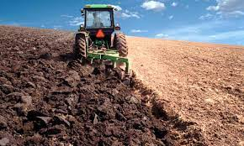
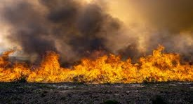 | 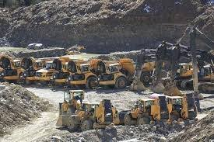

Activity
Paragraph writing
With reference to Fiji, discuss two problems related to soils and suggest two solutions.

Lesson # 52
Strand: Physical Geography
Sub Strand: Vegetation (NZ)
Learning Outcome: Describe the types of vegetation in NZ
STUDY THE MAP BELOW
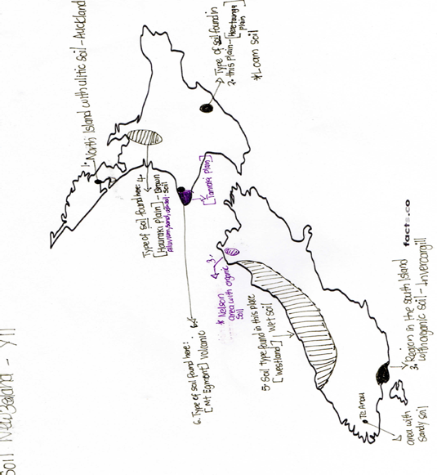

Activity
- Type of soil found in Mt Egmont - ________________
- Organic soil found in this area due to high sunshine hours- ________________
- Soil type found in Auckland city- ________________
- This largest plain in south island with alluvium soil- ___________________

Lesson # 53
Strand: Physical Geography
Sub Strand: Vegetation (NZ)
Learning Outcome: Describe the types of vegetation in NZ
TYPES OF VEGETATION IN NZ
- Indigenous or native- refers to the plants that are found in that particular place before they have been altered by people.
- Exotic vegetation- are man-made forest trees that are found in many parts of NZ but the volcanic (Kaigaroa Plateau) is most important for commercial forest. Example the south island exotic forest- in Nelson District called Golden Downs Forest.
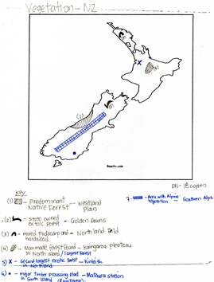

ACTIVITY
Familiarize with vegetation type in New Zealand

Lesson # 53
Strand: Physical Geography
Sub Strand: Vegetation (NZ)
Learning Outcome: Examine the types of native forest in NZ
Native forest- Podo-carp and broadleaf tree types
Podo-carp- Rimu, totara, matai, miro and kahikatea
Broadleaf – Kamahi, Rata and Tawa

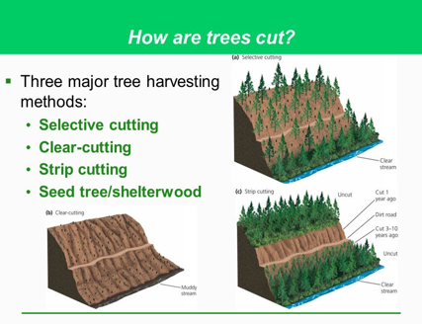
Activity
Define
- selection felling
- strip felling
- coup felling
- clear felling

Lesson # 54
Strand: Physical Geography
Sub Strand: Vegetation (NZ)
Learning Outcome: Describe the factors affecting their distribution such as NZ Climate
Factors affecting their distribution
Climate
- Rainfall determines vegetation
- Vegetation varies as water availability changes with latitude
- Note ; Trees grow in areas with over 750mm of rain
Grasses grow in areas of low rainfall.
- The biggest forest eg. Kauri located in warm moist and humid in northern areas of North Island.
Relief
The altitude determines the type of vegetation. Air cools us it rises so high areas have cold temperatures and generally thin soil.
These areas have sparse and short vegetation. Areas of low elevation (height) have relatively warmer climates and characterized by taller trees.
Trees become progressively shorten as altitude increases, this process is known as ALTITUDINAL ZONATION.

ACTIVITY RESOURCE STUDY
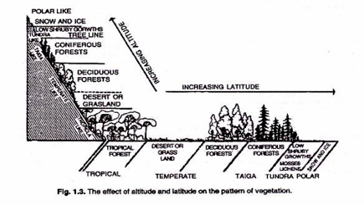

- State how altitude affects vegetation in the resource above.
- Describe one way in which temperature affects the spread of vegetation.
- State the conditions of growing tropical forest.

Lesson # 55
Strand: Physical Geography
Sub Strand: Vegetation (NZ)
Learning Outcome: Describe the effect of people on vegetation
EFFECT OF PEOPLE ON VEGETATION
- Human Activities
- Hydro-electric power
- Tourism
- Generated electric powers from lake
- Extensive pastoralism (sheep farming)

Climate
Most common tree radiate pine it grows over twice as it does in North America.
Matures fast and ready to be logged.
Shelter belts grown- reduce wind speed.

Soil fertility
- High fertility favorable for cropping and market gardening
- High soil fertility, higher yield of good quality produce and better prices
- Poor soil fertility is managed, regular application of artificial fertilizer’s allow poor soils to be improved
- Due to low fertile soil- man made forest was established

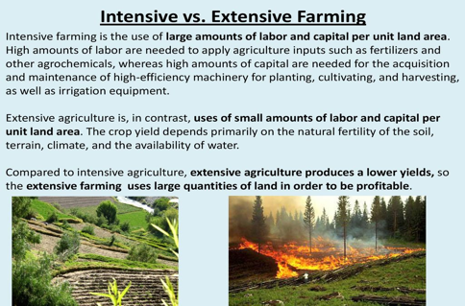

Activity
Compare and contrast the extensive pastoralism and intensive pastoralism
Extensive pastoralism | Intensive pastoralism

