YEAR ELEVEN
GEOGRAPHY
HOME LEARNING KIT
Week 3

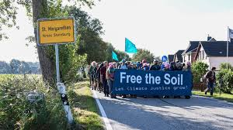

Name :
Year:
Index no:

Lesson # 46
Strand: Physical Geography
Sub Strand: Soil
Learning Outcome: Examine the problems related to soils in Fiji
Problems related to Fiji soils
The problems related to soils are caused by nature and human action. Man has been dependent on soil for development and this has led to soil degradation.
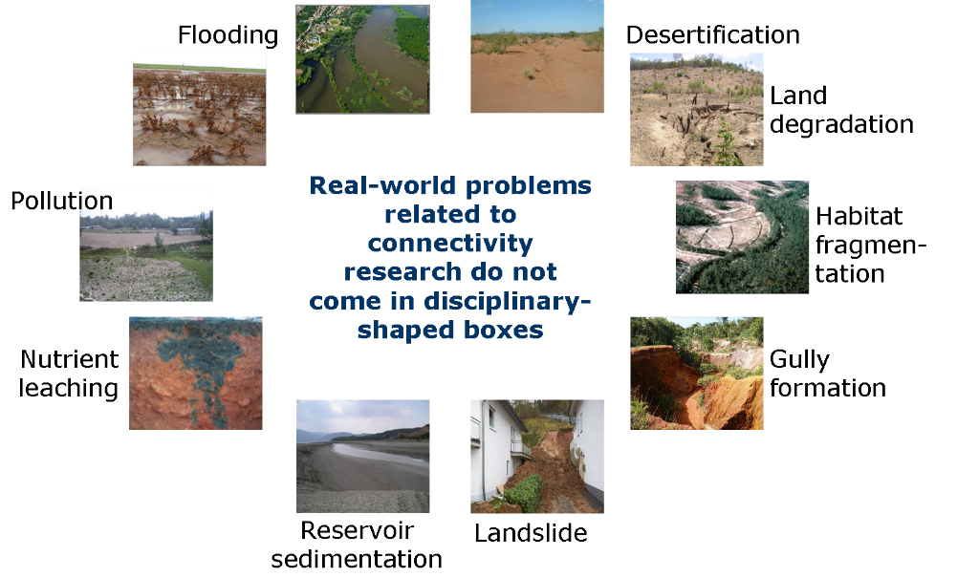

- Overgrazing
- Ploughing
- Burning
- Use of chemicals
- Deforestation- erosion
Activity
- Describe one problem directly caused by human to soils in Fiji.
- State how monoculture causes soil degradation.
- State two ways practice good farming techniques.

Lesson # 47
Strand: Physical Geography
Sub Strand: Soil (Fiji)
Learning Outcome: Describe the types of soils found in Fiji and their characteristics
Types of soils in Fiji
Climate and relief play an important role in the formation and classification of soils.
Characteristics | Type | Location
Andosols/ Andisols  - young soils  - formed from volcanic parent material  - well drained  - most fertile | Basalt and Esites | Tavueni
Recent soils  - soil developed from marine deposits  - best agricultural soils  - A-horizon  - Young and fertile | Alluvial soils- from river deposition on flood plains, deltas and banks  Colluvium- soils deposited by surface run-off on lower slope/ valleys | -Rewa Delta  - Navua  - Sigatoka  - Wainibuka  -Yasawa  -Dawasamu
Lateritic soil  - Deep reddish brown in color  - Deeply weathered and soluble minerals have leached out  - Low fertility | Areas with high precipitation | Laucala Island  Koro  Area between Suva and Navua  Naboro  Nabukavesi
Talasiga soil  - Poor soils repeated burning and clearing for long  - Low fertility | Sunburnt soil | Cane grown areas  Nadi, Lautoka, Ba Labasa

Activity
  - State two characteristics of Talasiga soil.
  - Describe how alluvium soil is formed.
  - Describe the process of leaching in lateritic soil.

Lesson # 48
Strand: Physical Geography
Sub Strand: Soil (Fiji)
Learning Outcome: Describe the types of soils found in Fiji and their characteristics

Vertisols  - Dark brown/black  - Rich in clay- holds plant nutrients  - Difficult to cultivate, swell when wet and cracks when dry |  | Found in large low lying areas
Lithosols  - Very thin soil due to high rate of erosion  - Relief is most important factor for formation |  | Found on steep mountain slopes of high island.
Coral limestone  - Is very porous (soil contains lot of air spaces)  - Little organic minerals  - Poorest soils in Fiji |  | Found on sandy low lying coral atolls and coastal areas. (Fulaga, Moala and Lakeba)
Hydromorphic  - Found in swampy areas  - Poor drainage  - Plant nutrients are not leached due to presence of water  - Highly fertile, sticky and water logged | Formed from gleying | Found at the river mouths (Rewa and Navua)  Floodplains of Labasa, Wailevu and Dreketi
Activity
Place a tick in the appropriate box
Soil type | Fertile | Infertile | Good for farming | Bad for farming
Alluvium
Lateritic
Lithosols
Andosols
Talasiga
Hydromorphic

Lesson # 49
Strand: Physical Geography
Sub Strand: Soil (Fiji)
Learning Outcome: soil types in Fiji
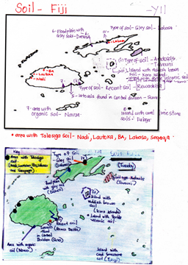

Activity
On the outline map of Fiji locate and name the following
- Island with fertile volcanic soil in the north of the Lomaiviti group
- The area with talasiga soil
- The island in the North where andosols are commonly found
- Region in the central division where latosols are commonly found
- A town in Vanua Levu where vertisols can be found
- An island with coral limestone soil

Lesson # 50
Strand: Physical Geography
Sub Strand: Soil (Fiji)
Learning Outcome: examine the soil conservation measures in Fiji
- Afforestation
- Contour
- Crop rotation
- Crop diversification
- Agro forestry
- Composting and mulching in farming
Resource study
Villagers of Vatulovona in Vanua Levu have raised concerns with their village headman on the continued erosion near their church.
By Laisa Lui
04 Nov 2019 10:00
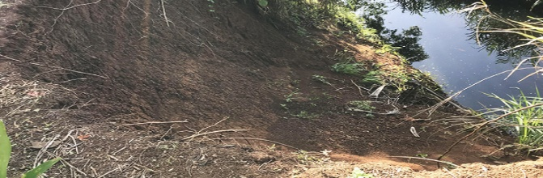
Soil erosion at Vatulovona Village in Vanua Levu. Photo: Laisa Lui.
2020-04-20
Villagers of Vatulovona in Vanua Levu have raised concerns with their village headman on the continued erosion near their church.
This was result of a recent heavy rainfall in the Northern Division.
Village headman, Savenaca Raisogo said they noticed how quickly the soil had been eroding in the past few months.
He had cautioned villagers and children to stay away from the steep slope until some embankment was built.
He said the steep bank was two meters from the village church building.
“In the past we used to plant cassava here, but now a huge chunk of land had been washed away.
Mr Raisogo added that for the time being they would be planting vativa grass otherwise the best solution would be to construct a solid protection to address the problem.
Kelera Dakai whose house is near the steep slope was worried that their house might get washed away in a flood if the banks are not protected.
She said that children may also fall into the slope if something was not done quickly.
Edited by Selita Bolanavanua
Feedback: laisa.kabulevu@fijisun.com.fj

- State one cause of soil erosion in the article above.
- Describe one negative impact from the activity.
- Suggest one solution to the problem.

