YEAR ELEVEN
GEOGRAPHY
HOME LEARNING KIT
Week 2

Name :
Year:
Index no:

Lesson # 40
Strand: Physical Geography
Sub Strand: Soil
Learning Outcome: study and analyse the soil horizon and its features

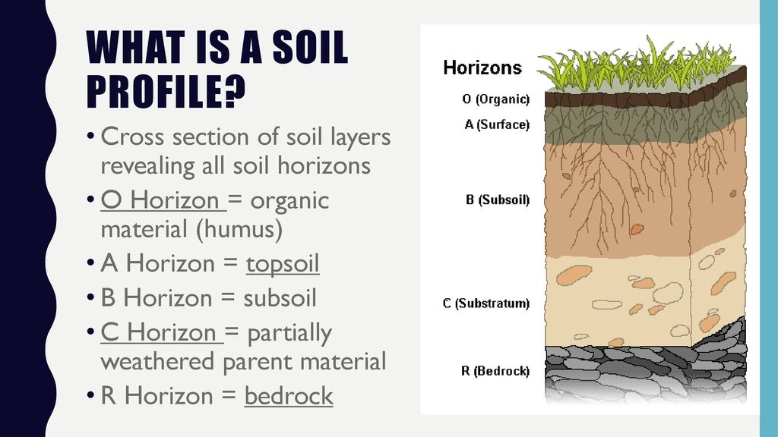

A soil horizon is a layer parallel to the soil surface, also the decaying matter on it (plant litter), whose physical, chemical and biological characteristics differ from the layers above and beneath. Horizons are defined in many cases by obvious physical features, mainly colour and texture.

Resource Interpretation
Study the resource above and answer the question
- Describe the features of A Horizon
________________________________________________
- Which horizon is rich with humus? Why?
________________________________________________
- What is found in bedrock?
____________________________________________________

Lesson # 41
Strand: Physical Geography
Sub Strand: Soil
Learning Outcome: study and analyse the soil structure
Soil structure. Soil structure describes the arrangement of the solid parts of the soil and of the pore space located between them. It is determined by how individual soil granules clump, bind together, and aggregate, resulting in the arrangement of soil pores between them.
- Organic matter- humus fron dead plants and animals
- Highest humus- temperate grassland
- Low humus- dry climate
- Soil moisture- helps in upward and downward movement plants
- Clay reduces infiltratration rastes retains water
- Air fills pore spaces left by soil moisture
- Biota needs carbon dioxide gives out oxygen
- Soil organisms
Activity
- Discuss how soil moisture plays a vital role in soil structure.

- How does temperature affect humus content

Lesson # 42
Strand: Physical Geography
Sub Strand: Soil
Learning Outcome: Describe ways to improve soil nutrients
SOIL NUTRIENT
NUTRIENT is essential for plant growth and maintenance of fertility of soils.
Soil exhaustion can be avoided by:
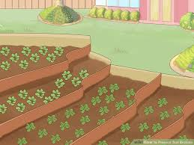
- Adding natural fertilizers- cow dung, goat manure, poultry
- Adapting crop rotation method
- Fallow- do not plant on the land for some time
- Shifting cultivation
- Contour farming
- Mulching
Warm temperature + soil moisture = HUMUS
(FUNGI AND BACTERIA WORK BETTER IN WARM TEMPERATURE)

ACTIVITY
- Describe the ways to avoid soil exhaustion in your own words.

Lesson # 43
Strand: Physical Geography
Sub Strand: Soil
Learning Outcome: Analyse the soil erosion process, the causes and conservation methods
Soil erosion
Is the removal of the top layers of soil due to the action of wind an water
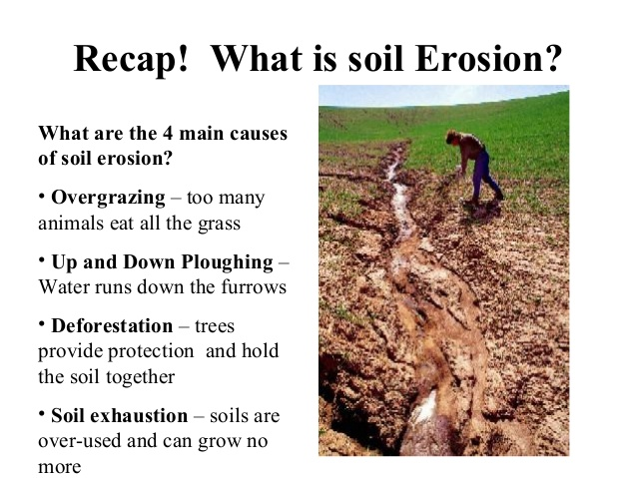
Also extensive human activities, monoculture activities where farmers only choose to plant one type of crop for easy task, routine and maximize profit making.
Soil conservation
- Contour ploughing.  - Terrace farming.  - Keyline design.  - Perimeter runoff control.  - Windbreaks./shelter belts  - Cover crops/crop rotation. | - Soil-conservation farming.  - Salinity management.  - Crop diversification  - Fallowing  - Agroforestry
Activity
- State two ways to reduce soil degradation
- Discuss two ways the soil has been degraded.

Lesson # 44
Strand: Physical Geography
Sub Strand: Soil
Learning Outcome: examine the afforestation method of conserving soil.
- Vegetative cover (page 72)
- Contour ploughing /terracing
- Strip cropping
- Adopting artificial and natural fertilizers
- Adopting crop rotation methods

Impact of climate change on soil
Affects production in agriculture
Loss of peat soils
Increase damage to land degradation

Resource study Activity

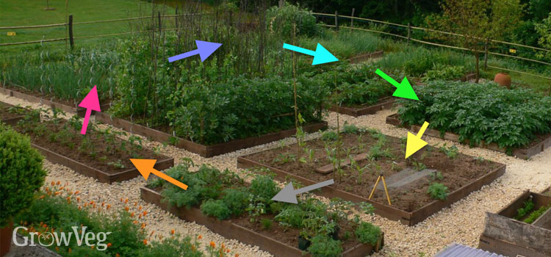

  - Identify the type of soil conservation method shown.
_____________________________________________
  - State two benefits of practicing this method to soil.
_____________________________________________
  - Suggest how the Agriculture ministry can sustain agriculture in Fiji.
______________________________________________________
Lesson # 45
Strand: Physical Geography
Sub Strand: Soil
Learning Outcome: Revision Purpose
I test myself
Mapping
Locate and label the following features on the map of NZ
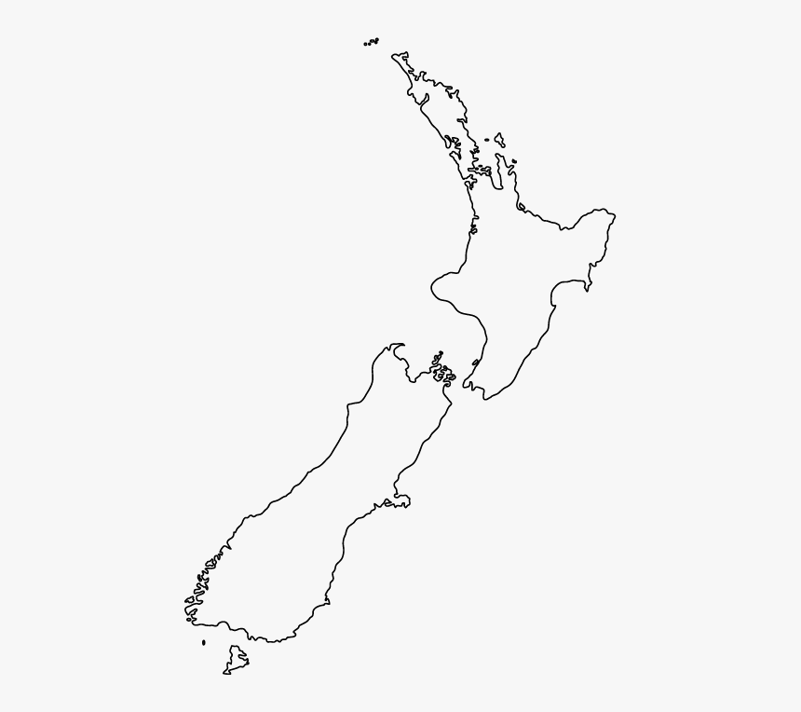

- A finger lake
- Mt Egmont
- A alluvial plain
- Hauraki Gulf
- Karst region
- Alpine fault
- A braided stream

