YEAR 11
GEOGRAPHY
HOME LEARNING KIT
Week 1

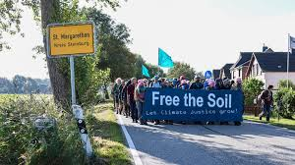

Name :
Year:
Index no:

Lesson # 35
Strand: Physical Geography
Sub Strand: Soil
Learning Outcome: define soil, types and characters
Soil
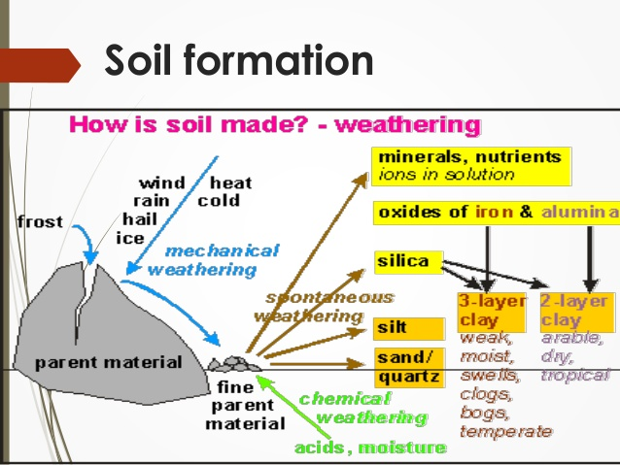

- Soil is a natural surface layer that contains living matter and it can support plants.
- It contains minerals and humans (decayed organic plants and animal) water, air and living organisms.
- The study of soil science is called PEDOLOGY
SOIL TYPES and characteristics
- A particular temperature and amount of precipitation influence soil formation.
- Cold climate such as tundra areas have soil of little use for agriculture.
- In cold climate soil have slow decomposition (Tundra)
- Physical processes breaks down rock fragments of regolith in smaller pieces- soil
Activity
Short answers
- Define soil
- State two of its uses
- Describe one factor needed for soil formation
- State a reason for slow soil formation in colder regions.

Lesson # 36
Strand: Physical Geography
Sub Strand: Soil
Learning Outcome: describe the soil patterns
Patterns of soil in NZ
ZONAL SOIL- very young, climate and organic life are considered to have been the major influences in formation
AZONAL SOIL- is intro zonal depends on all the five factors example parent material, climate topography (relief) organism (biota) time.
Soil type  - Zonal soil | spodosols/podsols, acidic due to heavy rain  Poor for agriculture  Soils of coniferous forest  Improve- apply fertilser- good for potatoes
- Brown earth /forest soil | Occupy areas under deciduous wood land  Roots of trees draw up nutrients  Earthworms- carry minerals up and down  Good supply of nutrients
- chernozems | Very fertile, good for wheat growing, no leaching, grass die and becomes humus
- laterite | Due to leaching, formed in humid tropical areas, poor soil
- Tropical black earth | Formed from volcanic rocks, in humid region, usually fertile, soil is exhausted.

Activity
1.Describe the soil pattern in zonal soils
2. Why lateritic soil is known as poor soil
3. Give one characteristics of Chernozems.

Lesson # 37
Strand: Physical Geography
Sub Strand: Soil
Learning Outcome: describe factors of soil formation
Process of soil formation
Factors Affecting Soil Development. Soil research has shown that soil profiles are influenced
by five separate, yet interacting, factors: parent material, climate, topography, organisms, and time. Soil scientists call these the factors of soil formation.

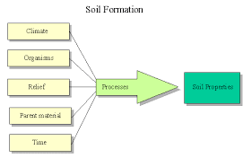

Activity
- Name two factors affecting soil formation
________________________________________
- Describe how climate affects soil formation
______________________________________________________________________________________________________________________________________

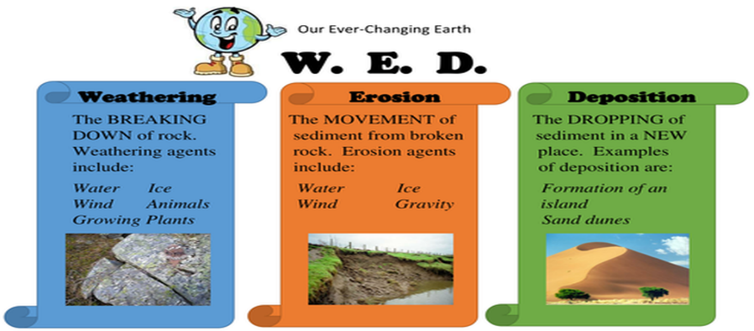
Activity
- Discuss how topography affects soil formation
- Differentiate between process of organic sorting translocation process. (research on google)
- State how weathering affects soil formation

Lesson # 38
Strand: Physical Geography
Sub Strand: Soil
Learning Outcome: locate and label the types of soil found in NZ
NOTE:
AREAS OF ALPINE, ZONAL AND AZONAL SOIL (RESEARCH)
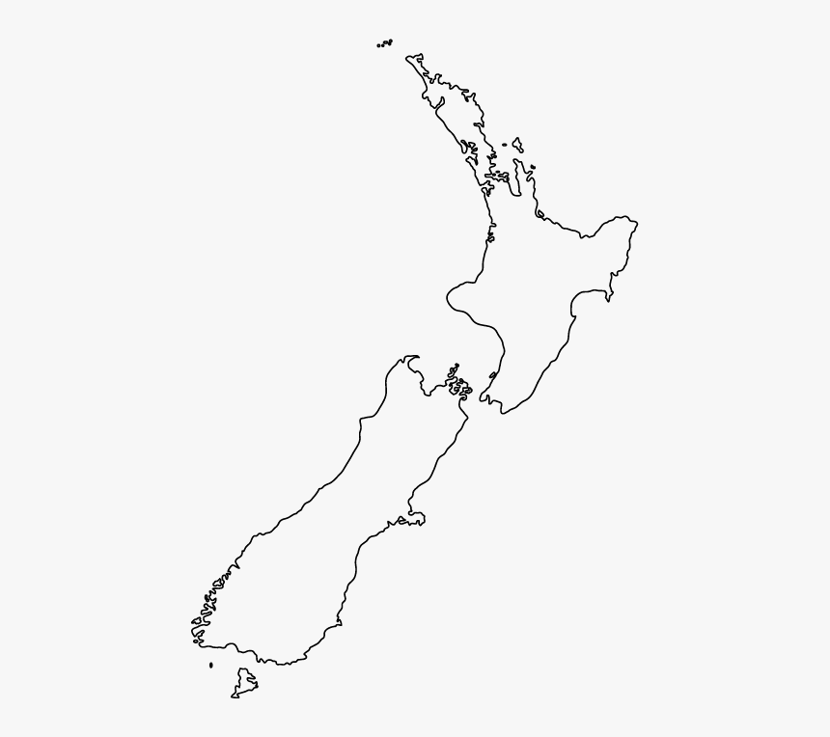

ACTIVITY : USE THE ESSENTIALS OF MAP DRAWING

Lesson # 39
Strand: Physical Geography
Sub Strand: Soil
Learning Outcome: Discuss the process of soil formation
Soil Processes
- Leaching, in geology, loss of soluble substances and colloids from the top layer of soil by percolating precipitation. ... In such areas rapid bacterial action results in the absence of humus in the soil, because fallen plant material is completely oxidized and the products are leached away.
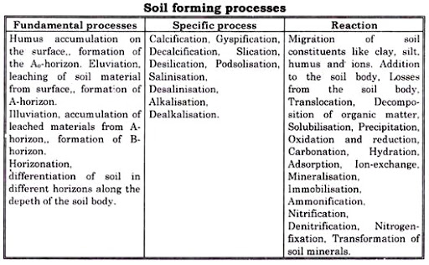

Activity
- Define the following:
- Calcification
- Gleying
- Podsolization

