HOME LEARNING KIT GEOGRAPHY – YEAR 11
WORKSHEET 10
- Essay
With reference to either Fiji or India describe two population problems that the nation is faced with and two ways in which the government has tried to address those problems.

B. Resource Interpretation
Use the resource given below and your knowledge to answer the question
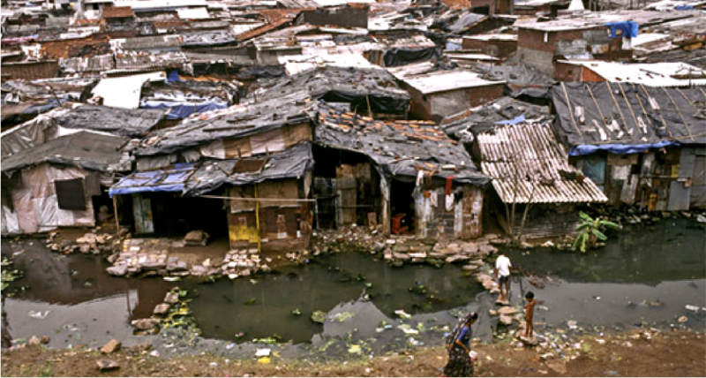

(i) Name the settlement shown above.
(ii) State two problems of this settlement.
Short Answers
- State two problems in a city with rural to urban drift.
- List two pull factors in rural urban drift.
- Suggest how the town and country planning can reduce informal settlement in towns.

