HOME LEARNING KIT GEOGRAPHY – YEAR 12
WORKSHEET 9
- Resource Interpretation

Use the resource given below and your knowledge to answer the question that follows.

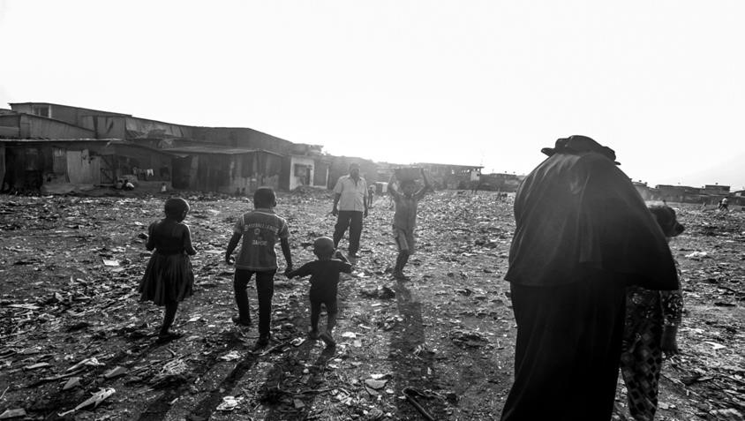

Source:
http://www.aljazeera.co
m

Describe one social problem shown in the picture above as a result of population
growth.

- Definitions

Define any two of the following:

  - population control (iii) Demographic Transition Model

  - emigration (iv) population change

- Extension of Ideas

Choose any four concepts listed below and state how each one relates to population growth or settlement patterns.

  - voluntary migration
  - inflation
  - new technology
  - brain drain
  - congestion
  - job investment

