HOME LEARNING KIT GEOGRAPHY – YEAR 11
WORKSHEET 8
- Graph Interpretation
Use the resource given below and your knowledge to answer the question
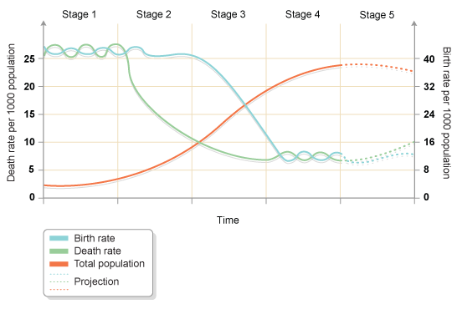
(i) Name the model shown above.
(ii) State one way to control birth rate.
(iii) Suggest one way to control birth rate in stage 1.
(iv) State two reasons to achieve population control in stage 5.

- Extension of ideas

- Natural decrease
- Brain drain
- Dependent population
- Workforce
- Population distribution
- Poverty
- Immigration

- POPULATION PYRAMID
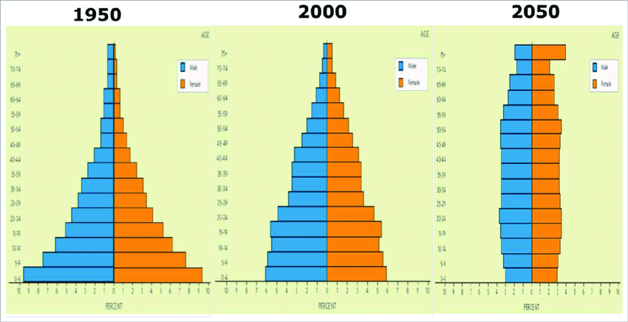

- Identify the under developed, developing and developed country.
- State the reasons for wider base in the pyramid in 1950.
- Suggest two advantages of narrow base and top in the pyramid in 2050.
- Define the independent group of population and their role in a country.
- Describe one method to control growing population in a country.

