RATU NAVULA COLLEGE
LESSON NOTES
WEEK 3

SCHOOL: RATU NAVULA COLLEGE YEAR/LEVEL: 11
SUBJECT: ENGLISH

LESSON # 50: DIARY ENTRY
STRAND: WRITING AND SHAPING
S/STRAND: COMMUNICATION TEXT TYPES
L/O: IDENTIFY AND ORGANISE RELEVANT IDEAS TO SUIT TOPIC
.

DIARY ENTRY
What is a diary entry?
It is a personal record/reflection of significant events and feelings you do not want others to know about.
Exploring Feelings: Ask yourself
- How do different situations make me feel?
- Do I record my feelings, emotions and experiences down?
- What is a diary entry? Structure
- Date/day is compulsory. [Time, mood and venue are optional].
- Salutation – give diary a personalised name e.g. Dear Rosi.
- Introduction - Includes a topic sentence to introduce what you are writing about; consider the who, when and what questions. Do not include a greetings, such as, “How are you?”]
- Content – 3 paragraphs: focus should be on one day event only.
- Conclusion
- Sign off – signature or name at the end Language Features
- Use of: Past tense, First person narration (I), Subjective language, personal pronouns, informal expressions, contractions, emotive expressions and descriptions can be used.
- Avoid: mobile texting language, vernacular words/phrases and slangs. Content
- Creativity, imagination and expression are important.
- You should write as if you have experienced a part of the situation.
- One does not write about things experienced on a daily basis. Only matters of some significance are recorded.
- It is a secret record of one’s life, so you can be very honest about your feelings and emotions.
THEME: COVID
(e) Write a diary entry based on your experiences during this COVID 19 pandemic that is occurring in Fiji.

LESSON # 51 –BOOKED FUTURE
STRAND: READING AND VIEWING
S/STRAND: LANGUAGE FEATURES AND RULES
L/O: USE APPROPRIATE DEVICE TO LINK IDEAS AND SENTENCES.

What is the poem about?
‘Booked Future’ is about the influence of people and the role of books in the personas life. The persona’s education and future path are controlled by the teacher, the preacher and the dealer. Each relies on the books but in different ways.
Subjects and Persona’s
The Persona
The persona doesn’t talk about himself in the poem but by the end of it we know quite a bit about himself. He was afraid of some of his teachers and didn’t understand everything they were saying.
He didn’t like religion and felt that the path was too narrow. But he experiences a breath of fresh air in the shelves of books on dealer’s shelves.
Now he is on ‘a road paved by pen’ so he is probably a writer or someone whose life has been influenced by words from books. The road goes forward for the persona who has probably made a life for himself.
The Teacher
The teacher appears to the persona as a threatening figure. He covers the board with ‘black fear’ which might refer to the persona’s fear of all that he has to learn which might have painful consequences if he doesn’t learn it.
The Preacher
The preacher does not even appeal to the persona. He ‘shrouds the pew with dark hot dread’. The persona while sitting on a pew is covered with a shroud [messages from the word] and it becomes hot and dreadful.
The Dealer
The dealer is a book seller who sells books not only for money but sees books as an important tool of learning. He airs his shelves with a ‘warm breeze’ which symbolize the care he has for the books. For the persona, the warm breeze is a breath of fresh air.
Poets Style/ Technique of Writing
- Shape
The poem has unusual shape; it is like a staircase with stairs going down. It allows us to wonder which way the teacher’s stairs of white volume is leading the persona.
The final stanza seems to also be getting narrower instead of wider.
- Choice of Words
The choice of words used by the poet creates images for example, the teacher ‘covers’, the preacher ‘shrouds’ and the dealer ‘airs’.
- Repetition
The repetition of the words ‘Books, book, books’ at the beginning of the poem suggest a feeling of tiredness of the persona with books surrounding him/her. The singular book refers to the ‘preacher’ who uses only one holy book to map out his narrow trail.
- Alliteration
‘Paved by pen’ is an attraction phrase, made more attractive by the alliteration of ‘paved’ and ‘pen’ which suggest that one’s life is paved by the pen or all that is learnt from books.
- Effective title
The title of the poem is effective in allowing us to see that one’s future is already written down for him. The title suggest that no matter what ‘books’ control our lives.

Themes and lessons
Theme: Education
Lesson
- Importance of Books
The lesson is that our lives are controlled by books whether we hate of love them. Books educate a person in all areas of one’s life. In church, the preacher uses the book (bible) to preach and control the lives of people. In school, a teacher uses books to teach children and the dealers give books to allow one to free his/ her mind.
- Freedom and control
Books can be for a person a source of freedom and control. For teachers, if they are narrow minded and teach according to books and not from experience in life than a student might feel ‘covered in black fear’ on the other hand if a wise teacher uses his/ her knowledge of what is in the books to educate a child than he/ she is paving a wider path for the child he/ she teaches.

Activity
- Define the following words:
- Shroud
- Paved
- Dread
- Volumes
- What is the general mood of the poem? What are some words used to help convey this mood?
- Do you think the persona has a choice in life?

LESSON # 52 -LANGUAGE OF SPORTS COMMENTARY
STRAND: LISTENING AND SPEAKING
S/STRAND: LANGUAGE FEATURES AND RULES
L/O: IDENTIFY FEATURES OF SPORTS COMMENTARY.
.

Language of Sports Commentary
A live sports commentary is a voiced and unplanned account of a sports event.
The commentary takes place ‘as it happens, when it happens’.

Commentator- a person who does the reporting.
Tone- Varied as the voice changes due to the pace of the game.
Linguistic Features
Voiced hesitation- these are natural and spontaneous sounds like ‘er, um,ooh’ and so on.
This happens when the commentator tries to clarify (or explain) his/ her thoughts in a short time that is available.

Hesitation- (unvoiced) a short interval or stop.
Happens when the commentator tries to breathe and think of what to say next.

Sports Jargon- these are words that are used for a particular sport.
For example, kick (soccer); try, conversion, scrum (rugby).
Stuttering
- when the commentator unknowingly repeats consonants in a word, for example,…r…r…rr..rugby.
Happens when the pace of the game is fact and exciting.

Verbal Contractions- these are shortened words such as can’t, isn’t etc.
Commentator does not have to use formal and complete sentences.
Gives the language an informal tone.

Incomplete Sentences (Ellipsis)- commentators use incomplete sentences due to the changing pace of the game.

Simple Present Tense- used to indicate the current time that the game is occurring.

Incorrect Word Order- the commentator unknowingly places his words incorrectly due to the sudden change in the game.

Simile- a comparison using ‘like’ or ‘as’. E.g. Tomasi speeds like a leopard.

Metaphor-comparison without using‘like’ or ‘as’. E.g. Bill is now a hungry lion after the deer.

Aim of using simile and metaphor: is to make the game more exciting.

Exclusion of Subject- the subject is excluded when the commentator wants to focus on the receiver of the action. E.g.Over to Peni.
Active Voice- the focus is on the subject rather than the receiver of the action. E.g. Ponipate kicks the ball.

ACTIVITY

- Sports Jargon
Identify specific words used for each sports listed below.
Rugby | Soccer | Netball | Cricket

LESSON # 53
STRAND: READING AND VIEWING
S/STRAND: COMMUNICATION TEXT TYPES
L/O: READ AND DEMONSTRATE UNDERSTANDING.

COMPREHENSION

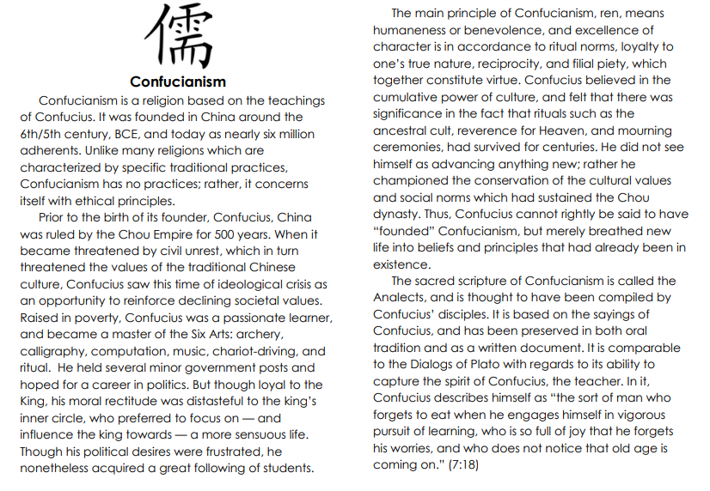

ACTIVITY
  - Is Confucius the founder of Confucianism?
  - Describe the practice of Confucianism?
  - What political event occurred that paved the way for Confucianism?
  - Why was Confucius unsuccessful in securing a political career?
  - What is the main principle of Confucianism?
  - What is the sacred scripture of Confucianism called and who wrote it?

LESSON # 54
STRAND: WRITING AND SHAPING
S/STRAND: COMMUNICATION TEXT TYPES
L/O: IDENTIFY AND DIFFERENTIATE LINGUISTIC AND NON-LINGUISTIC FEATURES OF PERSUASIVE LANGUAGE.

Language of Advertisement
- Promotion of products through radio, newspapers, television and internet.
Tone: Persuasive-achieved through the usage of emotive vocabulary.
Mode:
- Printed-through newspapers, flyers and banners.
- Spoken- through radio and T.V advertisement and through door to door sales.
Features
Linguistic Features (language usage in this sample)
- Emotive words- these are usually pleasing to hear and read.
- Words are mostly ‘positive adjectives’ such as tasty, sweet, delicious etc
- Its effect is that the advertiser hopes to win the affection for the products being advertised.

- Adjectives
- Positive, comparative and superlative adjectives are used. For e.g. great, greater, greatest.
- Adjectives are intentionally used to make a positive statement about the quality of product being advertised.

- Euphemism- are words or expressions which are considered more pleasant and acceptable than the words they replace.
- E.g. Fragrance is a euphemistic word for smell.

- Unqualified Claims- these are claims (or expressions) that may not be true.
- Unqualified claims are used to overstate the quality and the use of products to make it more noticeable and attractive.
- Can also lead to cheating by the advertiser.
- Some examples of unqualified claims are: The World’s Number One, Best For Your Car etc

- Alliteration- the use of consonant sounds in a series of words. For example, Wonder White washes whiter than snow.
- Are used to create a pleasant sound effect to attract the attention of the people.

- Imperative verbs
- Are used to create a sudden response in the readers to buy the product. For e.g. BUY TODAY!!
- Effectiveness: creates a commanding tone

- Rhetorical Questions- questions to which no answer is required.
- Effectiveness: capture the attention of the reader.

- Pun- are words with double meanings used to create a more effective and interesting presentation.

- Pronouns -replaces a noun.
- Used to create a personal tone between the advertiser and the reader.

- Neologism -words that are formed by combining two words (coinage) such as Breakfast + Lunch= Brunch.
- Effectiveness: capture the person’s attention and for a favorable impact.

Non-Linguistic Feature
- Bold Prints- attract the attention of the readers. Rhetorical questions often appear in bold letters.

- Pictures- attract the attention of the readers. Pictures are used for appeal.

- Cartoons- presents the advertisement in a funny way. The aim is to make a memorable impression to promote the product.

- Logos and Trademarks- symbols imprinted on the advertisements. Provides authenticity of the product and allows the readers to recognize the products.

ACTIVITY
Study the sample below and answer questions that follow.

.

QUESTIONS
- Identify the tone of the above sample.
_____________________________________________________________________
- How the tone in (1) above is achieved?
_____________________________________________________________________

- Identify a persuasive adjective used and comment on its effectiveness.
__________________________________________________________________________________________________________________________________________
- Identify a non-linguistic feature used in the above sample and give an example.
____________________________________________________________________________________________________________________________________________________________________

