11.2.2 Application Software
Lesson 43: Features of Application Software

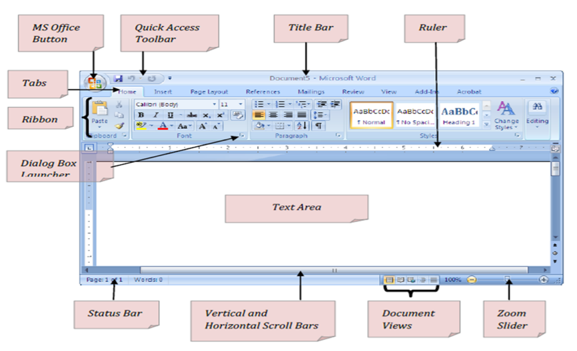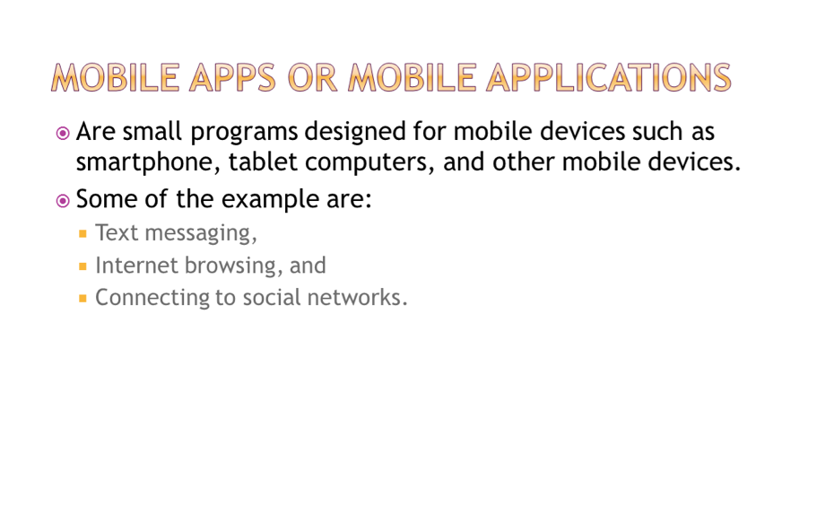

Lesson 43: Common Features of Application Software
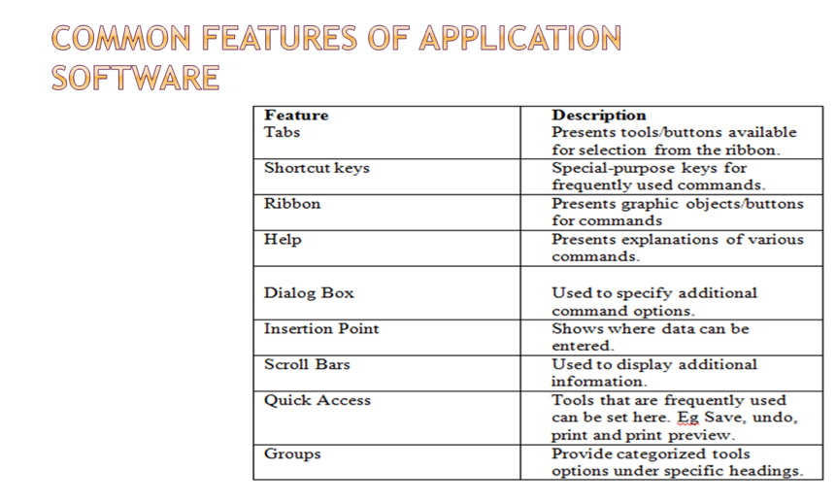

Lesson 44: Define the Acronym “WYSIWYG”
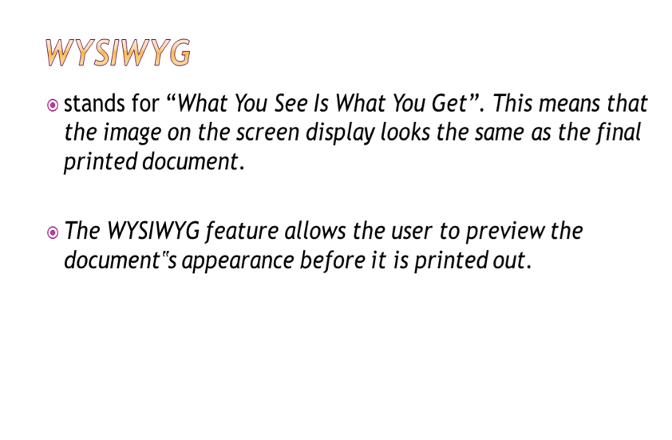

Lesson 45: Describe Word Processing Software
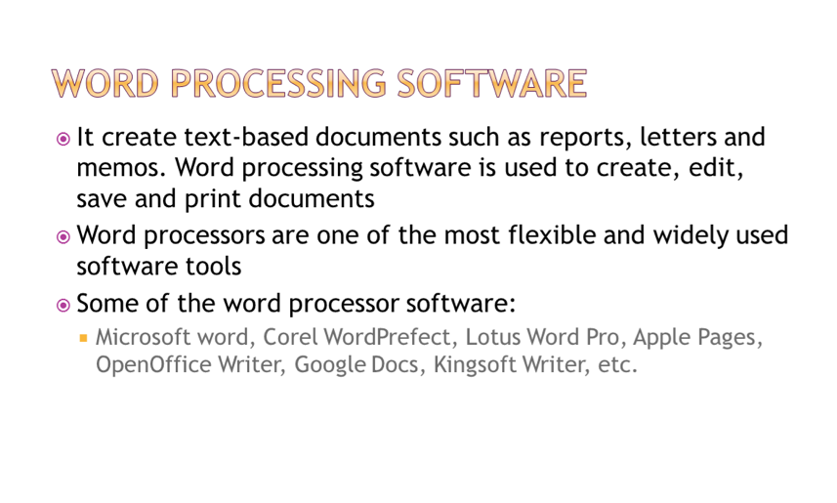
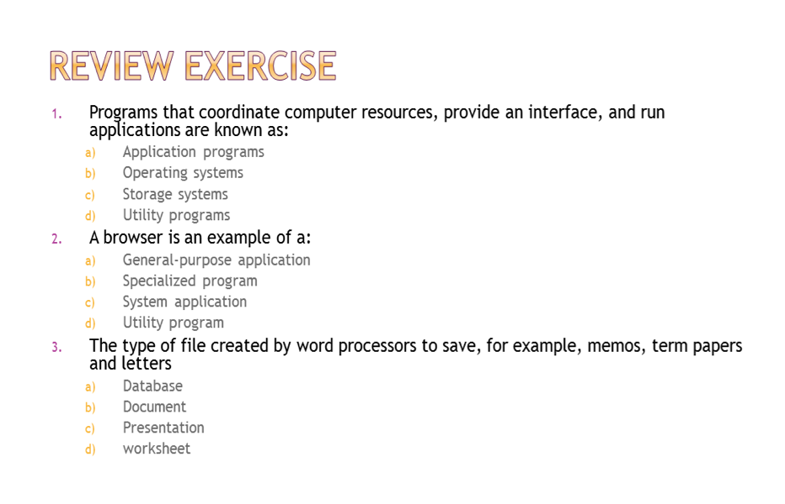

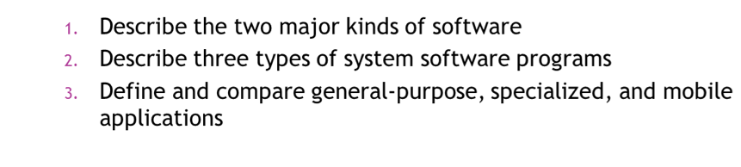
Lesson 46: Features of Word Processing Software
CLO: Define and Describe Word Processing Software Featrues
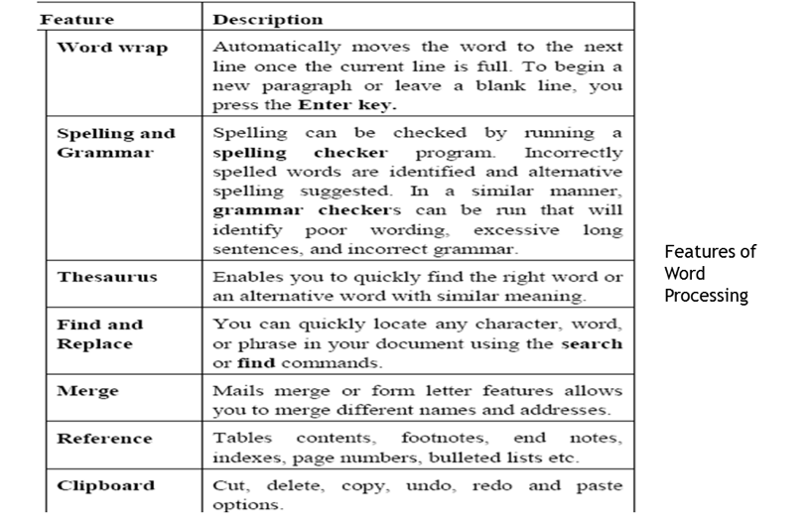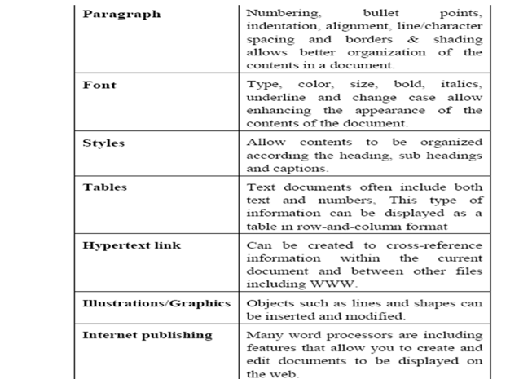

Lesson 47: Spreadsheet Software
CLO: Define and Describe Spreadsheet Software
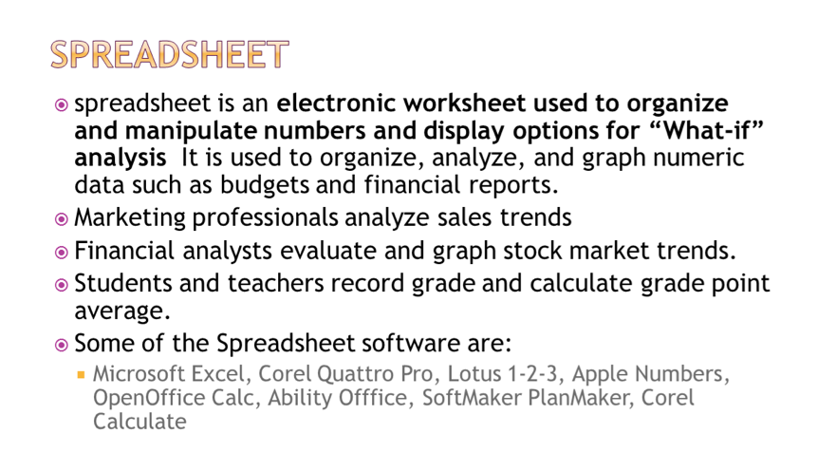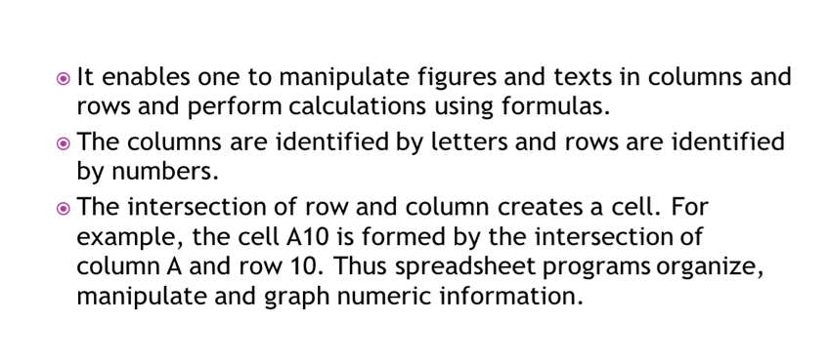

Lesson 48: Spreadsheet Software
CLO: Spreadsheet Features Formatting Cells
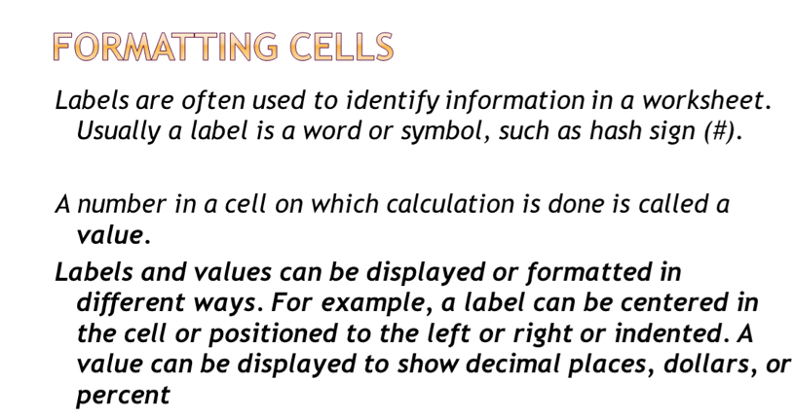

Lesson 49: Spreadsheet Software
CLO: Spreadsheet Features :Formulas and Functions Cells
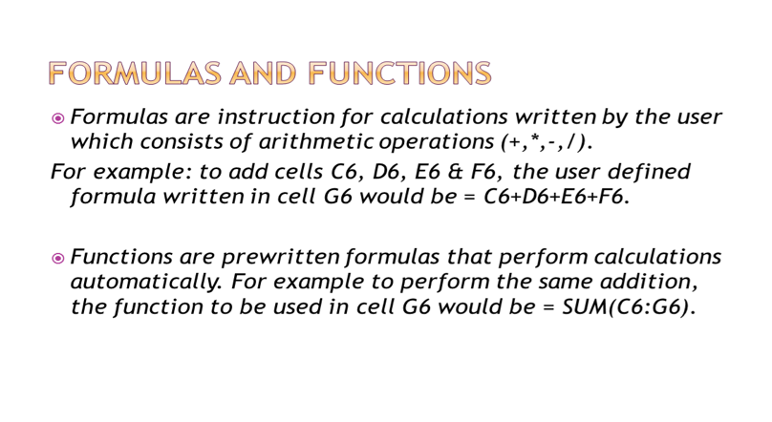

Lesson 50: Spreadsheet Software
CLO: Spreadsheet Features : Features of a Worksheet
