RATU NAVULA COLLEGE
HOME-BASED LEARNING-2021
YEAR 11B: CHEMISTRY

WEEK 1
LESSON NUMBER 25
STRAND 3 REACTIONS
SUB-STRAND 3.1 CHEMICAL EQUATIONS AND CALCULATIONS
LEARNING OUTCOME
- Writing the names and formula of common ionic and covalent compounds.
Chemical Formulae
- Are used to express the composition of molecules and ionic substance in terms of chemical symbols.
Example: water- H₂O ; Carbon dioxide-CO₂; Oxygen gas –O₂
WRITING CHEMICAL FORMULA:
CROSSOVER –METHOD:
STEPS : | EXAMPLE
- Write the cation( positive ion) first followed by the anion(negative ion). | Write the chemical formula of calcium hydroxide  Ca²⁺ OH⁻
- Write the charges above each symbol | 2+ -  Ca OH
- Cross the charges | 2+ -  Ca OH
- Put the charges as subscript (do not write the positive and negative signs)  NOTE:  - SUBSCRIPTS OF 1 ARE NEVER WRITTEN | Ca(OH)₂

Exercise 1
- Write the formula for the following compound:
- Sodium chloride
- Magnesium Chloride
- Sodium carbonate
- Name the following compound:
- Al₃O₂
- AgNO₃

LESSON NUMBER 26
STRAND 3 REACTIONS
SUB-STRAND 3.1 CHEMICAL EQUATIONS AND CALCULATIONS
LEARNING OUTCOME
- Calculating the percentage composition from formula mass and molecular mass.
 | Molecular Mass | Formula Mass
Definition | -used to express the mass of molecules  - the mass is calculated by adding the atomic masses in the molecule.  - no unit; only atomic mass unit(a.m.u.) | -used to express the MASS OF IONIC COMPOUNDS.  -Similar to MOLECULAR MASS.  -no unit; only atomic mass unit  (a.m.u)
Example | CO₂ :  _{ELEMENT} ATOM MASS TOTAL  C 1 12 12  O 2 16 32  44amu | CaCl₂:  _{ELEMENT} ATOM MASS MASS TOTAL  Ca 1 40 40  Cl 2 35.5 70  110amu

Law of Definite Composition
- The law of definite composition was proposed by Joseph Proust based on his observations on the fixed composition of chemical compounds.
- This law states that chemical compounds are composed of a fixed ratio of elements as determined by mass.
- Elements combine in whole numbers: it is not possible to have a compound with portion an atom.
Example 2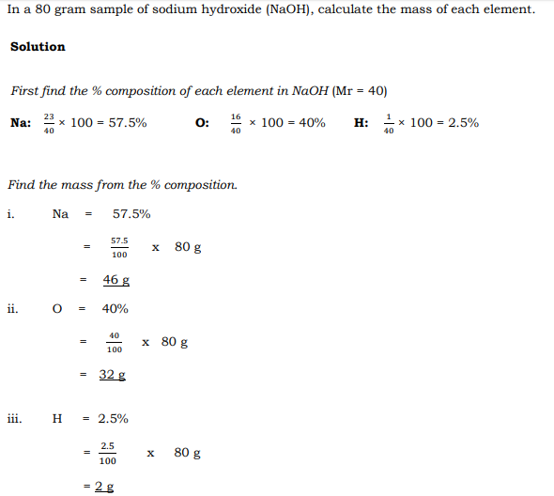
Note :Exercise 2 is (i)-(iii)

LESSON NUMBER 27
STRAND 3 REACTIONS
SUB-STRAND 3.1 CHEMICAL EQUATIONS AND CALCULATIONS
LEARNING OUTCOME:
- Writing Chemical equation from chemical statements and vice-versa.
Chemical Equation:
- A way of illustrating(denoting) a chemical reaction using the symbols for the participating particles ( atoms, molecules, ions, etc) ;
For Example:
2Mg_{(s)} + O_{2(g)} 2MgO_{(g)}
That is:
Note: 1. Single arrow ( ) –irreversible reactions ; Double arrow( )- reversible reactuons.
- The different phases of the reaction are indicated as follows: (s)-solid; (g)-gas; (l)-liquid; (aq)-aqueous .
- The coefficient eg; 2Mg indicates the relative numbers of molecules reacting.
OBTANING NET IONIC EQUCATION
Ionic equation
Indicates the reactant and/ or products that exists primarily as ions in aqueous solution.
To get a net ionic equation:
- write the balanced molecular equation
- write the balanced complete ionic equation
- cross out the spectator ions that are present
- write the leftover as the net ionic equation

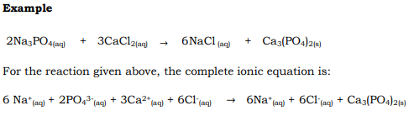
Exercise
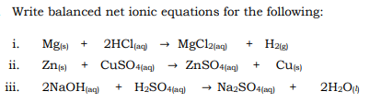

LESSON NUMBER 28
STRAND 3 REACTIONS
SUB-STRAND 3.1 CHEMICAL EQUATIONS AND CALCULATIONS
LEARNING OUTCOME:
- Define and verify the Law Of conservation of Mass
Law of conservation of mass
- The law of conservation of mass was established in 1789 by French Chemist Antoine Lavoisier
- This law states that mass is neither created nor destroyed in any ordinary chemical reaction.
- Therefore the mass of the reactants will always be equal to the mass of the products.
Example
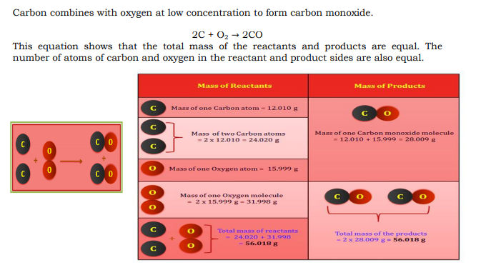

Example 2
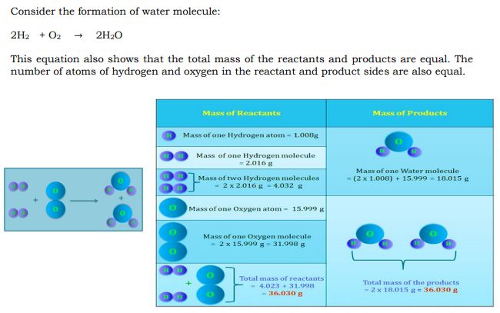

Examples showing the Law of Conservation of Mass
1. In an experiment where 50 g of sodium was reacted with 76 g of chlorine to form sodium chloride salt, it was found that 126 g of the salt was formed.
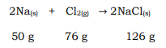
2. When 24.8 g of copper carbonate is strongly heated, it produces 16 g of copper oxide and. . 8.8g of carbon dioxide gas.
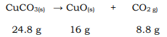

3. When a 10 g sample of iron reacts with oxygen to form 18.2 g of ferric oxide, 8.2 g of . . . oxygen was needed.
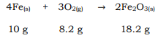

Exercise
- If 178.8 g of water is separated into hydrogen and oxygen gas and the hydrogen gas has a mass of 20.0g, what is the mass of the oxygen gas produced?
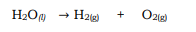

- From a laboratory process, a student collects 28.0 g of hydrogen and 224.0 g of oxygen. How
much water was originally involved in the process?

