RATU NAVULA COLLEGE
HOME-BASED LEARNING-2021
YEAR 11B: CHEMISTRY

WEEK 2
LESSON NUMBER 29
STRAND 3 REACTIONS
SUB-STRAND 3.1 CHEMICAL EQUATIONS AND CALCULATIONS
LEARNING OUTCOME
Types of Reactions
- The chemical principles that involves changes:
- Combustion
- Synthesis
- Decomposition
1. Combustion: chemical term for the burning of substances in oxygen to form compounds called oxides. Though oxygen does not burn, it is used as it supports combustion.
- Metals will burn completely in oxygen to form metallic oxides.
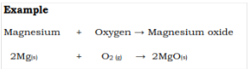
- The oxides are ionic compounds and are basic in nature.
- Metals burn with distinctive flame.
- Non-metals burn completely in oxygen to form non-metal oxides. These oxides are molecular substances and are acidic in nature. Most are gases at room temperature.
- Organic compounds burns completely in oxygen to produce carbon dioxide and water (complete combustion). A lot of energy is released. Incomplete combustion will form harmful products such as carbon monoxide, soot (unburnt carbon) and less heat is released.
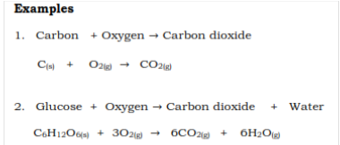

2. Synthesis: Naturally occurring elements combine chemically to form compounds. When two non-metals combine, a covalent substance is formed. However, metals combine with a non-metal to form ionic compounds.
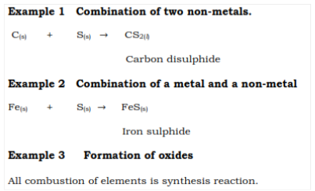
3. Decomposition: some carbonates and nitrates are decomposed by heat. Carbonates are decomposed to form carbon dioxide and the oxide of the metal.
The set up below shows the laboratory preparation of carbon dioxide by the decomposition of marble chips, CaCO₃
-The presence of the carbon dioxide formed can be tested by passing it through lime water.
-calcium oxide was also used to form a paste to straighten/ stiffen wavy hair.

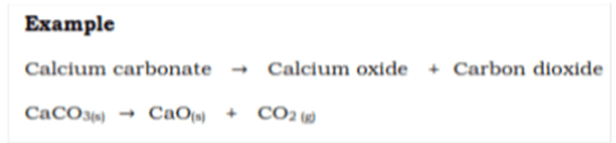
- Green copper carbonate crystals will decompose to form a black solid, copper oxide (CuO).

- White lead carbonate is decomposed to form the yellow solid, lead oxide (PbO).
- The nitrates of copper, lead and zinc will changed to liquid by gentle heating. The salt had dissolved in its water of crystallisation. When the liquid is strongly heated, a brown gas is given off and a solid deposit is also formed. The other gaseous product is oxygen.
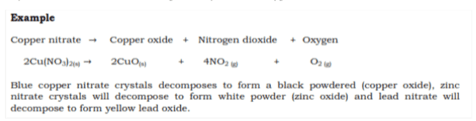
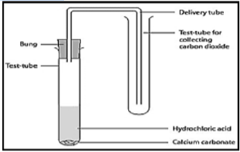

Exercise 5
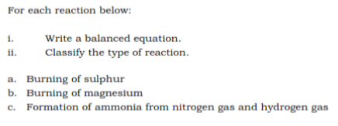

LESSON NUMBER 30
STRAND 3 REACTIONS
SUB-STRAND 3.1 CHEMICAL EQUATIONS AND CALCULATIONS
LEARNING OUTCOME
Types of Reactions
- The chemical principles that involves changes:
- Neutralisation
- Precipitation

4. Neutralisation (acid-base reaction) - acids react with bases to form salt and water. Of the acid will react with the hydroxide ion of the base to form water
- Acidic Substances include mineral acids, citrus juice, vinegar, and gastric juice and non-metal oxides.
- Bases are oxides and hydroxides of metals, ammonia and carbonates.
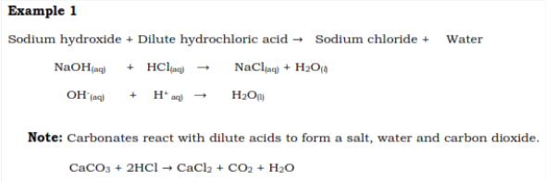
5. Precipitation - is the formation of an insoluble salt from the mixture of two different clear solutions.
- The insoluble salt formed is the precipitate (ppt). Example: formation of scum by mixing soap solution and hard water. Scum is a precipitate.
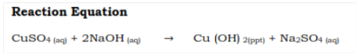

Exercise 6
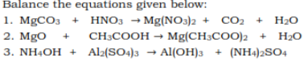

LESSON NUMBER 31
STRAND 3 REACTIONS
SUB-STRAND 3.1 CHEMICAL EQUATIONS AND CALCULATIONS
LEARNING OUTCOME
Types of Reactions
- to understand and explain the chemical principles that involves changes
6. Double Displacement - When two different salt solutions react forming a clear solution. Thresultant salts formed are both soluble in water. It is termed double displacement as the anions are exchanged between the two cations.
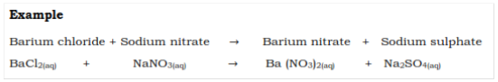
7. Oxidation-Reduction
- Oxidation is the gain of oxygen. For example, combustion and corrosion reaction
- Reduction is the loss of oxygen. Oxidation and reduction reactions occur simultaneously.
- As a substance is reduced, the other reactant will be oxidised.
NOTE:
- oxidation is the loss of hydrogen or electrons
- Reduction is the gain of hydrogen or electrons
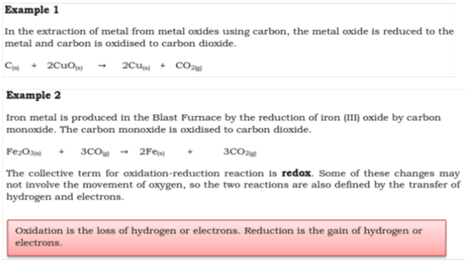

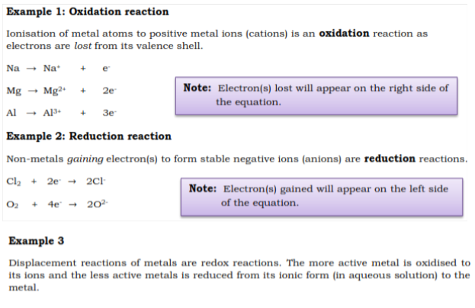

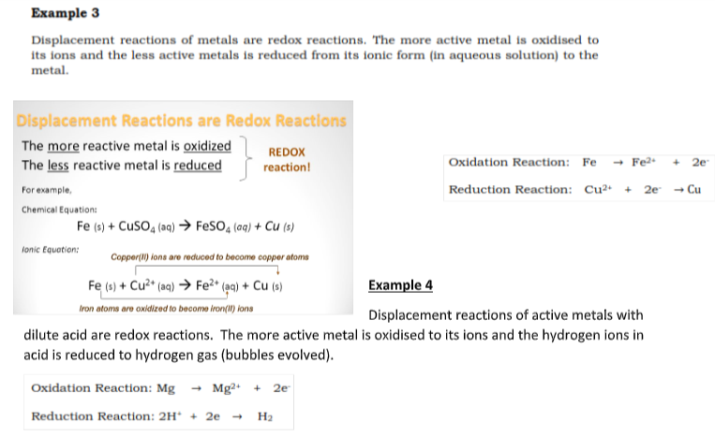
Exercise 7
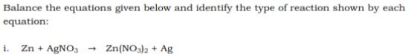
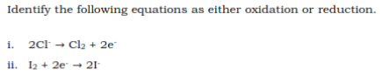

LESSON NUMBER 32
STRAND 3 REACTIONS
SUB-STRAND 3.1 CHEMICAL EQUATIONS AND CALCULATIONS
LEARNING OUTCOME
Electrolysis
Objective: at the end of this topic, students should be able to:
- to understand and explain the chemical principles that involved in electrolysis
- Show that electrolysis of molten and aqueous salt experimental set-up involves oxidation and reduction
Notes:
- Redox is commercially used in a process called electrolysis.
- Electrolysis is the decomposition of an electrolyte by passing an electric current through it.
- An electrolyte is a molten salt or solution that conducts electricity.
- Electrolysis is carried out in an electrolytic cell, as in Figure below.
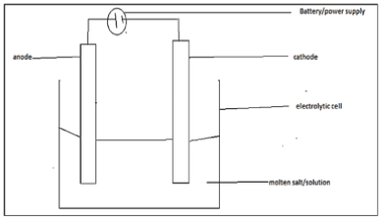
The components of an electrolytic cell are:
1. Electrolyte – molten or solutions of ionic compounds. The mobile/free ions are the carriers of electric current. Examples include: NaCl_{(l)}, NaCl_{(aq)}, H2O_{(l)}, MgCl_{2(aq)}, CuSO_{4(aq).}
2. Batteries/Direct Current, DC power supply – source of current, creates or discharge ions in the electrolyte. The electrode potential should be large enough to drive the reactions.
3. Electrodes – connects batteries/DC power supply to electrolyte. The two types are anode (positively charged) and cathode (negatively charged). Electrodes are usually inert or unreactive and a conductor of electricity. A common electrode is carbon (graphite) as it is inert and a conductor. Less reactive metals such as copper, iron and zinc, are used in electroplating.
Electrolysis of a salt solution
Anode reaction
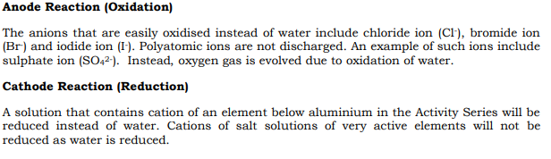
The figure below shows the electrolysis of brine, concentrated NaCl_{(aq)}; it is an important industrial application as it produces much needed chlorine. The salt solution contains the electrolyte, sodium ions, chloride ions and water.
Water is reduced at the cathode instead of sodium ions as it was easier to reduce; at the anode, chloride ion was easier to oxidise than water.
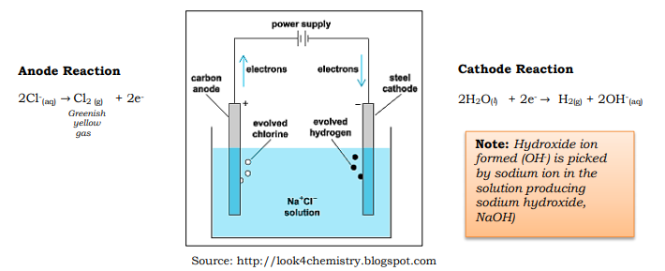
Exercise 8
- Define redox reaction.

LESSON NUMBER 33
STRAND 3 REACTIONS
SUB-STRAND 3.3 Acids, Bases and Salts
LEARNING OUTCOME
- Differences between acids and bases
- Illustrate the differences between diluted and concentrated solutions, weak and strong acids and alkalis using the pH scale.
Acids
Acids form hydrogen ions /protons (H+) or hydronium ions (H₃O⁺) in solution.
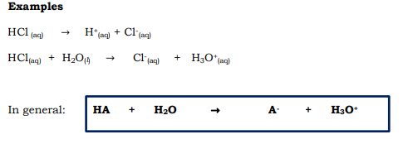
Properties of Acids
- Have a low pH (below 7).
- Neutralises bases to form water and a salt.
- Have a sour taste.
- Changes blue litmus to red.
- React with many metals to produce hydrogen gas.
Examples of Acids:
- Hydrochloric acid (HCl), sulphuric acid( H₂SO₄) and nitric acid (HNO₃)
- Citric acid (in orange juice or lemon juice)
- Acetic acid (in vinegar)
- Phosphoric acid (in Coke)
- Ascorbic acid (in vitamin C tablets)
- Uric acid (in urine)
- Stearic and lauric acid (in cosmetics)
Bases/Alkalis
Form hydroxyl ions (OH⁻) in solution.
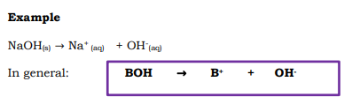
Properties of Bases/Alkalis
- Have a high pH (above 7).
- Changes red litmus to blue.
- Neutralises acids to form water and a salt.
- Have a bitter taste.
- Feels slippery.
Examples of Bases/Alkalis
- Ammonia
- Calcium hydroxide (caustic lime/lime water)
- Lithium hydroxide
- Potassium hydroxide (caustic potash)
- Sodium hydroxide (caustic soda)
- Many bleaches, soaps, toothpastes and cleaning agents
- Window cleaners may contain ammonia
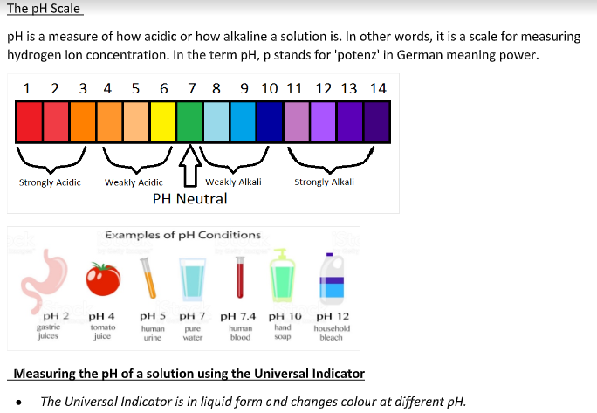
Steps in measuring the pH of a solution using the Universal Indicator:
1. Take the test solution in a test tube. If solid substance EXAMPLE, salt, dissolve by adding distilled water to it.
2. Place a drop of the Universal Indicator using a fine dropper into the solution.
3. Observe the colour produced and match it with the different colour shades of the standard colour pH chart.
4. Note down the pH of the colour chart that matches most closely with the colour produced on the pH paper.
Strengths of Acids and Bases
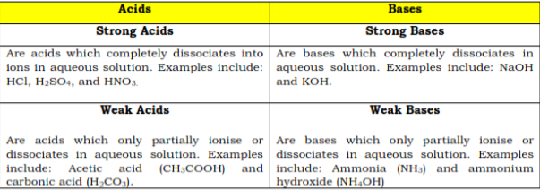
Solutions
A solution consists of a liquid (the solvent) with a substance (the solute) dissolved in it.
For example:
- Milk is a solution consisting of water (the solvent) with lactose and salts dissolved in it.
- Ocean water is a type of solution that has many dissolved ions in water.
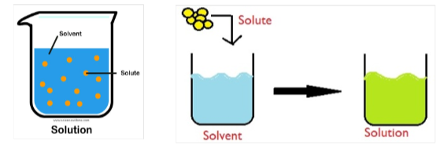
Dilute and Concentrated solutions
Dilution involves adding more solvent to a solution so that the concentration of the solute becomes lower.
The total number of solutes in the solution remains the same after dilution, but the volume of the solution becomes greater, resulting in a lower concentration.
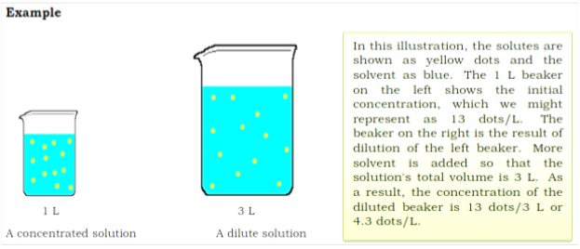

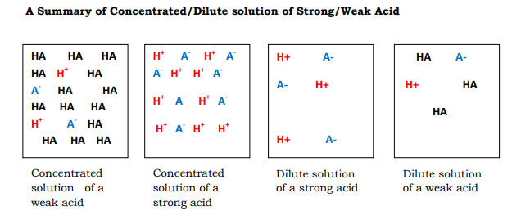
Neutralization reaction – the formation of a salt
- When an acidic solution and a basic solution are mixed, hydroxide ions react with hydronium ions to produce water molecules. 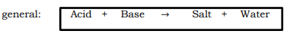
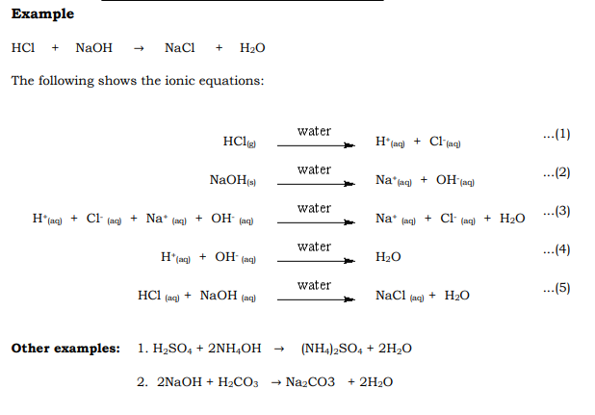
Properties Salts
- Salts are product of an acid-base reaction.
Many salts are soluble:
- For this reason, most drugs are salts (most often sodium). This gets the drug into the bloodstream as all sodium compounds are soluble
- If a drug cannot be turned into a salt, it will not dissolve in water and is useless to a patient as it will not enter the bloodstream.
- Salts are ionic compounds
- Salts are hydroscopic: they absorb water very well to form hydrates.

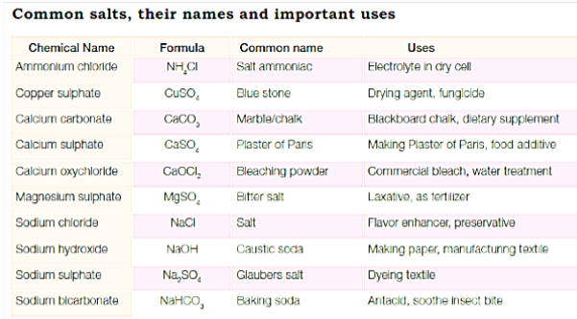
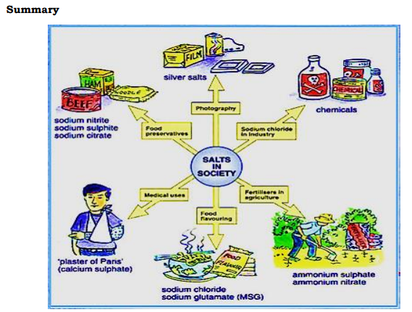
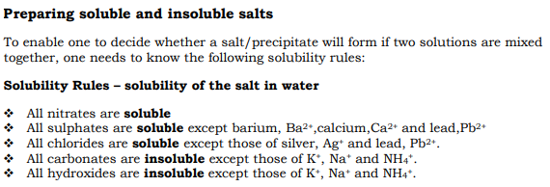
Exercise 9:
- Acids are substances that
A. has high pH.
B. turns blue litmus paper red.
C. turns red litmus paper blue.
D. forms hydroxide ions in solution.

2. Bases are substances that
A. always has low pH.
B. change red litmus paper blue.
C. change blue litmus paper red.
D. reacts with metals to produce hydrogen gas.

Fill in the blanks
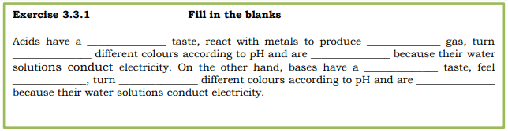
- Acids are substances that form hydronium ions in the solution. Define weak acid and provide an example.
_________________________________________________________________________________________________________________________________________________________________________________________________________________________________________________________________________________________________________________________________________________________

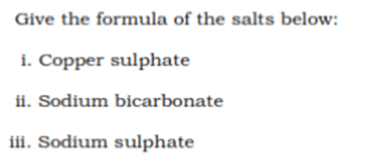

LESSON NUMBER 34
STRAND 3 REACTIONS
SUB-STRAND 3.3 Acids, Bases and Salts
LEARNING OUTCOME
- Analyse the formulae, names and properties of salts to explain their uses, preparation and industrial application.
- describe ways to prepare salts and differentiate between hydrated and anhydrous salts.

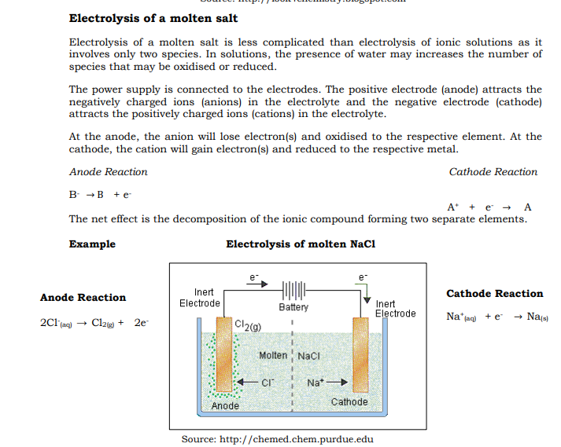
- Sodium ions (Na⁺) gains electron and is reduced to sodium metal at the cathode. Chloride ions moves to the anode and is oxidised by losing electrons to form chlorine gas.
- The anode is separated from the cathode by a diaphragm.
- It prevents the greenish yellow chlorine gas

Other Examples
- Electrolysis of molten Lead Bromide Using Carbon Electrodes

- Electrolysis of Copper Sulphate solution Using Carbon
- Copper sulphate solution contains the electrolytes; copper ions, sulphate ions and water.
- Copper ions are attracted to the cathode and are reduced to reddish brown copper metal.
- Sulphate ions are attracted to the anode. However, water is oxidised as sulphate ions cannot be oxidised.
- It releases oxygen gas, so a colourless gas is formed at the anode.
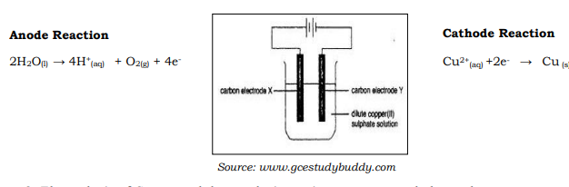
- Electrolysis of Copper sulphate solution using copper metal electrodes
This set up is used in the industrial production of copper metal. In the figure below, impure copper is the anode and pure copper is the cathode.
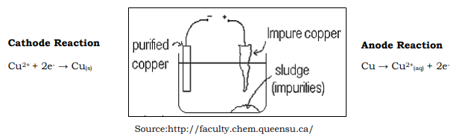
- Electrolysis of water using carbon electrodes
Electrolysis of water is used industrially to produce hydrogen gas. Water reduced at the cathode produces hydrogen gas and water oxidised at the anode forms hydrogen ions.
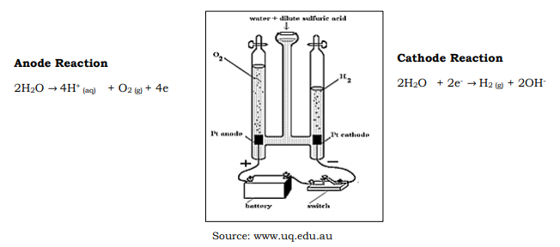

Exercise 10:
- Why is graphite used as an electrode?
_______________________________________________________________________________________________________________________________________________________________________________________________________________________________________________________________________________________________________________________________________________________________________________________
- Why does an open can rust faster than an unopened can?
_______________________________________________________________________________________________________________________________________________________________________________________________________________________________________________________________________________________________________________________________________________________________________________________
3. Study the set up given below. The iron nail is touching the zinc nail as they are tied together.
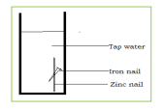
- Will the iron corrode? Give a reason for your answer.
__________________________________________________________________________________________________________________________________________________________________________________________________________________________________________________________________________________________________________________________________________

- The zinc nail was removed. State an observation that you will make after a few days
__________________________________________________________________________________________________________________________________________________________________________________________________________________________________________________________________________________________________________________________________________

