STRAND 1 : YEAR 11 - BIOLOGY -STRUCTURE AND LIFE PROCESSES
SUBSTRAND: 1.6 ANIMAL FORM AND FUNCTION
LEARNNG OUTCOME: DISCUSS THE SKELETAL SYSTEM
LESSON NO: 34
THE SKELETAL AND MUSCULAR SYSTEM
-The human skeletal system is a framework of bones and cartilage held together.
-Muscles pull on these bones causing movement.
Types of skeleton
1. Hydostatic skeleton
- is a skeletal system which is based on the presence of a liquid. The muscules pulls against each other for movement. Example are annelids.
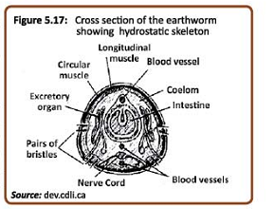

2. Exoskeleton (Externam skeleton)
-This is a skeletal where there is a bony structure but it is located on the outside of the animals body.
- Animals with these types of skeletal includes insects and crustaceans (crabs).
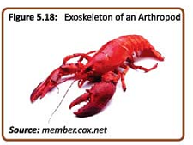
3. Endoskeleton (internal skeleton) is a skeleton system where a calcareous framework of bones are locates on the inside of the body. All the muscles tissue is attached to the outside of the bony framework.
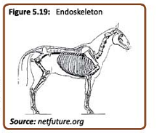

STRAND 1 : STRUCTURE AND LIFE PROCESSES
SUBSTRAND: 1.6 ANIMAL FORM AND FUNCTION
LEARNNG OUTCOME: DISCUSS THE SKELETAL SYSTEM
LESSON NO: 35
Functions of the skeleton
1. it provides a support for the human body.
2. it holds up the body thus allowing movement.
3. it gives shape to the body and provides protection to the internal organs.
The structure of bone
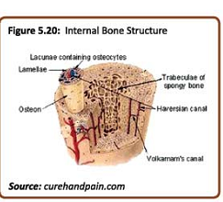
- When in the embryo stage, the skeleton develops as cartilage. The cartilage then grows into bone.
- Bone and cartilage are mde of a typre of connective tissue, where the cells are surrounded by extra-cellular matrix.
- Long bones have bone marrow inside them where the red blood cells are made.
- Long bones whose inside section is thicker are known as compact bone.
- Short bones are those such as carpels found in the hands. The bones of the skull and the scapular are flat bones, while bones of the vertebrate and ribs are irregular bone.

STRAND 1 : STRUCTURE AND LIFE PROCESSES
SUBSTRAND: 1.6 ANIMAL FORM AND FUNCTION
LEARNNG OUTCOME: EXPLORE DIFFERENT TYPES OF JOINTS
LESSON NO: 36
JOINTS
-This is where 2 bones meet and hold together by connective tissue known as ligament. To avoid the abrasion of bones as they come into contact, the outlying tissue at the point of contact is covered with cartilage.
Types of joints
1. immovable joints- cannot be moves such as bones that make up the skull. Here the bones are held together with the cartilage.
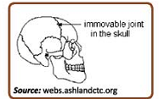
2. Ball and socket joints
- such as those found at the hips and shoulders. It allows movement in all directions.
- at the shoulder and scapula joints allows the arm to rotate

3. Gliding joints
-Are where the bobes easily glide up and down and from side to side such as those found in the ankles and wrists.
4. Hinge joints – are like those in the elbow and knee, where the bones move backwards. Movement is only in one direction.
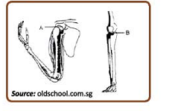
5. Pivot joint – is found between the first two vertebrate. It allows the neck to rotate.
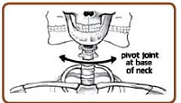
A typical joint structure
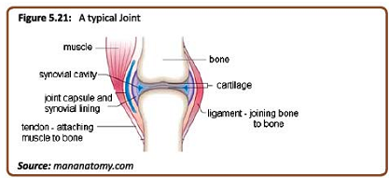
STRAND 1 : STRUCTURE AND LIFE PROCESSES
SUBSTRAND: 1.6 ANIMAL FORM AND FUNCTION
LEARNNG OUTCOME: EXPLORE DIFFERENT TYPES OF MUSCLES
LESSON NO: 37
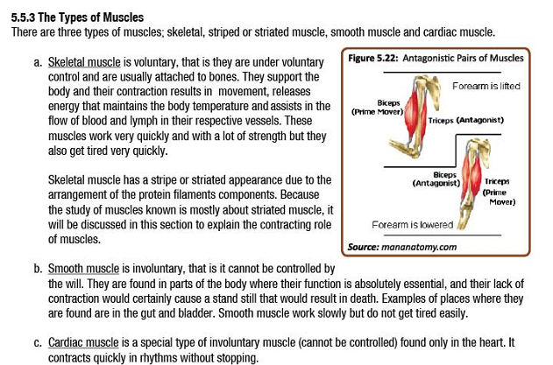
STRAND 1 : STRUCTURE AND LIFE PROCESSES
SUBSTRAND: 1.6 ANIMAL FORM AND FUNCTION
LEARNNG OUTCOME: EXPLORE DIFFERENT TYPES OF MUSCLES
LESSON NO: 38
The structure of muscles
- Skeletal muscles are found together in bundles.
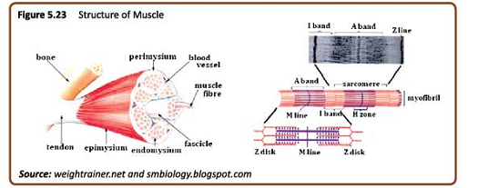
-the muscle bundle consists of the fiber bundles also held to other bundles by connective tissues.
-actin are thin filaments of protein while myosin are much thicker protein filaments.
-The arrangement of these 2 myofilaments produces the striated appearance.
- the contracting unit of the myofibril is known as sarcomere.
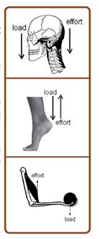
Movements
-joints facilitates the movements.
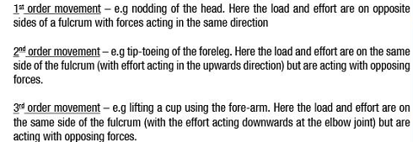

STUDENT WORKSHEET TERM 2 (WEEK1)

1. An organism that has a segmented body and hydrostatic skeleton belongs to phylum
A. Mollusca (snails). B. Annelida (earthworms).
C. Platyhelminthes (flatworms). D. Arthropoda (insects).

2. Name the 3 different types of skeletal system?
3. List 2 advantages of the exoskeletal system.
4. differentiae between the bone and cartilage?

5. Explain the antagonistic movement of muscles?

6. Explain briefly why the skull muscle is called immovable skeletal system?

7. The joint found in the elbow is an example of a _________________ joint.
A. hinge B. gliding
C. immovable D. ball and socket

