YEAR 11 BOLOGY WORKSHEET 3
STRAND 1 : STRUCTURE AND LIFE PROCESSES
SUBSTRAND: 1.6 ANIMAL FORM AND FUNCTION
LEARNNG OUTCOME: DISCUSS THE TYPES OF SENSE ORGANS IN HUMANS LESSON NO: 44
THE SENSE OF HEARING AND THE STRUCTURE OF THE EAR
STRUCTURE OF THE EAR
-the ear is made of 3 major parts. 1. Outer ear 2. Middle ear 3. Inner ear
- the outer ear consists of the external pinna and a canal.
- the middle ear has 3 small pieces of bones which link the ear drum to the inner ear.
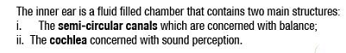
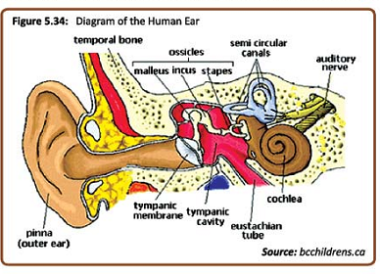
Malfunctions of the ear
Several things can affect the perception of sounds:
1. too much wax secreted by the ear can obstruct sound waves from reaching the eardrum.
2. pressure in balance in the ear, if the tube is blocked by infection, sound reception can be affected.
The sense of taste
There are 4 basic tastes that can be affected by the tongue.
1. sour 2. Sweet 3. Bitter 4. salt
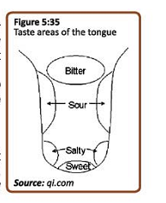

STRAND 2 : LIVING TOGETHER
SUBSTRAND: 2.1 ORGANISM AND THE ENVIORNMENT
LEARNNG OUTCOME: EXAMINE POPULATION ATTRIBUTES, GROWTH AND REGULATION.
LESSON NO: 45
Ecology – is the study of relationships of living things and their interactions with their environment.
The environment is made of both living things (biotic factors) and non-living things (abiotic factors).
Important terms
1. Organism- is a living individual that belongs to a certain species. Example a tree, a rat.
2. Species – is a group of individuals of the same kind that are able to interbreed and produce fertile offspring.
3. Population – individuals of the same living together in an area at a particular period of time.
4. Community – is made up of the different populations in an area. The individuals in a population interact with each other.
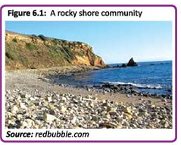
5. Ecosystem – is made up of the community of organism interacting with each other and their physical environment.
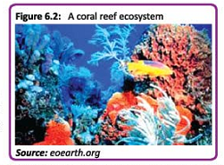

6. Habitat- is the place where the organism lives.

7. Adaptation – is a characteristic or feature that an organism has to help it survive. Eg a thorn is an adaptation of a lemon tree, it keeps herbivores from eating it.

STRAND 2 : LIVING TOGETHER
SUBSTRAND: 2.1 ORGANISM AND THE ENVIORNMENT
LEARNNG OUTCOME: EXAMINE POPULATION ATTRIBUTES, GROWTH AND REGULATION.
LESSON NO: 46
POPULATIONS
Is a group of organisms of the same species living in a given area at a given period of time.
There are certain features of a population that can be used to describe a population
1. Population size- it refers to the number of individuals in a population. Eg N=12dogs.
2. Population range- this refers to the area within which the population is found.
3. Population density- this refers to the number of individuals which may be present in each unit of area.
EXAMPLE 1
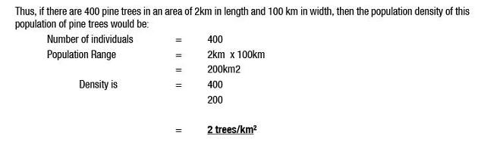
POPULATION DISTRIBUTION
1. Uniform distribution- where the individuals are evenly distributed.
2. Clumped Distribution- where individuals are found in groups in an area.
3. Random Distribution- where individuals are distributed unevenly throughout the area.
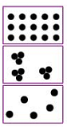
STRAND 2 : LIVING TOGETHER
SUBSTRAND: 2.1 ORGANISM AND THE ENVIORNMENT
LEARNNG OUTCOME: EXAMINE POPULATION ATTRIBUTES, GROWTH AND REGULATION.
LESSON NO: 47
Age of population
Within any population, one will find individuals of varying ages. There are 2 factors that control the age structure of any population.
(i) natality or birth rate (ii) mortality or death rate
Survivorship curves – are a useful way of showing mortality and natality rates for different populations. Survivorship is a chance of remaining alive.
3 types of survivorship curves
Type I – mortality is low at youth, many individuals survive to reach an old age. E.g. humans.
Type II – there is equal chance of dying at any time in life. E.g. insects.
Type III- Many die at a young age eg Fish
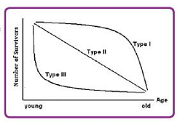
Age pyramid – shows information about the number of organisms of a particular age group that is alive in a population.
There are 3 types of age pyramids
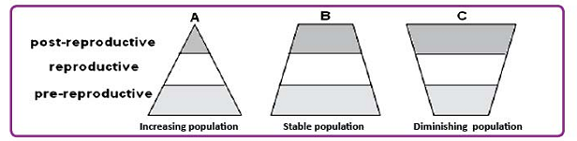

Carrying capacity – is refers to the maximum size of the population that can be supported by the resources in the environment in which they live.

STRAND 2 : LIVING TOGETHER
SUBSTRAND: 2.1 ORGANISM AND THE ENVIORNMENT
LEARNNG OUTCOME: EXAMINE POPULATION ATTRIBUTES, GROWTH AND REGULATION.
LESSON NO: 48
POPULATION GROWTH
When a species is placed in a new environment where there are sufficient resources, the growth of its population will be representative of an exponential or J- shaped curves.
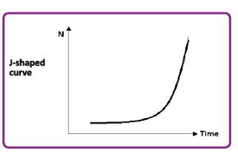
S-shaped graph or the sigmoid graph shows the natural population growth rate.
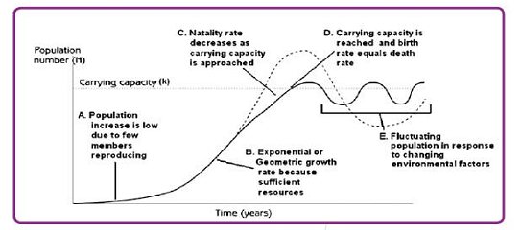

YEAR 11 BIOLOGY
WEEK 3 WORKSHEET
1. The population size that an environment can sustain indefinitely is known as the
A. carrying capacity. B. equilibrium phase.
C. maximum population size. D. exponential population size.
2. In biology, a graph showing a J-shaped curve indicates a population growth that is
A. regulated. B. unregulated.
C. exponential. D. independent.
3. A farm that is 200m in width and 300m in length has 10,000 coconut trees
growing on it. Calculate the
(i) range of the coconut tree population;
(ii) population density of coconut trees on the farm.
4. The diagram given below shows survivorship curves indicating the proportion of individuals
surviving to each age for a given species or group of individuals
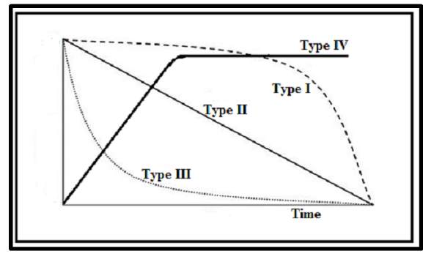
An example of a species that shows Type I survivorship is
A. humans who produce few offspring but care for them well.
B. fishes and invertebrates with a high death rate immediately following birth.
C. birds and lizards with roughly constant survival probability regardless of age.
D. frogs which produce a large number of offspring with highest mortality at early age.

