YEAR 11 - BIOLOGY WORKSHEETS -WEEK 2
STRAND 1 : STRUCTURE AND LIFE PROCESSES
SUBSTRAND: 1.6 ANIMAL FORM AND FUNCTION
LEARNNG OUTCOME: DISCUSS THE HUMAN SKELETON SYSTEM
LESSON NO: 39
THE HUMAN SKELETON
-The framework of the human skeleton is divided into 2 major sections:
a. the axial skeleton comprising of
i. skull ii. Rib cage iii. Vertebral column
b. the appendicular skeleton consists of the:
i. girdles ii. limbs
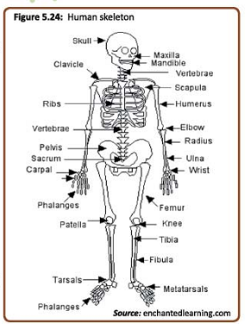
Malfunction of the skeletal system
1. where the bone is affected. Example fractures and rickets.
2. where the muscles are affected. Example sprains.
3. where the joints are affected. Example arthritis.
STRAND 1 : STRUCTURE AND LIFE PROCESSES
SUBSTRAND: 1.6 ANIMAL FORM AND FUNCTION
LEARNNG OUTCOME: explore the nervous system LESSON NO: 40
-The sensitivity and coordination is controlled by 2 separate but inter related and interconnected system.

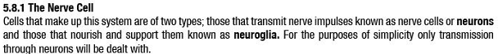
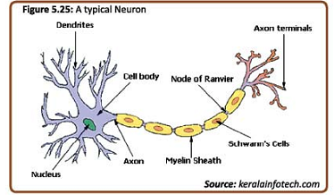
The table below shows the parts of the neuron and its function
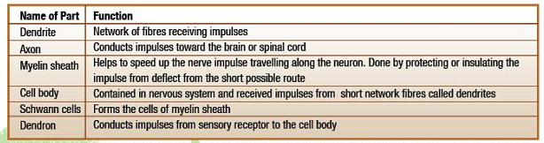
STRAND 1 : STRUCTURE AND LIFE PROCESSES
SUBSTRAND: 1.6 ANIMAL FORM AND FUNCTION
LEARNNG OUTCOME: DISCUSS THE TYPES OF NEURONS LESSON NO: 41
There are 3 types of neurons: 1. Sensory neuron. 2. Motor neuron 3. Interneurons
1. sensory neurons- receives impulse from senses e.g. eyes, ears etc.
2. motor neurons- transmits impulse from rely center to the motor causing responses.
3. interneurons- conveys messages between neurons .
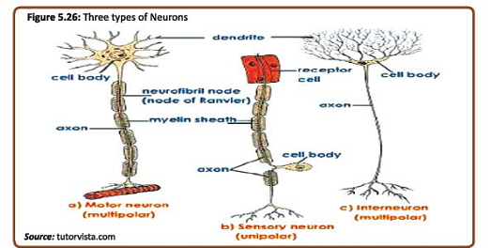

The nervous system
The central nervous system is made up of the brain and the spinal cord.
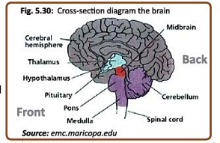
1. THE SPINAL CORD- Is a mass of nerves cells arranged in a hallow tube.
- the function of the spinal cord is to conduct messages to and from the brain.
2. THE BRAIN- It weighs about 1.3kg in a average adult human.
- it is covered by a number of membranes called meninges, and is protected by the skull.

STRAND 1 : STRUCTURE AND LIFE PROCESSES
SUBSTRAND: 1.6 ANIMAL FORM AND FUNCTION
LEARNNG OUTCOME: DISCUSS THE TYPES OF SENSE ORGANS IN HUMANS LESSON NO: 42
THE SENSE ORGANS OF HUMAN

The human body has elaborate system of very efficient and highly effective receptors.
1. the sense of vision and the structure of the eye
- the human eye is a very complex receptor organ.
- each eye has a lens system for focusing light onto the retina surface contacting cells that converts the light rays into the electric impulses.
- these electric impulses are then sent to the brain by the designed nerves called the optic nerves.
- the amount of light entering the eyes is regulated by the diaphragm called the iris which contains 2 sets of muscles. (radial) and (circular) muscles.
-these muscles form the perimeter of the space known as pupil.
- the pupil is a window through which light travels.
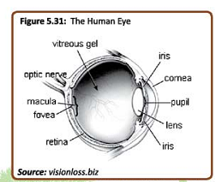
Vision – the translation of the object being looked at by the eye onto an image in the retina is made possible by the property of the light to bend as it travels from one medium to another.
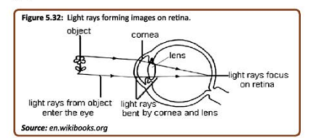
STRAND 1 : STRUCTURE AND LIFE PROCESSES
SUBSTRAND: 1.6 ANIMAL FORM AND FUNCTION
LEARNNG OUTCOME: DISCUSS THE TYPES OF SENSE ORGANS IN HUMANS LESSON NO: 43
MALFUNCTION OF THE EYE
THE 2 MOST COMMON DEFECTS OF THE EYE ARE:
1. FAR OR LONG SIGHTNESS
- This is a condition where the person can focus on things that are far away but not on close by objects.
- this defect is caused by imperfection in eye where the eyeball is too short and the lens ate not rounded.
- to correct the defect convex lens are used in spectacles (glasses).
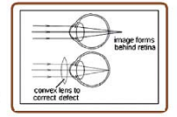

2. NEAR OR SHORT SIGHTNESS- The lens is too curved causing light rays from an object to bent too much.
-to correct this defect, biconcave lens are used.
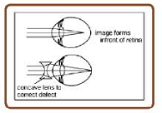
OTHER DEFECTS
A. Cataract- is a clouding over the lens as a result of protein breakdown.
- some factors that can speed up cataract are diabetes and injury.
B. Astigmatism – this is a condition that results from the lens being irregularly curved. When this happens the person may have blurred vision.

TERM 2 WEEK 2 WORKSHEET
BIOLOGY YEAR 11

(1) The diagram below shows a reflex action pathway.
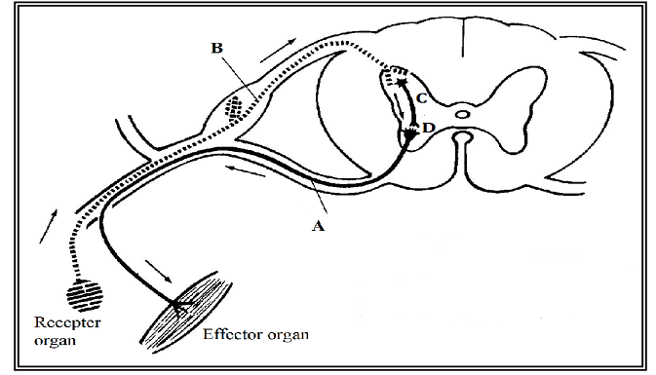
(i) State one functional difference between neurons A and B.

2. Name 2 main component of the central nervous system?

3. Name 2 conditions that can cause malfunction of the skeletal system?

4. what does long sightness mean? How can one overcome the problem of long sightness?

5. Cataract is an eye disease in humans. What 2 factors can increase the risk of cataract in humans?

6. Differentiate between the function of a motor neuron and a sensory neuron?

