WEEK 7 YEAR 11 APPLIED TECHNOLOGY
STRAND: BASIC HOME IMPROVEMENT
LESSON 59: PLUMBING
LEARNING OUTCOME: DEFINE PLUMBING
- A Plumber is someone who installs or repairs piping systems, plumbing fixtures and equipment such as water heaters.

- Plumbing is the skilled trade of working with pipes, tubing and plumbing for drinking water systems and the drainage of waste.

- Plumbing also refers to a system of pipes and fixtures installed in a building for the distribution of potable water and the removal of waterborne wastes.

- Plumbing is usually distinguished from water and sewage system, in that a plumbing system serves one building, while water and sewage systems serve a group of buildings or a city.

- The schematic drawing shows the method of connection from the water main to a house
The major categories of plumbing systems or subsystems are:
- Portable Cold and Hot Water
- Supply Traps, Drains and Vents
- Septic System
- Rain Water and Surface Water Drainage
- Fuel/Gas Piping
LESSON 60: DIRECT WATER SUPPLY SYSTEM
LEARNING OUTCOME: IDENTIFY DIRECT WATER SUPPLY SYSTEM WITH ITS ADVANTAGES & DISADVANTAGES
- A direct water supply system is one where large high reservoirs provide a good mains supply and pressure.

- In this system the whole of the water to the sanitary fittings is provided directly from the main supply.

- The schematic drawing shows the method of installing the direct water system to a small house.
- ADVATANGES OF DIRECT WATER SYSTEM
- In a direct system all the cold water taps and WC cistern are fed off the rising main.

- Suitable drinking water is available from every cold tap and there is sufficient water pressure especially for electric showers.

- There is a substantial savings in pipe work especially in multistory buildings. This is due to the rising main supplying water to all fittings and cold water distribution pipes being omitted from the cistern.

- DISADVANTAGES OF DIRECT WATER SYSTEM
- The main disadvantage is a greater risk of contaminated water getting into the water main through back siphoning.

- There is a tendency to have more trouble with water hammer due to more points being connected direct to the main.

- During peak periods there is a tendency for the lowering of supply and with building on higher grounds, a possible temporary loss of supply.

LESSON 61: INDIRECT WATER SUPPLY SYSTEM
LEARNING OUTCOME: IDENTIFY INDIRECT WATER SUPPLY SYSTEM WITH ITS ADVANTAGES & DISADVANTAGES
- An Indirect Water Supply System is where only the kitchen sink is fed from the rising main, all other cold water outlets are fed indirectly using gravity from head tank (cistern), usually situated above the roof level.

- The hot water outlets are also fed from the same head tank.

- The schematic drawing shows the method of installing the direct water system to a small house.
- ADVANTAGES OF INDIRECT WATER SUPPLY SYSTEM
- In this system Back Siphonage of contaminated water is eliminated.

- In areas where the mains pressure is low, the storage or Head Tank ensures a constant supply of water.

- DISADVANTAGES OF INDIRECT WATER SUPPLY SYSTEM
- Larger and longer pipes are required.

- A large cistern or Head Tank is required.

- Difficult to accommodate the Large Cistern or Head Tank unless fixed in the roof space, this is generally undesirable.

- Drinking water not available from all cold water outlets.

- Less chances of noisy pipes or water hammering.

LESSON 62: VALVES
LEARNING OUTCOME: IDENTIFY THE TYPES OF VALVES & ITS USES
- VALVES
- Valves used to control the flow along a pipeline are known as the globe or gate types.

- Both types close slowly and therefore do not usually give rise to problems of water hammer.

- GLOBE VALVES
- These are used on high-pressure systems.

- Shown below is a section of one type of globe valve; the metal-to-metal seating type is often used for heating systems and the composition valve for very high-pressure systems where a complete shut off is required.

- A stop valve is used for domestic water installations. When the valve is used on cold water service pipe- work the jumper should be loose which tends to act as a non-return valve and prevent backflow into the main.

- GATE VALVES
- These are used for the control of fluids in low-pressure systems, such as on distribution pipe work from storage cisterns, or on low-pressure heating systems.

- They offer much less resistance to the flow of fluids than the globe valve.

LESSON 63: TAPS
LEARNING OUTCOME: IDENTIFY THE TYPES OF TAPS & ITS USES
- There are several types of taps, sometimes referred to as ’screw down‘ types, which are designed to shut off the supply slowly and thus prevent water hammer.

- Bib taps are used for fitting over a sink or for washing down purposes when it is then fitted with a hose outlet. The tap can be plain brass or chromium plated.

- Pillar taps which can be used for baths, wash basins and sinks.
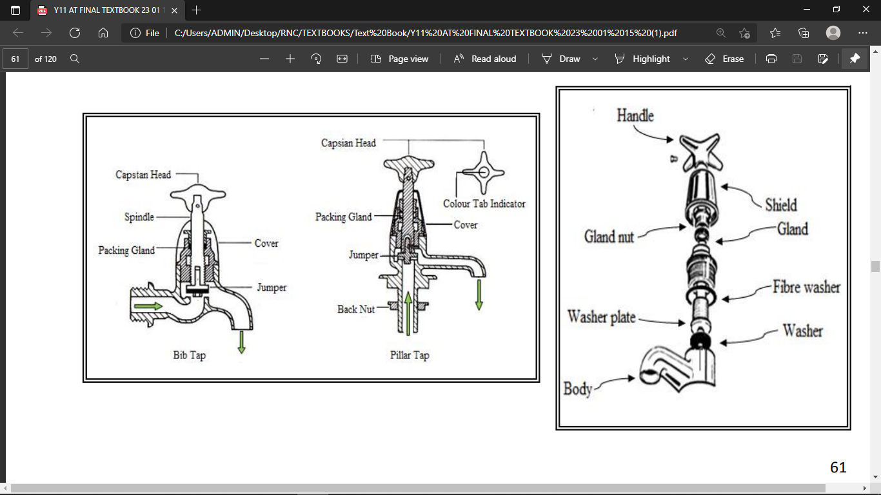
ACTIVITY
- Define Plumbing

- What does a plumber do?

- State the two water supply system

- State the use of a valve

- Identify the two types of valve

WORKSHEET

1.Name the following

