WEEK 6 YEAR 11 APPLIED TECHNOLOGY
STRAND: ENGINEERING MATERIAL
LESSON 54: STAYS & BRACKETS
LEARNING OUTCOME: IDENTIFY THE TYPES OF STAYS & BRACKETS
- Lid Support
- This stay is used to support lids of boxes and cabinets.
- Straight Stay
- A stay that can be used for any lid or flap.

- It has an advantage over others in that it can be fixed in any open position by turning a thumb-screw thus locking the stay.
- Shelf Bracket
- This is a metal bracket for supporting shelves.

- There are a number of types available, the most popular being the pressed steel type which is usually finished black japanned.
LESSON 55: CASTORS
LEARNING OUTCOME: IDENTIFY THE TYPES OF CASTORS

- Peg Castor
- This castor is used for chairs, tables and other movable articles of furniture.
- Tea Wagon Castor
- This is used for light movable furniture such as tea wagons and is fitted in the same way as the peg castor.

- It has a rubber or composition wheel for silent and smooth movement.
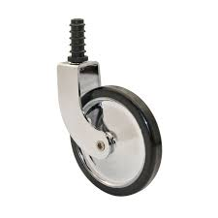
- Shepherd Castor
- This is a newer type of patent castor.

- It is made in a number of sizes to suit light and heavier articles of furniture.

LESSON 56: KNOBS, HANDLES AND PULLS
LEARNING OUTCOME: IDENTIFY TYPES OF KNOBS, HANDLES AND PULLS

- Knob
- It may be fixed to the door or drawer by means of a bolt.
- Drawer Pull
- They screw on to the outside surface of the drawer and are used more for office desks and kitchen fitments than furniture.

- Wooden Drawer or Door Pull
- The wooden drawer pull is usually fitted to cheaper work or where the pull is to be painted to match the rest of the job.
- Handles
- These handles have two thin threaded bolts and are bolted to the door or drawer.

LESSON 57: NAILS
LEARNING OUTCOME: IDENTIFY TYPES OF NAILS

- Box nails
- Much like common nails.

- They have a smaller diameter body and larger, thinner head.

- They are used for box and crate construction.

- Finishing nails
- Have small heads slightly larger than the body.

- They are use where nails head be hidden.

- The head is set below the surface with nail set, and then filler is used to cover the hole.

- They are used for furniture, and molding on cabinets.

- Casing nails
- Look much like finishing nails, but have a large, cone- shaped head.

- This gives them more holding power than finishing nails.

LESSON 58: RIVET & SCREWS
LEARNING OUTCOME: IDENTIFY RIVETS & TYPES OF SCREWS
- RIVETS
- A rivet is a permanent method of fastening two or more pieces of metal together.

- The head is performed by stamping, the second head closed by pneumatic hammer or hydraulically whilst red- hot.

- Small rivets are closed by hammer and set.
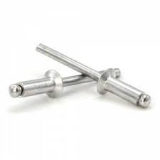
- Screws
The part of a screw are:
- The Head-This gives the screw its name, such as round head, countersunk and raised head.

- The shank-The body of the screw which is threaded to a point for – about two thirds of its length.

- The shank determines the thickness of the screw.

- The thread- The spiral groove, which draws the screw into the timber and provides its holding power.

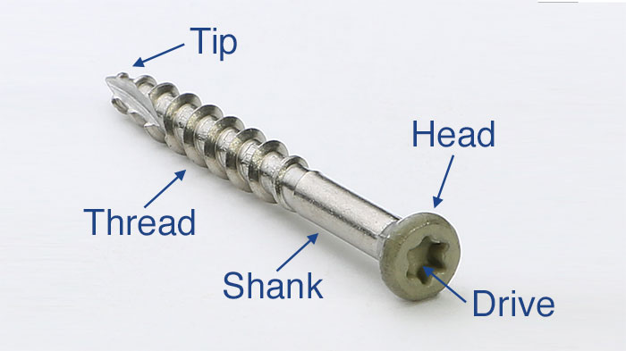
ACTIVITY
- State an advantage of straight stay

- Identify the types of castors

- How are knobs attached to doors & drawers?

- Name the types of nails

- Name the parts of a screw

WORKSHEET
1. Name the following

