RATU NAVULA COLLEGE
YEAR 11 NOTES AND ACTIVITY 2021 – WEEK 5
AGRICULTURAL SCIENCE
LESSON 48: NATURAL AND ARTIFICIAL VEGETATIVE METHOD OF PLANT PROPAGATION
LESSON OUTCOME: Distinguish among and explain natural vegetative propagation and artificial vegetative propagation methods
Natural vegetative propagation methods
Method | Propagation | Examples
Vegetative propagation by roots | Swollen tap root  -a primary root that grows vertically downward and gives off a swollen lateral roots | Carrot, raddish, turnip
 | Adventitious root  -aerial roots that arise from a stem or trunk, penetrates the soil. | Asparagus, sweet potato, yam, dahlia etc
Artificial vegetative propagation methods
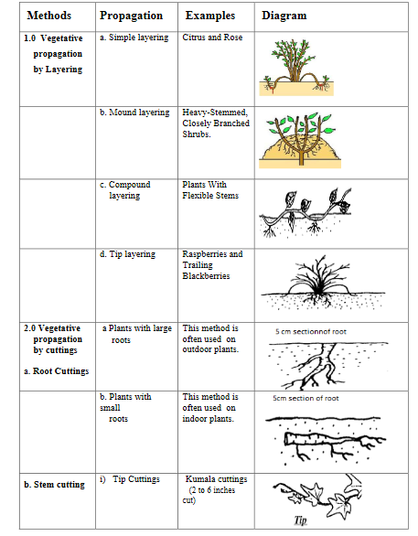

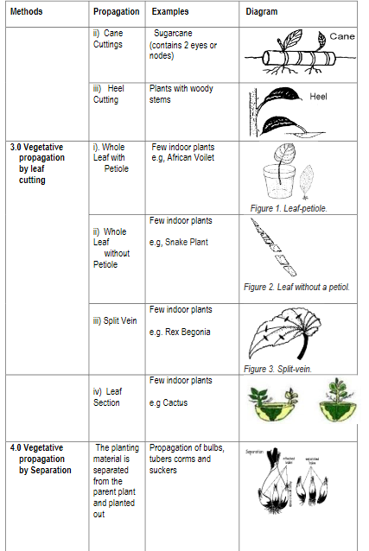

LESSON 49: MICRO PROPAGATION (TISSUE CULTURE)
LESSON OUTCOME: Describe tissue culture

Protoplast – the colorless material comprising of the living part of the cell
Aseptic – free of pathogenic microorganisms
Callus culture – a growing mass of unorganized plant cells
Explant – pieces of tissue or organ removed from a plant

What is micro propagation?
- It is a method of producing a large number of plants from a small piece of plant tissue or cells cultured in a nutrient medium.
- The aseptic culture of plant protoplasts, cells, tissues or organs under condition which lead to cell multiplication or regeneration of organs or whole plants.

Steps in micro propagation
Step 1: select planting material
- Choose healthy plant with desired characteristics eg. Axillary bud
Step 2: Initiation stage
- The explant is extracted from the planting material chosen under sterile condition. The tissues are placed in a nutrient medium with disinfectant solution for a period of time. Alcohol. Bromine water, silver nitrate can be used as disinfectant.
Step 3: Multiplication stage
- The explant is placed in a growth medium which help to undergo rapid tissue multiplication and formation of a callus.
Stage 4: Rooting stage
- The callus is divided up and provided with a different growth medium to induce root formation
Stage 5: Acclimatization stage
- Transfer of growing plants to potting medium for growing out and hardening.

Advantage and disadvantage of micro propagation
Advantages | Disadvantages
Produce large number of plants in a short time | Requires sophisticated facility / lab
Produce disease free plants | Requires skilled people
A method that use a small explant from a plant to mass produce plants | High production and maintenance cost

Activity
- Describe how tissue culture is done.
- List three advantages of tissue culture.

LESSON 50: OVERVIEW OF LANDSCAPING
LESSON OUTCOME: Explain, identify the four main elements of and distinguish among the main types of landscaping.

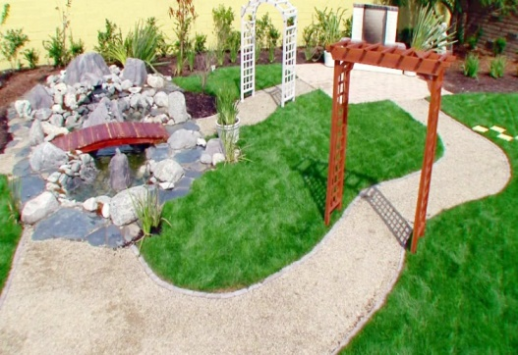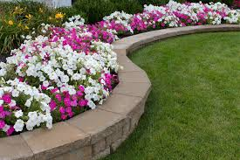

Landscape Architecture - the design of outdoor public areas, landmarks, and structures to achieve environmental, social-behavioural or aesthetic outcomes.

Landscaping - any activity that modifies the visible features of an area of land, including: living elements, such as flora or fauna

Aesthetic - concerned with beauty or the appreciation of beauty. Ornamental - a plant grown for its aesthetic appearance.

The four main elements of a landscape are:

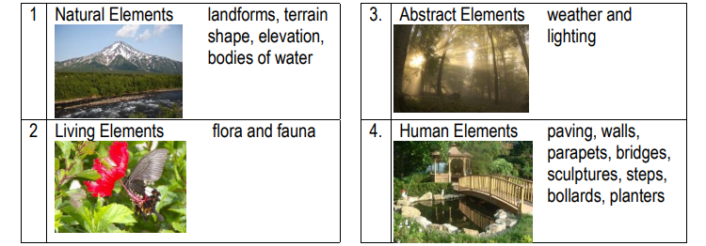

Landscaping is divided into two components which complement each other.

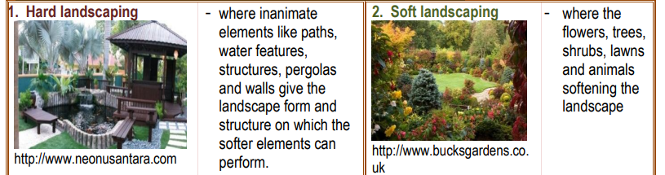

Types of landscaping include :

- Environmental landscaping -which is used for educational, sporting and aesthetic purposes

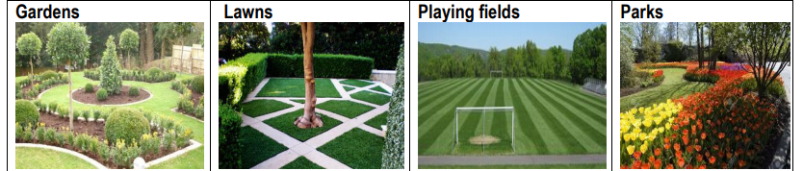

- Residential landscaping - which is meant to improve the area to be lived in by individuals and families.

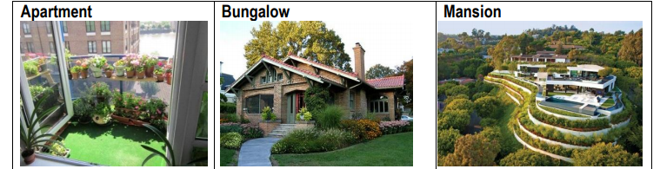

- Commercial landscaping - which involves buildings used for business

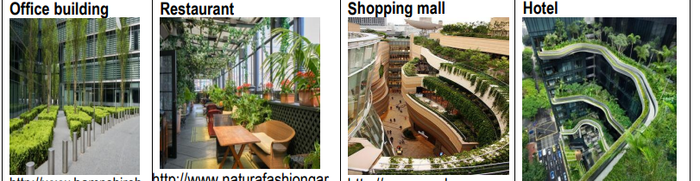

STUDENT ACTIVITY
- Differentiate between soft and hard landscaping.

LESSON 51 : BENEFITS OF LANDSCAPING

LESSON OUTCOME: Discuss the benefits of landscaping.

Conservation - the act of preserving, guarding, protecting or wise use

ADVANTGES OF LANDSCAPING

1. Economic reasons

a) Increases tourist revenue –tourists visit are attracted to landscaped venues and accommodation.

b) Increased property value - a well landscaped garden can increase the value of property.

c) Employment - grounds keeper, landscape planner and maintenance labourer.

- Life style reasons

a) Physical exercise
b) Healthy food
c) Therapeutic – afford patients solace and tranquility and so assist in healing.
d) Privacy – shrubs, trees and buildings provide a private outdoor space for relaxation.
e) Creates outdoor rooms – the relaxed outdoor setting provides a suitable environment for learning, entertaining and exercising.
3. Environmental reasons
a) Protects water quality
b) Improves air quality – plants filter air of impurities.
c) Reduces noise, wind and glare – landscapes can be planned to minimise the effect of pollution including noise, wind and glare from direct and reflected sunlight.
d) Conserves energy-reduce the fluctuations in temperature and keep environment clean.
e) Haven for Wildlife-shelter for wildlife

LESSON 52: LIMITATIONS OF LANDSCAPING

LESSON OUTCOME: Discuss the disadvantages of landscaping.

Site - the location on the surface of the earth.
Investment - time, energy, or matter spent in the hope of future benefits

Disadvantage
1. Requires a lot of time and effort
2. Landscaping is expensive
3. An expert is required to carry out landscaping
4. Wild fire can be a hazard
5. Less attractive due to less range of species
6. hard to find native species

STUDENT ACTIVITY

- Explain why landscaping can be a costly exercise.

- Discuss the disadvantages of landscaping.

