**RATU NAVULA COLLEGE**

**YEAR 11 NOTES AND ACTIVITY 2021 – WEEK 4**

**AGRICULTURAL SCIENCE**

**Lesson 43**: Soil Consistence

**Learning Outcome**: Define soil consistence and discuss factors that influence soil consistence

***Cohesion***: attraction of one molecule to another of the same type

***Adhesion***: attraction of molecules of different types

***Plasticity***: ability to be molded

**What is soil consistence?**

It is the ability of soil particles to stick together (cohesion) or to stick to other objects (adhesion). It is the measure of mechanical strength of soil.

Soil consistence indicates three things:

* Amount and type of clay material
* Condition of tillage
* Potential for compaction

**What influence soil consistence?**

* Soil texture: the strength of soil increase when there is a lot of clay in it. Sand is very weak.
* Mechanical compaction: soils which are compact have higher consistency. Eg clay soil
* Organic matter content: organic matter is cementing agents that hold soil particles. Soil with more organic matter have high consistence.
* Cementing agents: organic matter, silicate clays, limes (CaCO3) are examples of materials that hold soil particles together.
* Soil density: when density increase strength also increase.
* Water content of soil: dry soil is more stronger than wet soil

**Activity**

1. Differentiate between cohesion and adhesion.
2. Explain the importance of soil consistence.
3. State two factors that influence soil consistence.
4. List three things that soil consistence indicate.
5. Name three cementing agents that improve soil structure.

**Lesson 44**: Evaluating and describing soil consistence

**Learning Outcome**: Discuss how soil consistency is evaluated and described

***Atterberg limits***: basic measure of critical water content of fine grained soil such as its shrinkage limit, plastic limit and liquid limit.

Soil consistence is measured using Atterberg limits. (Albert Atterberg was a Swedish scientist)

He discovered two things:

* When soils have very low moisture, it becomes more solid.
* When there is more or high moisture content, soil and water may flow.

The behavior of soil can be divided into 4 basic types: solid, semisolid, plastic, liquid.

**Soil consistency is evaluated and described for three moisture levels**:

* ***Wet soil***: consistency is identified by its *stickiness* and *plasticity* eg. Non sticky, slightly sticky, very sticky or non-plastic, slightly plastic and very plastic.
* ***Moist soil***: provides a measure of tendency for peds or soil mass to break when pressure is applied. Eg. Loose, friable, firm
* ***Dry soil***: the degree of resistance is related to the attraction of particles to each other. Eg. Loose, soft, hard

**Lesson 45**: Importance of soil consistence

**Learning Outcome**: Discuss the importance of soil consistence

Soil consistence is important because it describes the way in which soil behaves.

Soil consistence affects 5 things:

* Tillage: machines interact with soil as shown below:

|  |  |
| --- | --- |
| **Machine** | **Effect on soil** |
| Moulboard plough | * Causes little shattering * Compact wet soil * May form clay pans |
| Disc plough | * Cause more shattering * Cause less compaction |
| Rotary hoe | * Develops fine soil structure * Causes excess shattering of soil |

* Vehicle and animal movement: if the soil is strong it will be able to handle the weight of vehicle and machines. If is soft, than vehicles may stuck
* Soil water: soil consistence will affect infiltration and percolation. It also determines the water holding capacity of soil.
* Soil productivity: soils with poor consistence have poor vegetation growth eg. Desert
* Structure: strong soils will be able to support the weights of buildings. It also determines the tillage operation to be used in the farm.

**Activity**

1. Discuss three importance of soil consistence.

**SUB STRAND: HORTICULTURE**  **PROPAGATION IN PLANTS**

**LESSON 46: OVERVIEW OF CROP REPRODUCTION**

**LEARNING OUTCOME:** Differentiate between the two types of crop reproduction.

There are two basic forms of reproduction in plants.

1. **Sexual reproduction**
2. **Asexual reproduction: a) Natural vegetative propagation** – which occurs naturally in plants.

**b) Artificial vegetative propagation** – mostly assisted by human intervention.

1. **Sexual reproduction** – production of offspring involving two parents releasing gametes e.g. using seeds.

2. **Asexual reproduction** - production of offspring involving single parent from which the planting material is extracted e.g. stem cuttings.

3. **Gametes** - refers to sex cells released from parents.

4. **Male gametes (plant)** - refers to pollen grains.

5. **Female gametes (plant)** - refers to ovules produced in the ovary.

6. **Pollination** – transfer of pollen grains from anther to stigma of flower by agents of pollination.

7. **Fertilization** - fusion of male and female gametes to form a zygote.

8. **Embryo** - is an advanced developmental stage of cells after zygote formation.

9. **Seed Dormancy** - resting stage of seeds or inactive growth stage of seeds.

**Reproduction in plants**

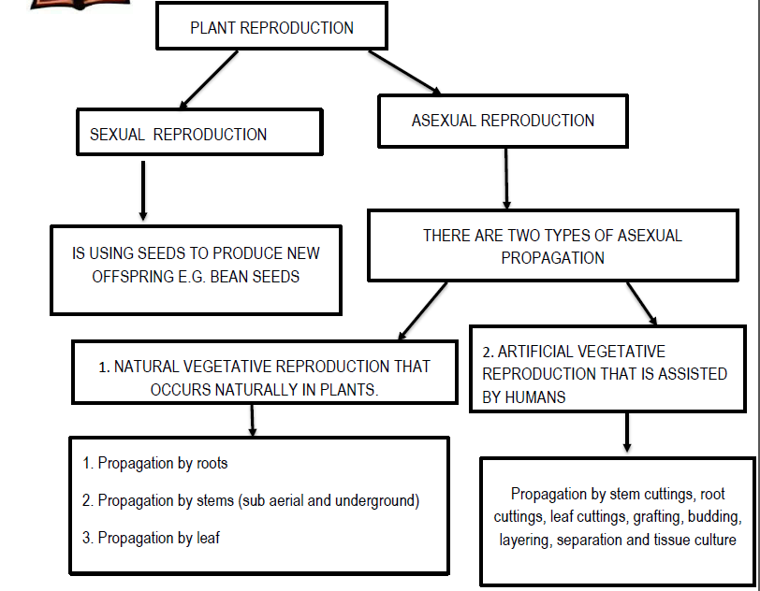

**STUDENT ACTIVITY**

1. Describe the following terms?

a. **Crop Reproduction**

b. **Plant propagation**

2. Differentiate between **Sexual reproduction** and **Asexual reproduction**

3. Differentiate between **Artificial vegetative** propagation and **Natural vegetative** propagation.

**LESSON 47:**  **SEXUAL REPRODUCTION**

**LEARNING OUTCOME:** Describe components of sexual propagation methods.

**VOCABULARY**

1. **Stamen** – male part of the flower

2. **Pistil** – Female part of the flower

3. **Axillary Bud** – (or lateral **bud**) is an embryonic shoot located in the axil of a leaf.

4. **Node** – The part of a plant stem from which one or more leaves emerge, often forming a slight swelling

5. **Prop Roots** – An aerial **root** that arises from a stem or trunk, penetrates the soil, and helps support the plant, as in mangroves. Also called **stilt root.**

6. **Underground stems** – are modified plant structures that derive from stem tissue but exist under the soil surface e.g. bulbs, corms, rhizomes.

7**. Leaf Venation** – The distribution or arrangement of a system of veins, as in an a **leaf** blade

8. **Aestivation** – the arrangement of petals and sepals in a flower bud before it opens.

|  |  |
| --- | --- |
| **Parts of a plant** | **Parts of a simple flower** |
|  |  |

**The Roots**

* main functions
  + absorption of water and minerals from the soil,
  + providing a proper anchorage to the plant parts,
  + **storing reserve food material**
  + **Synthesis of plant growth regulators.**

**What are prop roots?**

* Hanging structures that support a mangrove tree.

What are **stilt roots**.

* The stems of **maize** and **sugarcane** have supporting roots coming out of the lower nodes of the stem.

**The stem**

**Function:**

* storage of food,
* support,
* protection
* vegetative propagation

**Nodes-** The region of the stem where leaves are born

**Internodes**- are the portions between two nodes.

**Underground stems** - are modified to store food in them.

* potato,
* ginger,
* turmeric,
* colocasia

**Stem tendrils**

* develop from **axillary buds**,
* slender and spirally coiled
* Help plants to climb such as in gourds (cucumber, pumpkins, watermelon) and grapevines.

**Terminal bud**

* Primary growing point at the top of the stem of a plant.
* E.g. where a flower opens up on a plant.

Axillary buds of stems may also get modified into woody, straight and pointed **thorns**.

**The Leaf**

* Originate from **shoot apical meristems**. The axillary bud later develops into a **branch**.
* three main parts:
  + **Leaf base-** help hold the blade to light.
  + **petiole**
  + **lamina**/leaf blade- part of the leaf with **veins and veinlet’s**
* Veins provide rigidity to the leaf blade and act as channels of transport for water, minerals and food materials.

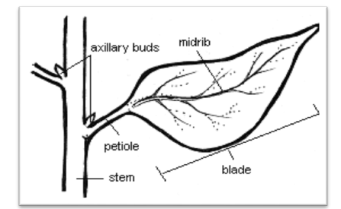

**The Flower**

* Sexual reproduction.
* **Androecium and gynoecium** are reproductive organs.
* When a flower has both androecium and gynoecium, it is called **bisexual**.
* A flower having either only **stamens or only carpels** is **unisexual.**
* **Aestivation:** The mode of arrangement of sepals or petals in floral bud with respect to the other members of the same whorl is known as Aestivation.

**STUDENT ACTIVITY**

1. Differentiate between Axillary Bud and Terminal Bud on a plant?