RATU NAVULA COLLEGE
YEAR 11 NOTES AND ACTIVITY 2021 WEEK 3
AGRICULTURAL SCIENCE
Lesson 39: Soil Structure
Learning Outcome: Define soil structure and describe how soil structure develops.
Soil aggregate: lump of soil particles
Soil ped: permanent aggregate separated from each other by space or cracks
What is soil structure?
It is the arrangement of soil particles and the spaces between them. In other words, it is the arrangement of primary particles including sand, silt and clay into soil aggregates.
Soil also contains pores or air space which is important for the movement of air, water and plant nutrients. It is also important for soil organisms and root growth.
How soil structure develops?
Soil structure is formed or developed through pedogenic (soil forming) process over a long period of time. It involves two steps:
- A clump of soil particles stick loosely together to form soil aggregates. These aggregates are influenced by plant roots, freezing, tillage, fungal activity.
- Weak aggregates are cemented to make them strong. The cementing agents are clay, iron oxides, organic matter and gums produced by microorganisms.

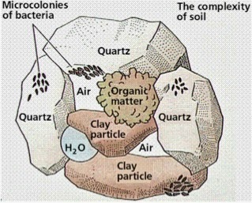

Activity
- Differentiate between soil particle and soil aggregate.
- Define soil structure.
- Discuss how soil structure develops.

Lesson 40: Describing soil structure

Learning Outcome: Discuss how soil structure is described.

Type: the shape or form and arrangement of peds
Class: the size of individual peds
Grade: degree of distinctness of the individual peds

Soil structure is studied in the field under natural condition and is described under three categories: type, class and grade.

- Type: describes the shape or form and arrangement pattern or peds.
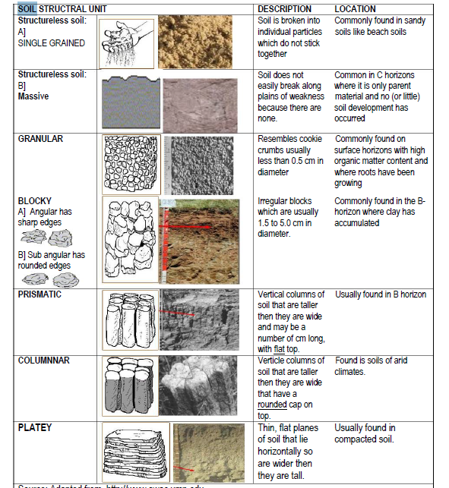

- Class: describes the size of individual peds. Each primary structure is differentiated into 5 size classes.
- Very fine
- Fine
- Medium
- Coarse / thick
- Very coarse / very thick
- Grade: indicates the degree of distinctness of the individual peds. It is determined by the stability of the aggregates. The grade of structure is influenced by moisture content and organic matter content and texture. Four terms are used to describe grade of soil structure:
- Structureless
- Weak structure
- Moderate structure
- Strong structure
Naming structure
For naming soil structure the sequence followed is grade, class and then type.
Example: strong coarse angular block, moderate thin platey

Activity
- Where can you find soil peds with prismatic and granular structure.
- Differentiate between grade and class of soil structure.
- Name two things that influence the grade of soil structure.

Lesson 41: Importance of soil structure

Lerning Outcome: Discuss the importance of soil structure

Soil porosity: the amount of air space in the soil that may contain air or water.

There are two categories of pore sizes in the soil.
- Macropores: large pores or space. More than 0.05 mm. It increases the hydraulic conductivity of soil allowing water to infiltrate and drain quickly. This pore allow eluviation and leaching. It also helps soil organisms and plant roots.
- Micropores: small pores with less than 0.05 mm. water stored in these pores are difficult for plant to use. Usually causes wilting because it may take time to infiltrate and drain out.

Importance of soil structure
Soil structure influences the following factors:
- Soil water - Germination of seeds
- Soil porosity - Root penetration and growth
- Soil aeration - Root access to water and nutrients
- Heat transfer

Activity
- Differentiate between micro-pores and macro-pores.
- List four things that soil structure affects or influence.

Lesson 42: Maintaining and improving soil structure

Learning Outcome: Discuss ways in which soil structure can be improved

Soil structure is easy to maintain then to improve.
Ways to maintain soil structure
- Tillage: know when to till the soil. It is good to till soil when it has proper moisture content.
Tilling soil when it is too wet will destroy soil aggregates.

Methods of tillage. Use tillage methods that will protect soil structure. Examples: zero tillage, strip tillage, mulching, ridging, minimize use of machines because it is too heavy.

- Cultivate only when soil has the right amount of moisture (not too wet)
- Limit traffic and use of heavy machines.
- Heavy machines will compact soil structure

How to improve poor soil or lost soil structure?
- Breaking hard pans (use disk plough)
- Maintain soil fertility
- Add organic matter to the soil
- Grow grass and legumes to cover soil
- Practice crop rotation
- Control soil erosion

Activity
- Explain two ways of maintaining soil structure.
- The soil structure in your farming area is slowly affected. List four ways on how you can improve the structure of the soil.

