RATU NAVULA COLLEGE
YEAR 11 NOTES AND ACTIVITY 2021 WEEK 2
AGRICULTURAL SCIENCE
LESSON 34: SOIL TEXTURE
Learning Outcome: Distinguish between the three soil separates and find out what soil texture is
Soil separates: size divisions of mineral particles in the soil
The mineral matter of soil is made up various sizes.
What are the three soils separates?
- Sand: a naturally occurring granular material made up of finely divided rock and mineral particles. The most common constituent of sand is silica (silicon dioxide SiO2) usually in the form of quartz. Second constituent of sand is calcium carbonate, as found on beaches and reefs.

- Silt: it is a granular material of size between sand and clay. It originates from quartz and feldspar. It is formed from mostly suspended sediments which are deposited at the bottom of rivers. It is non-sticky, plastic feel and usually has a floury feel when dry and slippery when wet.

- Clay: materials formed over a long period of time by gradual chemical weathering of rocks especially silicate-bearing.

Types of clay soils:
- Kaolinite which is mainly used for making seramics.
- Vermiculite mainly used in pot making because it is able to absorb water.
- Smectite known as swelling clay and used in bottoms of ponds.
- Attapulgite normally used in drilling operations.

What is soil texture?
Texture refers to the different sizes of soil particles or separates.

STUDENT ACTIVITY
- Differentiate between the three soils separates.

- Compare the relative size of the three soil separates to rocks, stones and gravel.

LESSON 35: CLASSES OF SOIL TEXTURE

Learning Outcome: Identify the classes of soil texture

Agricultural soils are divided into textural classes according to their physical texture.

Classes of soil texture
- Coarse textured soil: mainly consisting of medium to large size sand particles which includes sand and loamy sand.

- Medium textured soil: made of equal amount of sand, silt and clay which includes loam, clay loam, sandy loam and silt loam.

- Fine textured soil: made up of tiny clay particles which include clay, sandy clay and silt clay.

STUDENT ACTIVITY
- List the classes of soil texture.

- Differentiate among the particle sizes of sand, silt and clay.

LESSON 36: DETERMINING SOIL TEXTURE

Learning Outcome: Practice the determining of soil texture

Gritty: have rough edges and is rough to touch

How can you determine soil texture?
There are five methods to determine soil texture.

- Feel method: suitable for the field. It gives a rough idea of the texture of soil.
How to do it? Place soil on hard surface, add water to make it moist, pick some soil and rub between finger and thumb.

Does it feel gritty? If YES than it is SAND.
Does it feel smooth? If YES than it is SILT.
Does it feel sticky? If YES than it is CLAY.

- Ball throwing method:
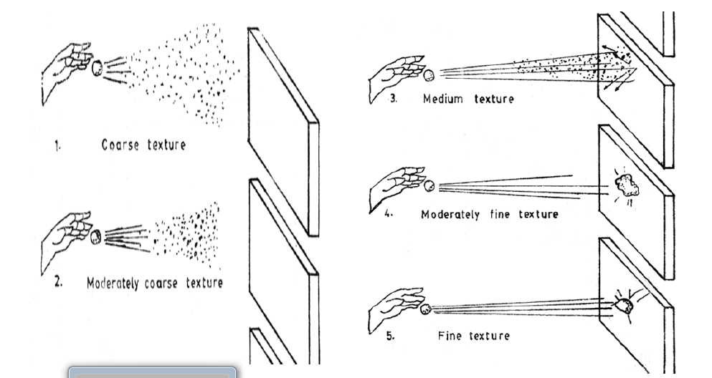

- Ball and ribbon method: how to do it?
- Take some soil and wet it so that it sticks together. Roll a ball of about 2.5 to 3.0 cm in diameter.
- Does the ball fall apart? If Yes than it is sand
- Roll the ball into sausage shape about 6cm long. Does the soil lose its form? If Yes than it is loamy sand.
- Keep rolling the soil. Does it lose its form? If Yes than it is sandy loam.
- Try to bend the sausage into half circle. Does the soil lose its form? If Yes than it is loam.
- Try to bend the sausage to a full circle. Does the soil lose its form? If Yes than it is heavy loam.
- Does the sausage have little cracks? If Yes than it is light clay.
- Does the sausage have no cracks? If Yes than it is clay.

- Pipette method and hydrometer method:
These methods are used to determine the proportions of sand, silt and clay in the soil. The proportions are than plotted in the Soil Textural Triangle to determine the soil texture.
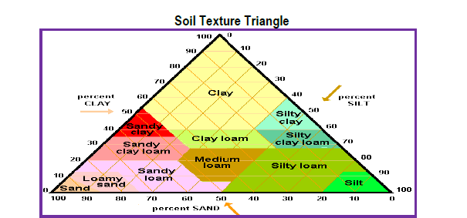
STUDENT ACTIVITY

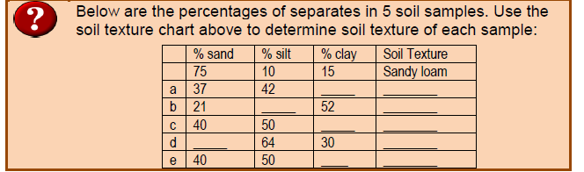

LESSON 37: IMPORTANCE OF SOIL TEXTURE

Learning Outcome: Discuss the importance of soil texture

Infiltration: process by which water on the ground enters the soil
Percolation: movement of water through the layers of soil

Importance of soil texture
- It affects infiltration, percolation, retention and releasing of water to plants
- It affects soil structure. Its development and stability
- It affects nutrient retention and availability
- It affects erodibility by wind and water
- It affects stickiness and ease of cultivation.

Drainage characteristics and suitability for drainage, cropping, temperature changes

Soil texture | Sand | Silt | Clay
Size (mm) | 0.5 – 2.0 | 0.002 – 0.05 | Less than 0.002
Macropores | More | Medium | Less
Medium pores | Medium | Medium | More
Micropores | Less | Medium | Very high
Percolation | High | Medium | Low
Leaching | High | Medium | Low

The table below shows properties of soil high in sand compared to soil high in clay
 | Soil high in sand | Soil high in clay
Water infiltration | Quick entry less run off | Slow entry more run off
Drainage | Drains quickly, more irrigation | Drains slowly, less irrigation
Water retention | Does not hold water for long | Hold more water-water logging
Air content | Air moves easily | Aeration is poor, small pores
Erosion | Easily eroded | Cannot erode easily
Nutrient retention | Cannot hold nutrients | Holds more nutrients
Ease of cultivation | Easy to plough | Hard to plough when wet

STUDENT ACTIVITY
- Discuss why farmers should determine the structure of soil on the farm before deciding which crop to grow.

LESSON 38: PARTICLE SIZE AFFECTS POROSITY AND PERMEABILITY

Learning Outcome: Discuss the relationship between particle size and soil permeability

Porosity: amount or volume of spaces between soil particles
Permeability: ability of air and water to flow between particles
The size of soil particles (texture) affects soil porosity and permeability.

Porosity
- Large soil particles like sand have more spaces so will have high porosity.
- Small soil particles like clay have tiny or small spaces so porosity will be low.

Permeability
Permeability and porosity are directly related.
- Soil with high porosity = high permeability
- Soil with low porosity = low permeability

Infiltration and Runoff
- Soil with high porosity and high permeability, water will infiltrate easily so less runoff.
- Soil with low porosity and low permeability, water will find it hard to infiltrate so there will be high runoff.
- More infiltration is better for the soil.

Activity for soil texture
- Discuss the relation between porosity, permeability and its effect on infiltration and runoff.

- Compare the water infiltration of soil with high sand and soil with high clay.

- List four ways of determining soil texture.

- State the use of the types of clay soils below:
- Smectite

- Kaolonite

- Vermiculite

