**HOME LEARNING KIT SOCIAL SCIENCE – YEAR 10**

**WORKSHEET 3**

**STRAND 2-TIME, CONTINUITY AND CHANGE**

**MULTIPLE CHOICE**

1. Who was in charge of accurately keeping the records of births and deaths

under the 1945 Fijian Affairs Ordinance?

A. The Buli

B. The Turaga-ni-Koro

C. The Council of Chiefs

D. The District Commissioners

2. Which political party has been in existence in Fiji after independence till today?

A. SODELPA

B. Fiji Labour Party

C. National Federation Party

D. Alliance Party

3. The Eve Commission in1957 recommend the?

A. increase in the price of cane

B. abolishment of the indenture system.

C. establishment of the Sugar Advisory Board

D. Establishment of the Colonial Sugar Refining Commission

**II.SHORT ANSWERS**

(i) Explain two duties performed by the Buli under the Fijian Affairs Ordinance in 1945?

(ii) List down the role played by the Provincial Council.

(iii)Name the person that introduced the 1945 Fijian Administration

(iv) Identify two important constitutional change made in 1963.

(v)Name Fijis first Prime Minister.

**RESOURCE INTERPRETATION**

Study the diagram given below and answer the following question

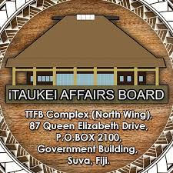

1. Name the person that established the above.

2. Write down one aim/purpose of the Board.

3. Outline two responsibilities of the Board

**PARAGRAPG WRITING**

In a paragraph briefly explain on how Fiji benefitted after gaining independence.

**HOME LEARNING KIT HISTORY – YEAR 11**

**WORKSHEET 3**

**Strand: Government and Governance**

**Sub-strand: Constitutional Development**

**Short Answer Questions**

1. Define constitution and state how constitutions Fiji has had since its independence?
2. Name the person responsible for conducting the first coup?
3. List two impacts of the second coup.
4. Discuss the main purpose of the 1990 constitution?
5. Give four negative impacts of the 1990 constitution of the economy.
6. Define:
7. Common Roll
8. Communal Roll
9. State the current constitution Fiji is following.

State how many constitutions did Fiji have before 1970, state them

**HOME LEARNING KIT GEOGRAPHY – YEAR 12A**

**WORKSHEET 3**

**STRAND: Human Geography**

**Sub Strand: Tourism**

**Definitions**

1. resort
2. tariff
3. charter
4. heritage
5. destination
6. dwell time
7. transit visa
8. long haul market
9. homestay
10. occupancy
11. tour operator
12. honeypot
13. backpacker
14. National Parks
15. domestic tourist
16. duty free shops (stores)
17. visa
18. package tour/package deal
19. souvenir
20. health tourism

**HOME LEARNING KIT HISTORY – YEAR 12A**

**WORKSHEET 3**

**STRAND: Time, Continuity and Change.**

**Sub Strand: International Relations (WW2) (Lesson 31-35)**

**ESSAY.**

Discuss **three** ways the countries represented by the ‘Big Three’

benefited from the Treaty of Versailles.

**The three countries were able to:**

▪ Gain more territories

▪ Maintain their armies and navies

▪ Continue to control their colonies

▪ Build up their industries

▪ Continue to dominate trade

▪ Gain more power

▪ Have defendable borders

▪ Able to satisfy public opinion of making Germany pay

**France:**

▪ To have revenge on Germany for French suffering

▪ To make Germany pay for the cost of damage

▪ To make sure that Germany would never be able to attack France again: take away German land; weaken her industries; reduce her armed forces.

**Britain:**

▪ To end German threat to British navy and empire

▪ To make Germany a non-aggressive country without colonies

**USA**

▪ To prevent Germany from becoming aggressive again

▪ To base the peace treaties on the fourteen points (Victor without vanquish – not to heavily penalized the vanquished)

**HOME LEARNING KIT GEOGRAPHY – YEAR 13**

**WORKSHEET 3**

**STRAND: Physical Geography**

**Sub Strand: Hydrology. (Lesson 37 - 41)**

**Resource Interpretation**

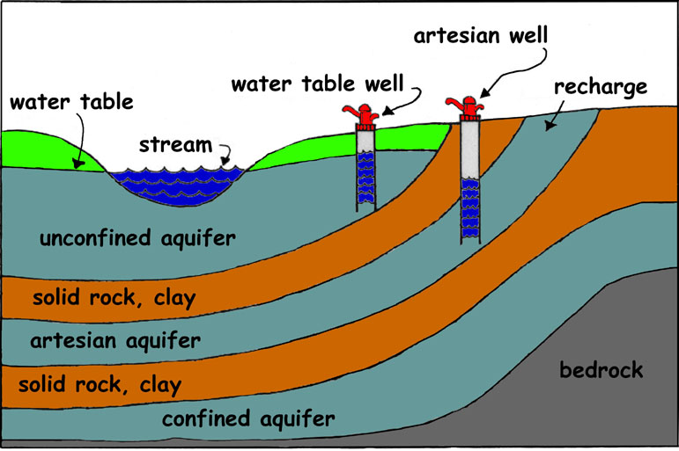

1. Explain what happens to the water table when groundwater is recharged.
2. Differentiate between **confined aquifer** and **unconfined aquifer.**
3. Define **artesian well.**

**Definitions**

1. Aquifer 6. Storm Flow
2. Watershed 7. Lag Time
3. Confluence 8. Tributary
4. Hydrograph 9. Laminar Flow
5. Stream Order 10. Rising Limb

**HOME LEARNING KIT SOCIAL SCIENCE – YEAR 9**

**WORKSHEET 3**

**Strand: Social Organisation and Processes**

**Sub strand: Regional Agency**

1. **MULTIPLE-CHOICE QUESTIONS**
2. The long form of the abbreviation SPTO is  
   A. South Pacific Training Organisation.   
   B. South Pacific Tourism Organisation.

C. Senior Training and Technology Officer.

D. Software Project and Tracking Oversight.

1. The Forum Fisheries Agency (FFA) was established in  
   A. 1977. C. 1981.  
   B. 1979. D. 1983.
2. The Pacific Forum Line has its headquarters in  
   A. Suva, Fiji.  
   B. Apia, Samoa.  
   C. Auckland, New Zealand.  
   D. Honiara, Solomon Island.
3. Which of the following agencies’ enable the member countries to protect and conserve the marine resources?

A. Forum Fisheries Agencies (FFA).

B. The Pacific Forum Line (Shipping)-(PFL).

C. South Pacific Tourism Organisation (SPTO).

D. South Pacific Applied Geoscience Commission (SOPAC).

1. The long form of the abbreviation SPREP is

A. South Pacific Risk Economic Partnership

B. South Pacific Relief and Emergency Program.

C. South Pacific Regional Environmental Programme.

D. South Pacific Research and Educational Programme.

1. Which of the following agencies adopted its present name in 2000?

A. Forum Fisheries Agencies (FFA)

B. The University of the South Pacific

C. South Pacific Tourism Organisation (SPTO)

D. The Pacific Islands Forum Secretariat (PIFS)

**Activity – Paragraph Writing**

In a paragraph, explain what the Melanesian Spearhead Group (MSG) is, when it was established and discuss **three** ways Fiji can benefit by being a member.

**HOME LEARNING KIT GEOGRAPHY – YEAR 12**

**WORKSHEET 3**

**STRAND: Human Geography**

**Sub Strand: Agriculture.**

1. **Resource interpretation - Organic practices**

|  |
| --- |
| * NUTRIENT MANAGEMENT PRACTICES IN ORGANIC FARMING |

1. **State two advantages of organic practices over in organic.**
2. **Describe how it benefits the biodiversity.**
3. **Suggest one way to encourage this among the farmers of Fiji**
4. **DEFINE**
   1. **Hybrid**
   2. **Food security**
   3. **Rotational grazing**

**HOME LEARNING KIT GEOGRAPHY – YEAR 11**

**WORKSHEET 3**

**STRAND: Physical Geography**

**Sub Strand: Soil**

**On the outline map of New Zealand locate and name**

**Use all essentials of map and draw the key**

1. Area of sandy soil in South Island
2. An area of volcanic soil in North Island
3. A region known in the South Island with organic soil
4. A region in the North Island with ulitic soil

