YEAR 10
SOCIAL SCIENCE
HOME LEARNING KIT
WEEK 8
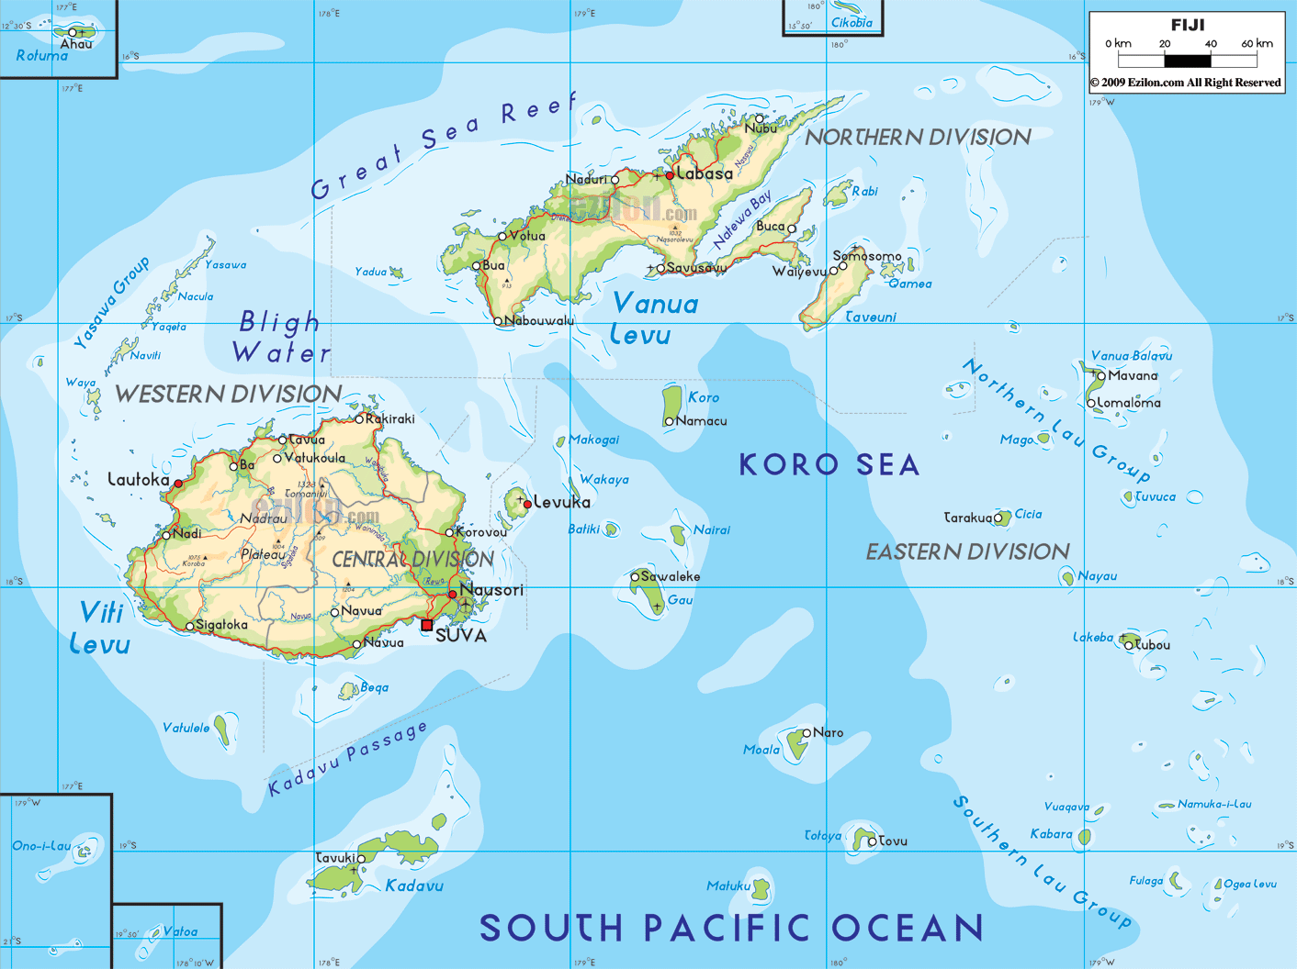
NAME
LEVEL
S/ID

LESSON 48
STRAND: PLACES AND ENVIRONMENT
SUB-STRAND: INDUSTRIES
LEARNING OUTCOME: To identify and appreciate the role and importance of industries in our country.
INDUSTRIES
-Industries cover all forms of economic activity including Primary, Secondary and Tertiary.

Primary-farming, fishing, mining and forestry
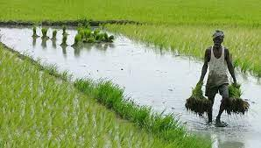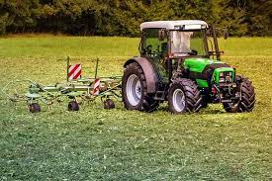

Secondary-manufacturing and construction

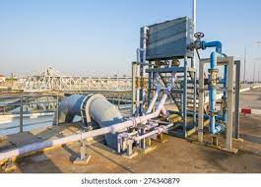

Tertiary-administration, retailing and transport
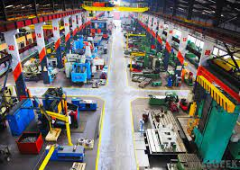

Factors Affecting the Location of Manufacturing Industry
1.Raw Materials
- Industries are located close to raw materials and
- Source of power

2. Power Supplies
  - Oil, coal, natural gas, electricity and hydro electric power

3. Transport
  - Plays a major role in moving raw materials and finished goods.

4. Markets
  - Located near industries.

5. Labor Supply

6. Capital

7. Government Policies

8. Land

9. Environment

CLASS ACTIVITY

1. Define industry
2. Identify the three types of industry.
3.List down two factors affecting the location of an industry.

LESSON 49
STRAND:PLACES AND ENVIRONMENT
SUB STRAND:EXPORTS AND IMPORTS
LEARNING OUTCOMES: To identify the major role of exports and imports in our country
WHAT ARE EXPORTS?
Exports refer to selling of goods and services to overseas countries and earning foreign reserves. Fiji exports sugar, timber, fruits and vegetables, garments, gold, kava, bauxite, copra and coconut oil

WHAT ARE IMPORTS?
Imports are the buying of goods and services and making payments for them. Fiji imports food, beverages, crude minerals, chemicals, manufactured goods, machinery and heavy equipment. Fiji’s major trading partners include Australia, new Zealand, China, France, Japan, Pacific Islands, India Malaysia, Singapore and USA to name a few.

CLASS ACTIVITY
1. Define the two terms (i)Exports (ii)Imports

LESSON 50
STRAND:PLACES AND ENVIRONMENT
SUB-STRAND:IMPORTANCE OF INDUSTRIES
LEARNING OUTCOME: To appreciate the vital contributions of industries in Fiji
WHY ARE INDUSTRIES IMPORTANT?
• Creates employment
• Earn foreign exchange
• Contribute towards Gross Domestic Product
• Leads to development of infrastructure in semi-urban areas
• Multiplier effect – development of other sectors such as transportation, banking, insurance
• Improves peoples’ standard of living
HOW DOES INDUSTRIES AFFECT THE ENVIRONMENT?
•Pollution is the contamination of the earth’s environment with materials that interfere with human health, the quality of life, or the natural functioning of ecosystems (living organisms and their physical surroundings.
•Although some environmental pollution is a result of natural causes like volcanic eruptions, most is caused by human activities.
•Human contamination of the earth’s atmosphere can take many forms and has existed since humans first began to use fire for agriculture, heating and cooking.
CLASS ACTIVITY
1. List down two importance of industries.
2. Briefly explain how industries affect the environment

LESSON 51
STRAND:PLACES AND ENVIRONMENT
SUB-STRAND;POLLUTION
LEARNING OUTCOME; To identify and differentiate the types of pollution in industries
POLLUTION
1.WHAT IS WATER POLLUTION?
- Contamination of water sources
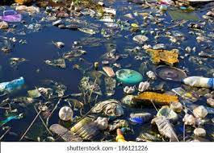
CAUSES OF WATER POLLUTION
- Sewage, industrial wastes agricultural wastes and chemicals are the main causes of water pollution.
EFFECTS OF WATER POLLUTION
- Primary effects of pollution occur immediately after contamination such as the death of marine lives, plants and wildlife after an oil spill at sea or industrial wastes pumped into the water source.

WAYS TO MINIMISE WATER POLLUTION
- Do not dispose household chemicals into water ways
- Do not let water run while washing
- Avid using pesticides

2.What is SOIL POLLUTION?
Harmful wastes polluting the soil
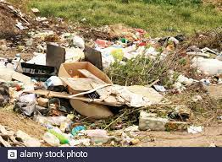
CAUSES OF SOIL POLLUTION
•Treating the soil with chemical fertilizers, pesticides and fungicides interferes with the natural processes occur within the soil and destroys useful organisms such as bacteria, fungi and other microorganisms.
•Solid wastes are unwanted solid materials such as garbage, plastics paper and synthetic materials, metals and wood.
•Areas where wastes are buried are called landfills are the cheapest and moist common disposal method for solid wastes worldwide.

WAYS TO MINIMISE
- Reduce
- Reuse
- Recycle
- Use biodegradable products
- 3.What is Air Pollution?
Air pollution is the presence of harmful gases emitted from factories, cars, burning and etc
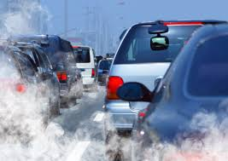
Effects of Air Pollution
1. It is harmful to human health
2. Can damage the eco-system and agricultural crops.
3. It increases daily temperatures creating heat waves and contributing to global warming

Ways to Reduse
1.Reduce carbon emission in the atmosphere
2.Reduse unnecesary burning.
3.Strict laws and regulation to be imposed

WHAT IS NOISE POLLUTION?
•Unwanted sound or noise such as that produced by airplanes, traffic, or industrial machinery is considered a form of pollution.

EFFECTS OF NOISE POLLUTION
•It can cause hearing loss, stress, high blood pressure, sleep loss, distraction, and lost productivity.
WAYS TO MINIMISE NOISE POLLUTION
- Do not listen to loud music
- Avoid unnecessary talking
- Avoid usage of large machines
- Do not beat steel
CLASS ACTIVITY
1.List down the three types of pollution.
2.Identify ways to reduce the three types of pollution

