YEAR 10
SOCIAL SCIENCE
HOME LEARNING KIT
WEEK 7
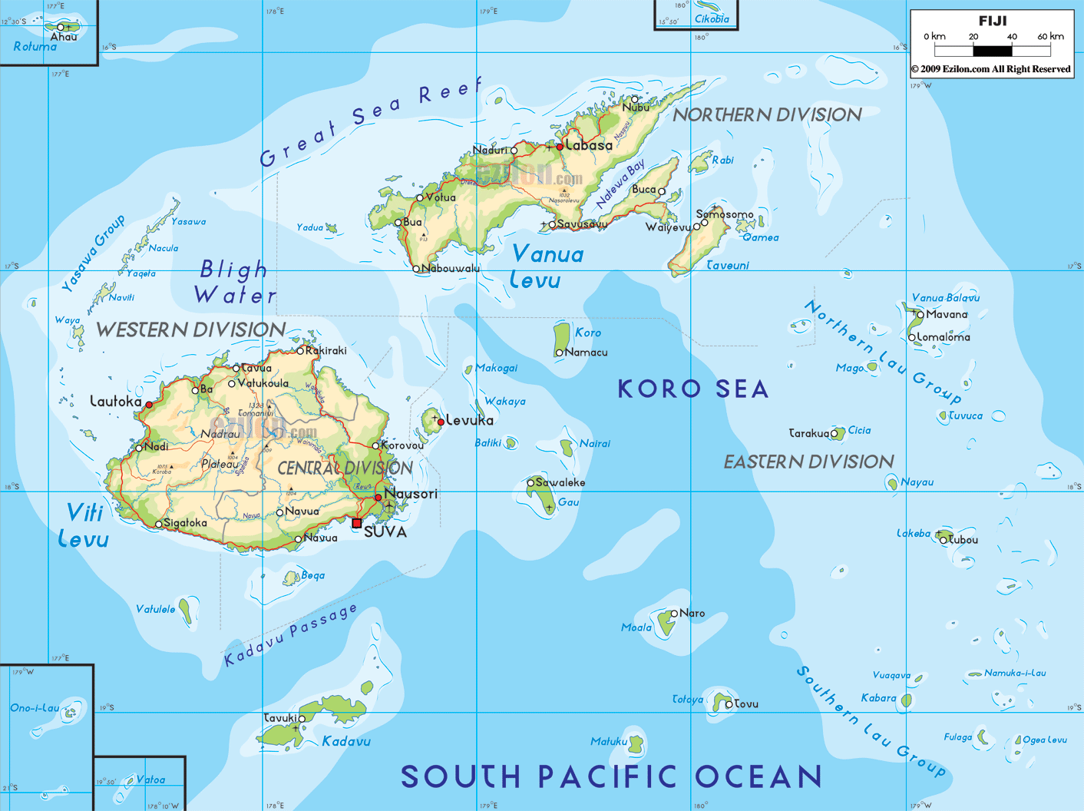
NAME
LEVEL
S/ID

LESSON 44
STRAND:PLACES AND ENVIRONMENT
SUB-STRAND:LANDUSE IN FIJI
LEARNING OUTCOME: Identify the different land use system in Fiji.
LANDUSE SYSTEM
HOW IS LAND USED IN FIJI AND CROPS
The use of land in Fiji is influenced by a combination of factors such as physical and cultural factors.
- Physical factors include relief, climate and soil.
- Social and cultural factors include people’s use of the land (Individual farmers), land ownership and land tenure, transport availability and access to markets, marketing methods, and capital available for development and improvement, market demands and prices.

What are the Physical factors affecting land use?
1. Relief and slope
• Whether the land is high, hilly and rocky or low, flat lands and big plains it will influence the type of crop grown there and how successful a farmer is in utilizing this land.
• Whether it is close or far from the water sources or rivers

2. Climate
• The amount of rainfall and solar radiation it receives
• Regularity(how often rain-falls)
•Seasonal distribution of rainfall (winter and summer)

3. Soil Characteristics
• Red dry and leached soil or dark, humid, rich and alluvial soil.

4. Temperature-warm and cool

5. Other factors
• Sunshine hours.
• Hurricanes
• Floods
• Other climatic extremes

CULTURAL AND SOCIAL FACTORS AFFECTING LAND USE

1. Individual farmers
•This depends on the farmer’s needs, skill and experience

2. Land ownership and type of tenure
•Lease or Freehold

3. Transport Availability and Access to Markets-
• how good are the services by roads, railway, boats and air transport and how near or far the markets are

4. Marketing Methods
• cooperatives
•contracts
• sale to middlemen

5. Capital Available for Development and Improvement
• source of credit and rates if interest(e.g. bank loans)-

6. Market Demands and Prices
• how much is needed and can be sold to make profits
(Both sets of factors are interrelated and other factors could be included e.g. Overseas demand and prices)

ACTIVITY
1.List down the two types of cultural and two types of physical factors affecting land use.

LESSON 45
STRAND:PLACES AND ENVIRONMENT
SUB-STRAND:TYPES OF FARMING
LEARNING OUTCOME: Identify the different types of farming system in Fiji.

THREE TYPES OF FARMING
- Village Farming/Non Village Farming
- Commercial Farming (crops)
- Pastoral Farming
1. Village Farming (Traditional Land use)
•The oldest and most widespread type of farming.
•Is an essential part of the traditional i-Taukei way of life.
Area
•Nearly half the country’s total agricultural land is used for village farming
•Villagers grow crops on land which they do not own(mataqali land)
•Land used is near the villages

Methods of Farming
•Labour or work is shared amongst the villagers
•Permission should be obtained first from the members of the clan (mataqali)
•A persons plot will be scattered, this is to give everyone a share of the fertile land
•The village headman (turaganikoro) let the villagers perform duties (e.g. clearing and planting)
•Farming is mainly subsistence
•Shifting cultivation is widely practiced in most villages (they move from place to place to leave the soil fallow for a while so as to regain its fertility)
•In the interior villages, the soils are not fertile except in the valleys. They practice semi subsistence farming (sell some of the crops in towns to buy clothes, kerosene and other food materials. This is widely practiced nowadays around Fiji as people struggle to buy things to their families’ satisfaction.

Crops Grown
•Cassava-drier infertile soils on hilly areas
•Yams-dry more fertile soils
•Dalo-wetter soil near rivers or the humid soils of the valleys
•Bananas-grows better in cool humid areas(near rivers or humid lowlands)
•Coconuts-coastal areas and reaching up to the hills
•Yaqona-inland where the soil is cool and humid(grown especially for commercial and traditional use)
•Market garden crops for villages mainly close to towns.

Size of the Farm

•Sizes of farms differ from place to place depending on type of farm (subsistence or semi subsistence), type of soil, climate, landform, the influence of different types of people.

NON VILLAGE SETTLEMENTS-(GALALA)
•Villagers who choose not to work under the village system as they establish themselves as individual farmers (galala farmers).

ACTIVITY
1. Name the three types of farming.
2. What are some of the methods of farming practiced in our villages.

LESSON 46
STRAND:PLACES AND ENVIRONMENT
SUB-STRAND: Commercial Farming
LEARNING OUTCOMES: To identify the major contribution and problems faced by commercial farmers
COMMERCIAL FARMING
Below is a table form of crops in Fiji for commercial purpose
CROPS GROWN | AREAS(LOCATION) | PROBLEMS
1.Sugarcane | - Dry parts of main islands(Sigatoka to Rakiraki)  - (exported toUSA,China,Japan,Canada,  Korea) | - Fluctuation of prices  - Strikes(mills and farmers)  - Global Recessions  - Natural Disasters  - Land Tenure
2.Rice | - Both dry rice and wet rice are grown  (dry rice is grown in cane belts/wet rice-wet areas such as Navua,Nausori,Dreketi,Bua)  (Sold locally) | - Uncertain rainfall  - Excessive rainfall(causes flooding)  - Poor drainage  - Pests and diseases
3.Yaqona | - Grown in most islands around Fiji(Kadavu,Vanua Levu,Lomaiviti etc)  - Exported to Europe,USA,Australia and Pacific islands | - Natural Disasters  - Theft  - Drop in world prices
4.Ginger | - Waibau,sawani,Naitasiri | - Erosion  - Drainage  - Pests and Disease
5.Cassava | - All over Fiji | - Market  - Weather conditions  - Fluctuation prices
6.Yams | - Grown anywhere in Fiji | - Climate  - Diseases  - No overseas market
7.Dalo | - Taveuni,Naitasiri,Tailevu,Navua | - Low prices  - Transportation  - Market  - Diseases  - Labourers
8.Bananas | - Naitasiri and along major river system in Fiji | - Flooding/Hurricane  - Market  - Pests/Diseases
9.Pineapple | - Salad Bowl Of Fiji(Sigatoka)  - Seaqaqa | - Diseases  - Markets  - Accessibility to markets
10.Potato | - Nadarivatu,Ra | - Quality is not the same as the imported ones
11.Pawpaw | - Salad Bowl of Fiji | - Climatic Extremes

ACTIVITIES
1.Choose a crop from the above table and write a paragraph on the following headings:
(i)Name of crop (ii)Areas Grown (iii)Problems faced

LESSON 47
STRAND:PLACES AND ENVIRONMENT
SUB-STRAND: Pastoral/Livestock/Poultry Farming
LEARNING OUTCOME: To appreciate and identify the problems faced by the above industries.

PASTORAL/LIVESTOCK/POULTRY FARMING
TYPE OF FARMING | AREAS | PROBLEMS
1.Pastoral | - Yaqara  - Yalavou in Sigatoka  - Uluisavou in Rakiraki | - Poor unimproved grasses  - Land not fenced  - Overstocking resulting in overgrazing  - Diseases
2.Sheep Farming | - Tavua Pastoral farm, Ra | - Lack of capital  - Lack of management skills  - pasture management
3.Goat Farming | - Grazed on all kinds of hilly places(Indo-Fijians) | - No fixed overseas market  For Fiji to import the livestock
4.Dairying | - South Eastern Viti Levu | - Diseases  - Market Demand  - Imported raw materials
5.Pig Farming | - Vuda Piggery | - Feed is too expensive  - Diseases  - No overseas market
6.Chicken/Duck Farming | - Crest Poultry, Ram Sami Poultry | - Diseases  - Shortage

ACTIVITIES
1.Choose a livestock from the above table and write a paragraph on the following headings:
(i)Name (ii) farming areas (iii) problems faced

