YEAR 10
SOCIAL SCIENCE
HOME LEARNING KIT
WEEK 6
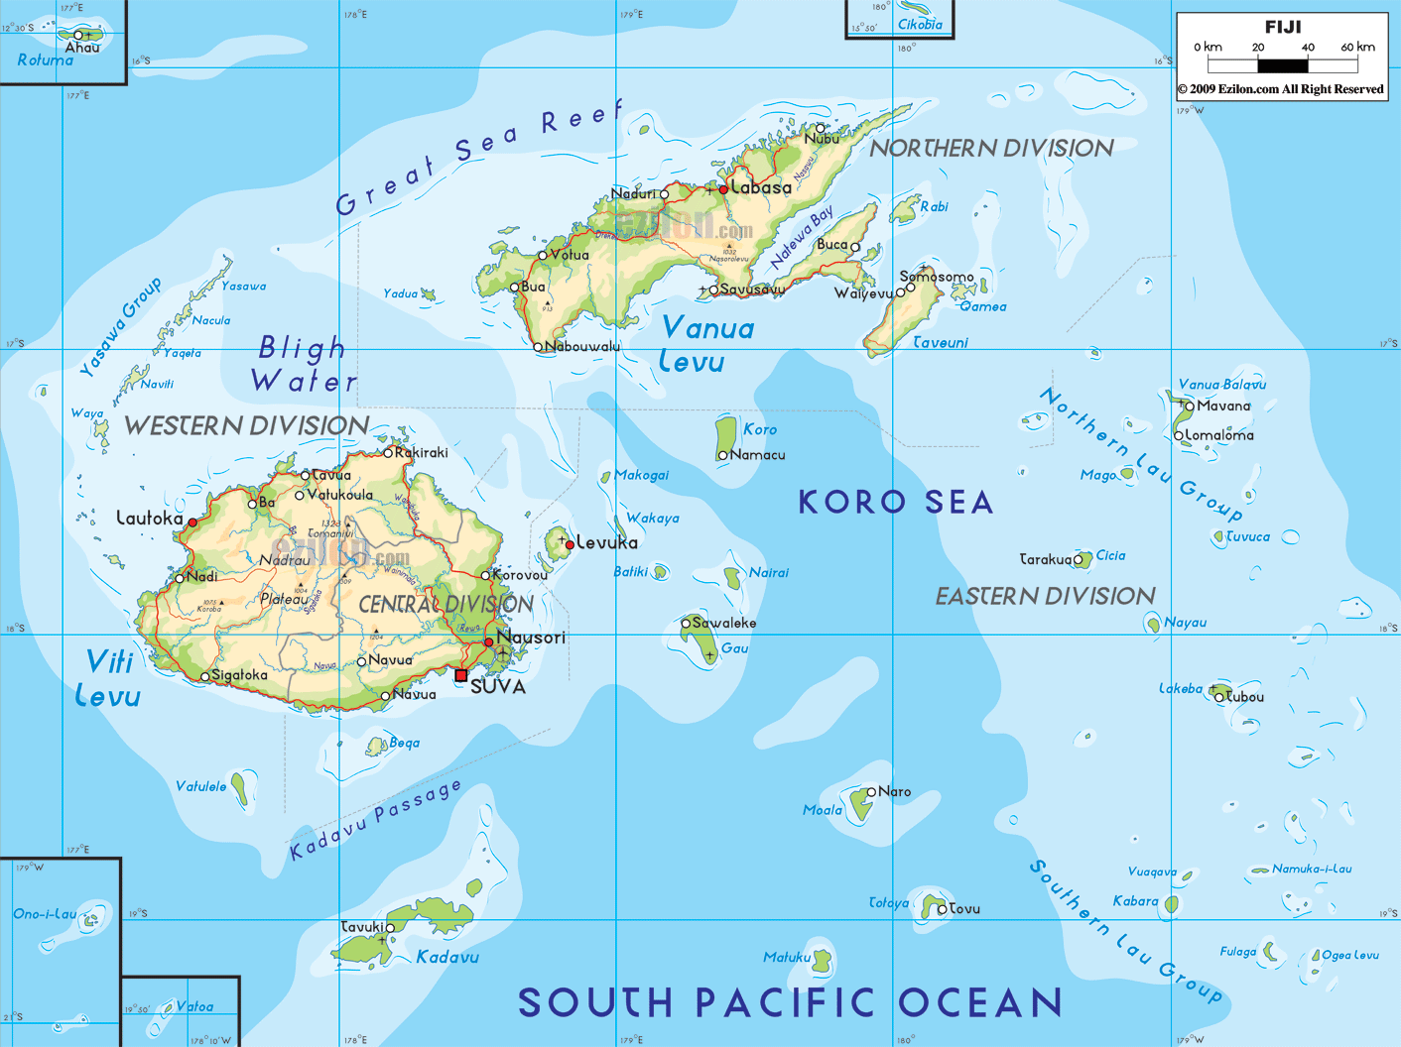
NAME
LEVEL
S/ID

LESSON 40
STRAND:PLACES AND ENVIRONMENT
SUB-STRAND:RAINFALL
LEARNING OUTCOME: Identify the different types of rainfall
RAINFALL
Types of Rainfall
There are 3 types of rainfall:

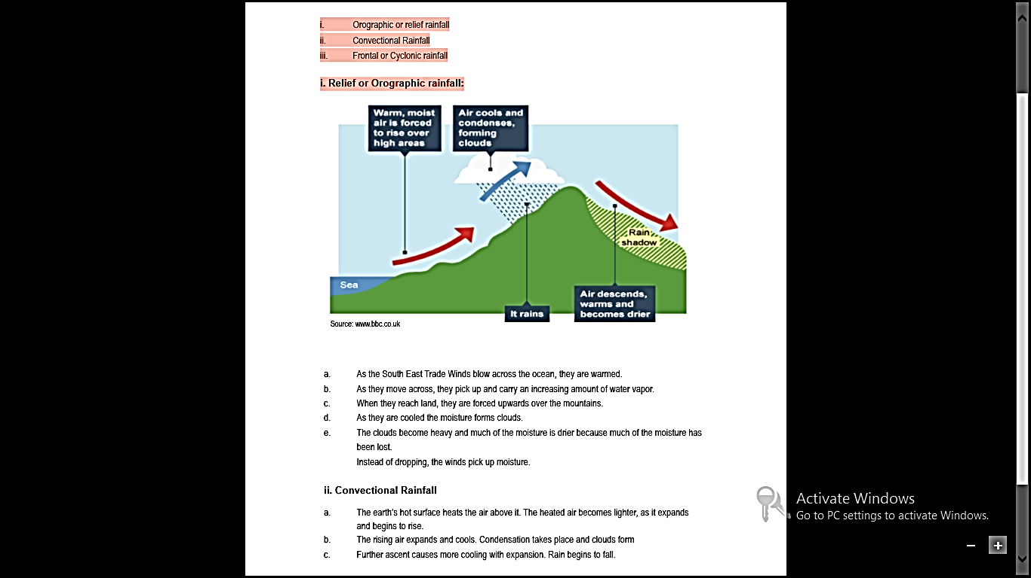

a. As the South East Trade Winds blow across the ocean, they are warmed.
b. As they move across, they pick up and carry an increasing amount of water vapor.
c. When they reach land, they are forced upwards over the mountains.
d. As they are cooled the moisture forms clouds.
e. The clouds become heavy and much of the moisture is drier because much of the moisture has been lost. Instead of dropping, the winds pick up moisture.

ii. Convectional Rainfall
a. The earth’s hot surface heats the air above it. The heated air becomes lighter, as it expands and begins to rise.
b. The rising air expands and cools. Condensation takes place and clouds form
c. Further ascent causes more cooling with expansion. Rain begins to fall.
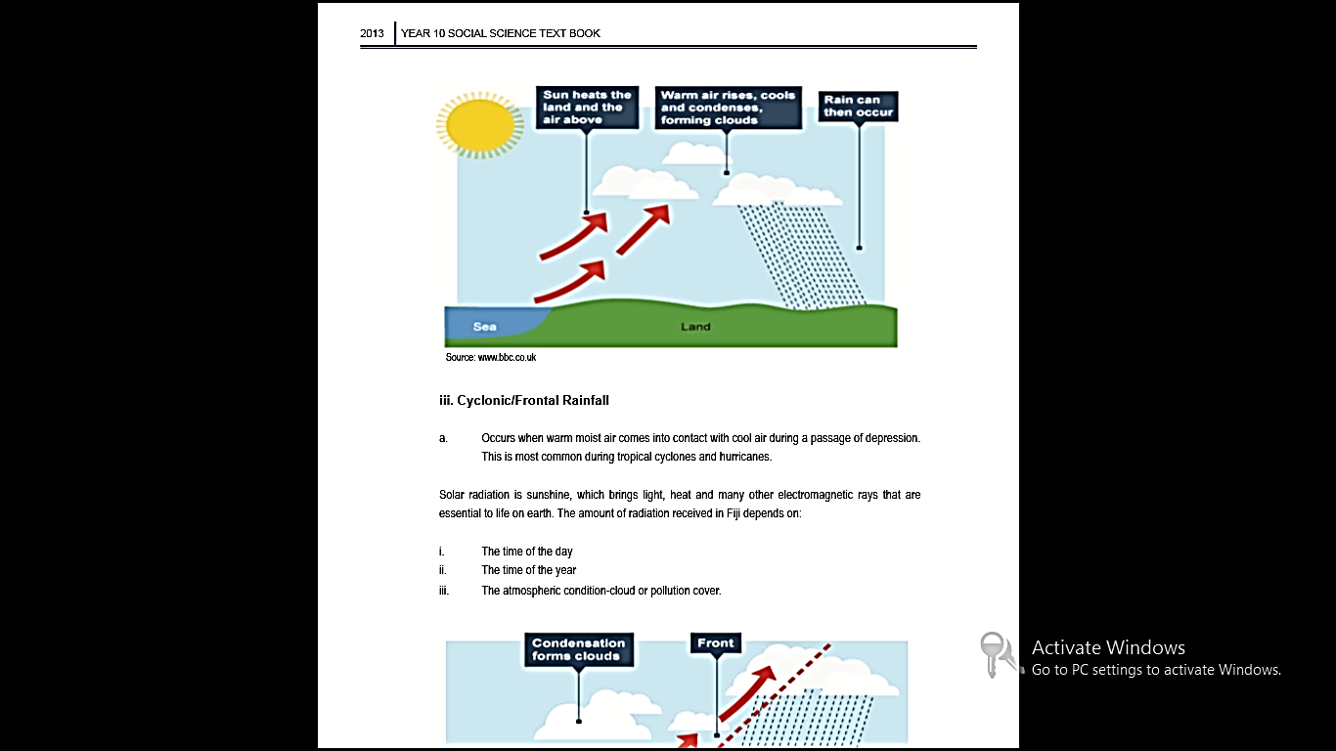

iii. Cyclonic/Frontal Rainfall
a. Occurs when warm moist air comes into contact with cool air during a passage of depression. This is most common during tropical cyclones and hurricanes.

Solar radiation is sunshine, which brings light, heat and many other electromagnetic rays that are essential to life on earth. The amount of radiation received in Fiji depends on:

i. The time of the day
ii. The time of the year
iii. The atmospheric condition-cloud or pollution cover.
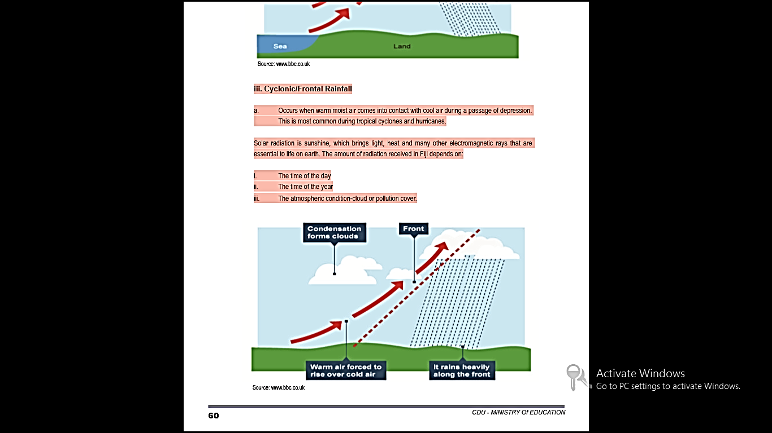
ACTIVITY
1 .Define rainfall.
2. Name the three types of rainfall and explain the difference.
LESSON 41
STRAND: PLACES AND ENVIRONMENT
SUB-STRAND: WIND SYSTEMS
LEARNING OUTCOMES: Identify the different wind systems
WIND
WHAT IS WIND?
Wind is moving air. It is expressed in kilometers per hour and measured with an anemometer. Wind direction is expressed as the compass point from where the wind is blowing. The two Wind Systems reaching Fiji and influencing the climate of Fiji is the South East Trade Winds and the North West Trade Winds.
The South east trade winds being our main prevailing wind system
WHAT ARE WEATHER MAPS?
Anticyclones-Large areas of high pressure shown on weather maps as H. Anticyclones usually bring fine, settled weather. The isobars are far apart.
Depressions-areas of low pressure shown weather maps as L. Depressions usually bring wet, windy weather. The deeper the depression, the more wind and rain it brings. The isobars are closer to each other.

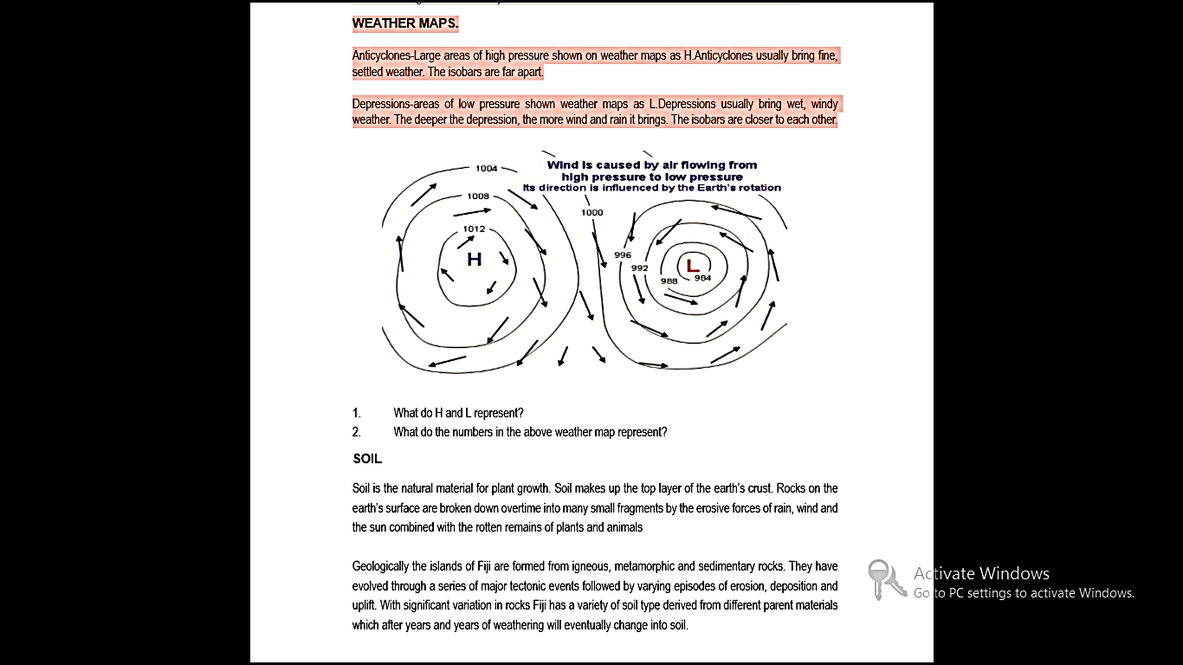ACTIVITY
1. Define wind.
2. Name the prevailing wind systems in Fiji.

LESSON 42
STRAND:PLACES AND ENVIRONMENT
SUB STRAND:SOIL
LEARNING OUTCOME: Identify the different structure of the soil surface
SOIL

WHAT IS SOIL?
- Soil is the natural material for plant growth.
- Soil makes up the top layer of the earth’s crust.
- Rocks on the earth’s surface are broken down overtime into many small fragments by the erosive forces of rain, wind and the sun combined with the rotten remains of plants and animals

- Geologically the islands of Fiji are formed from igneous, metamorphic and sedimentary rocks.
- With significant variation in rocks Fiji has a variety of soil type derived from different parent materials which after years and years of weathering will eventually change into soil.
TYPES OF SOIL IN FIJI
Characteristics | Type | Location
Andosols/ Andisols  - young soils  - formed from volcanic parent material  - well drained  - most fertile | Basalt and Esites | Tavueni
Recent soils  - soil developed from marine deposits  - best agricultural soils  - A-horizon  - Young and fertile | Alluvial soils- from river deposition on flood plains, deltas and banks  Colluvium- soils deposited by surface run-off on lower slope/ valleys | -Rewa Delta  - Navua  - Sigatoka  - Wainibuka  -Yasawa  -Dawasamu
Lateritic soil  - Deep reddish brown in color  - Deeply weathered and soluble minerals have leached out  - Low fertility | Areas with high precipitation | Laucala Island  Koro  Area between Suva and Navua  Naboro  Nabukavesi
Talasiga soil  - Poor soils repeated burning and clearing for long  - Low fertility | Sunburnt soil | Cane grown areas  Nadi, Lautoka, Ba Labasa
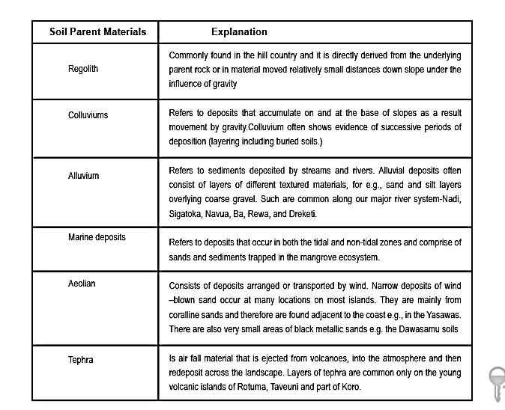

WHAT ARE THE FACTORS AFFECTING SOIL FORMATION?

i. Climate
- The direct influence of rainfall and temperature influence the type of soil the area will have.
- Rainfall is also responsible for the washing out (leaching) of main mineral elements and the movement of clay from soil horizons.

ii. Relief
- The shape of the land (its topography) and in particular its slope or steepness can have a major influence.
- They affect the amount of water available for weathering, leaching out of nutrients and other chemical and biological changes.

iii. Biological Factors
- Biological factors include human activities.
- Plants, climatic elements, organisms all contributes to the type of soil present there.
- Plants provide shade as well as plant litter which will greatly contributes to fertile soil.
- Animals that live in them (earthworms and beetles) as well as those that live on them such as chickens speed up the breakdown of dead plants and mix it with them as well as their droppings.

iv. Time
- The soil type is influenced by the amount of time over which the soil forming processes have been acting.
- Weathering and soil development do not happen suddenly, but gradually over great periods of time.

WHAT IS THE CLASSIFICATION OF SOIL IN FIJI?

Fiji’s soil can be grouped genetically as follows:
- Young sandy soils formed around the coasts of the island-coastal strand vegetation e.g. beach morning glory, (Vunivadra).
- Fertile, deep, agriculturally important alluvial soil occupied the valley bottoms most areas of cash farming.
- Shallow and moderately deep, dark colored nutrient rich soil on rolling and hilly land supporting native vegetation and grassland. • In the drier parts of Fiji the plants found are mostly thin barked with thin green leaves e.g. pine trees and nokonoko.
- In the wet parts of Fiji evergreen trees, fleshy leaves are the most native trees present in the highlands.e.gNamosi, Serua, Naitasiri and Tailevu.
- With some exceptions, Fiji’s soils are of low fertility. The high rainfall washes, or leaches the soluble minerals required by plants from the top layers of the soil.
- In Fiji lateritic soil is common and farmers practice shifting cultivation in order to re gain its fertility.

ACTIVITY
- Paragraph Writing

Throughout history man has been dependent on soil. However, with increasing human activities soil has been degraded.

Write a paragraph on five ways in which soil is degraded.

- Define the following terms
- Aforestation-
- Agro – forestry
- Discuss two ways in which we can conserve soil?
LESSON 43
STRAND:PLACES AND ENVIRONMENT
SUB-STRAND:VEGETATION
LEARNING OUTCOME: Identify the different types of vegetation.
VEGETATION

WHAT IS VEGETATION?
- Fiji shows some of the uniqueness and diversity of the terrestrial biota found in the Pacific.

- Flora (vegetation) is richer too on the main islands but some of the smaller islands also have a number of plats belonging to one family such as the ‘hibiscus tiliaceus’ (vau) and ‘hibiscus rosa-sinensis(senitoa) or hibiscus flower.

What are the major Types of Vegetation in Fij?
Fiji has 11 major types of vegetation
i. Tropical Lowland and rainforest
- Mainly evergreen broadleaf species. Very little undergrowth

ii. Montane or Sub Montaine Rainforest
- Dominated by broadleaved trees. Contains some needle-leaved or small –leaved species e.g. dakua, nokonoko
iii. Riverine/Riparian Forest
- Grow along freshwater streams and rivers. Trees are tall and buttressed e.g. Tahitian chestnut ivi, palms, forbs and broadleaf evergreens are common

iv. Swamp, Bog Forests
- Grow in freshwater or brackish swamps. Mostly buttressed trees also contains palms, sago, pandanus, and vutu species.
v. Seasonal Forests
- Contains deciduous forest and other that are adapted to withstand droughts and fires ( develop very thick bark ) e.g. molau, sacau, nokonoko and cau.
vi. Mangrove Forests
- In tidal rivers,estuaries,bays,muddy/silty ocean shores.e.gmangroves,sagale,pandanus.They are very important in terms of its usage for dyes, firewood, medicine , habitats for animals, crabs and trap silt to build new land, and fisheries as nurseries for fish.
vii. Atoll/Beach
- Strand Forest These are communities of Pan Pacific/Pan Tropical species. For e.g. coconuts, dilo, vutu, tavola, vadra/balawa.
viii. Woodlands
- Grasslands where trees cover at least 30% of the area. They have a broken canopy. There is a dense/thick undergrowth of grass and shrubs.

ix. Savanna/Grasslands
- Found in the drier areas with little and seasonal rainfall e.g. Western VitiLevu and Northern Vanua Levu. Apandanus savanna is found near Deuba.
x. Aquatic Freshwater Vegetation
- Reed swamps, floating plants (water hyacinths)otakarisi and aquatic weeds
xi. Marine Vegetation
- Sea weeds (lumi), algae, sea grasses etc.

What are Endemic plants?
- Plants that are native to Fiji

- Endemism is the process by which a plant is found only in one area and nowhere else in the world.
- Fiji’s endemic plants include the Tagimoucia(Medinilla water-housei) of Taveuni and Seaturamouintains,mama/ lutulutu/ovutu(Macarangamembranacea) of Vanua Levu and Selala(Rhizophoraselala)of the Samabula mangrove forest.

ACTIVITY
1.Define vegetation.
2.Identify the different types of vegetation.

