YEAR 10
SOCIAL SCIENCE
HOME LEARNING KIT
WEEK 5

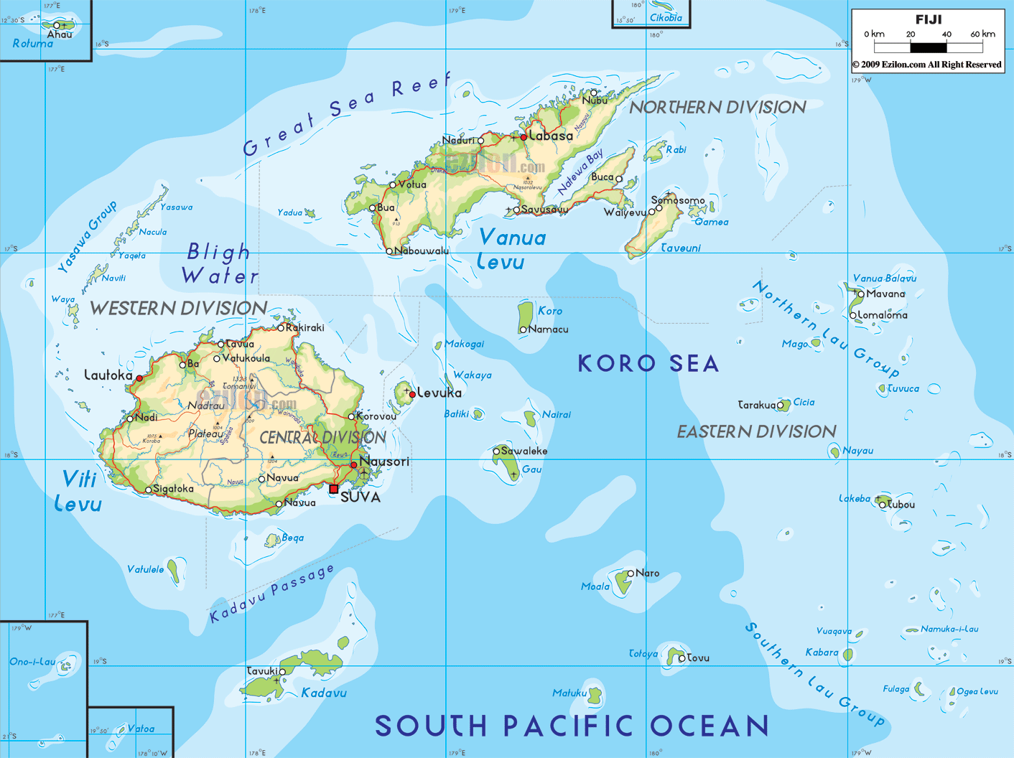

NAME
LEVEL
S/ID
STRAND:3 PLACES AND ENVIRONMENT

GEOGRAPHY OF FIJI

LESSON 36
STRAND:PLACES AND ENVIRONMENT
SUB-STRAND:LOWLANDS
LEARNING OUTCOME: Identify the role played by lowlands in our economy
WHAT ARE LOWLANDS?
- Lowland is limited in area i.e. along valleys and coastal areas
- Viti Levu has broad floodplains and deltas near the mouth of the rivers and along the coast.
- Viti Levu’s lowlands form only a small part of the total land area but they support the bulk of Fiji’s agriculture.
- In Vanua Levu, the lowlands are also restricted and most are found on the northern side where they are broken up into small pockets by ranges of low hills running out to sea.
- The sun burnt plains or the infertile grasslands of Vanua Levu is hot and dry during most part of the year and is called ‘talasiga’.
- Taveuni is called the Garden Island because of the richness of the young volcanic soils and productive plantations (yaqona, dalo and coconut).

ACTIVITY
1. Define lowlands.
2. Explain how low-lying areas in Fiji contributes to our overall economy.

LESSON 37
STRAND:PLACES AND ENVIRONMENT
SUB-STRAND:DRAINAGE SYSTEM
LEARNING OUTCOME: Identify the different types of river system
WHAT IS A RIVER DRAINAGE?
The typical drainage pattern of Fiji is radial drainage, whereby the rivers seem to radiate out like the spokes of a wheel.

PATTERNS OF RIVER DRAINAGE
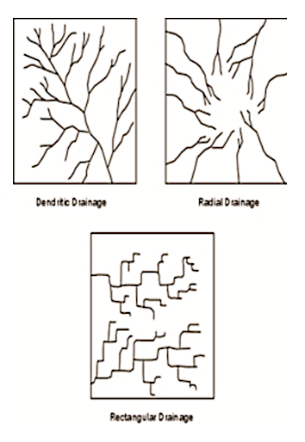

- The rivers flow from the central plateaus in all directions to the coast. The large rivers are fan shaped (many tributaries or streams) collect or meet to form a main stream which then meander across its lowlands to the sea. The main rivers in Vanua Levu.flow swiftly down to the coast because of the steepness of the land
- The three types of river system are dendritic,radial and rectangular..

What is Meandering River Pattern?
- A meander, in general, is a bend in a sinuous watercourse or river.
- A meander forms when moving water in a stream erodes the outer banks and widens its valley, and the inner part of the river has less energy and deposits silt.
- When a meander gets cut off from the main stream, an oxbow lake forms.

THE RIVERS IN FIJI
- Deepest River-Dreketi ( Vanua Levu )
- Widest and largest-Rewa ( Nausori )
- Longest-Sigatoka ( Nadroga )
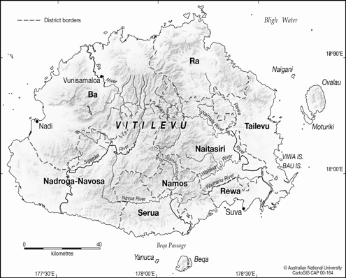 | 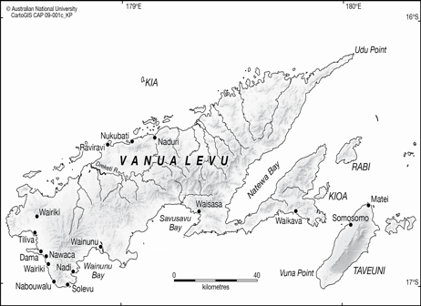

ACTIVITY
1. Identify the three types of river system.

2. Explain how rivers play an important role in a farming system.

3. Name the deepest, widest and longest rivers in Fiji.

LESSON 38
STRAND:PLACES AND ENVIRONMENT
SUB-STRAND:PLATEAUS
LEARNING OUTCOME: Identify the meaning of plateaus.
PLATEAUS

WHAT ARE PLATEAUS?
Plateaus are areas of fairly flat land.
The main plateaus in Fiji are:
i. Muanivatu - 1,131 m
ii. Colo-East - drained by the Rewa River
iii. NavosaPateau - drained by the Ba River
iv. Colo West - drained by the Sigatoka River
v. Navua - drained by the Navua River
vi. Nadrau - cradled between Mt Tomaniivi(1,323 m)

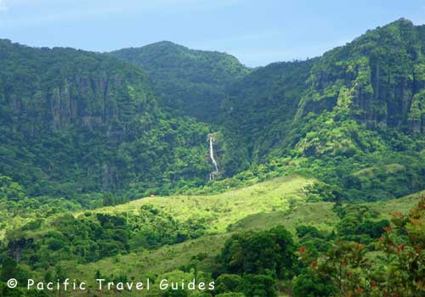
Source: www.beautifulholidays.com.au

ACTIVITY
1. Define plateaus.

LESSON 39
STRAND: PLACES AND ENVIRONMENT
SUB-STRAND: CLIMATE
LEARNING OUTCOME: Identify the types of climate experienced in Fiji.

WHAT IS CLIMATE?
Climate is the average weather condition of a place taken over a long period of time.

WHAT IS WEATHER?
Weather is the average weather condition taken over a short period of time usually within day.

Fiji’s climate
- Fiji’s climate is described as Tropical Oceanic type (in the tropics the islands are surrounded by the ocean).
- The windward sides of the larger islands are wetter and cloudier than the leeward sides.
- The smaller islands have a climate like the leeward sides of the large islands but the temperature range is smaller and rainfall is evenly distributed.

There are 3 types of climate in Fiji;
i) Windward areas (Wet) e.g.-Suva

ii) Leeward areas (Dry) e.g-Lautoka

iii) Smaller islands-evenly distributed rainfall e.g. - Makogai.

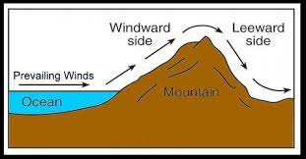

- The climate of the high islands is closely related to the South East Trade Winds.
- The official hurricane season south of the equator is November to April although they can occur in May and October.

WHAT ARE THE FACTORS THAT INFLUENCE CLIMATE?

1. Distance from the equator: (Latitude)
a) Fiji’s location in the tropics gives it ‘high sun’ throughout the year
b) Temperature is usually very high at 77
c) April to November (Winter Season) – the sun is overhead. (hot, dry days and cool nights)
d) Summer season is from November to April (cyclone season). Winds are more variable and the Northerlies in particular bring in heavy rain to the northern sides of the main islands.
e) Convectional rainfall occurs a lot during the summer months because of the greater amount of heat.

2. Distance from the Sea:
• Areas closer to the sea are warmer than those far away.
• These areas will receive more rainfall especially if it is on the windward side of the larger island

3. Insular Nature: (Size of the island)
• The larger islands have a distinct wet and dry climate
• The smaller islands have a more equable climate; evenly distributed rainfall and moderate temperature.

4. Relief
• The mountains of Fiji are not high enough to have snow and frost but are high enough to influence climate
• Their effects bring a distinct wet and dry side

ACTIVITY
1. Define.(i)Climate (ii)weather
2. Name the type of climate that Fiji experiences.
3. Identify the major wind system in Fiji.
4. Name the four factors that determine the climate experienced by an area.

