**YEAR 10**

**SOCIAL SCIENCE**

**HOME LEARNING KIT**

**WEEK 4**

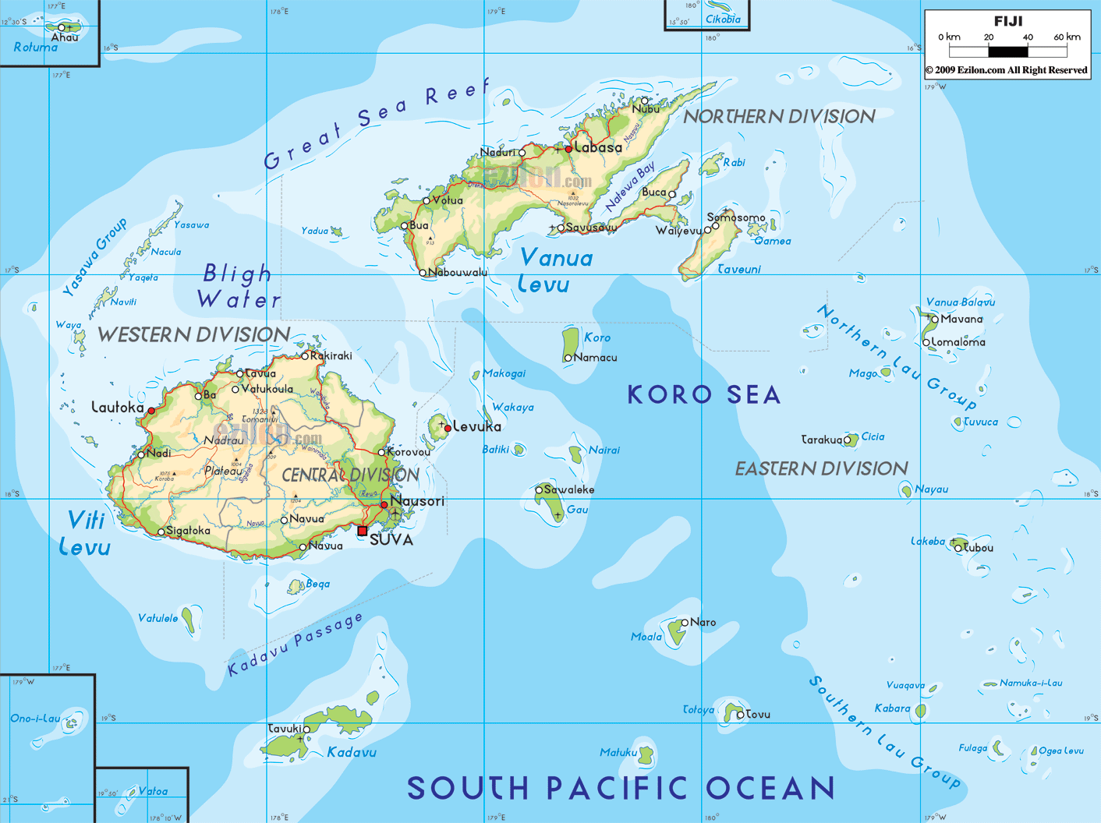

|  |  |
| --- | --- |
| NAME |  |
| LEVEL |  |
| S/ID |  |

**STRAND:3 PLACES AND ENVIRONMENT**

**GEOGRAPHY OF FIJI**

**MAP OF THE FIJI ISLANDS**

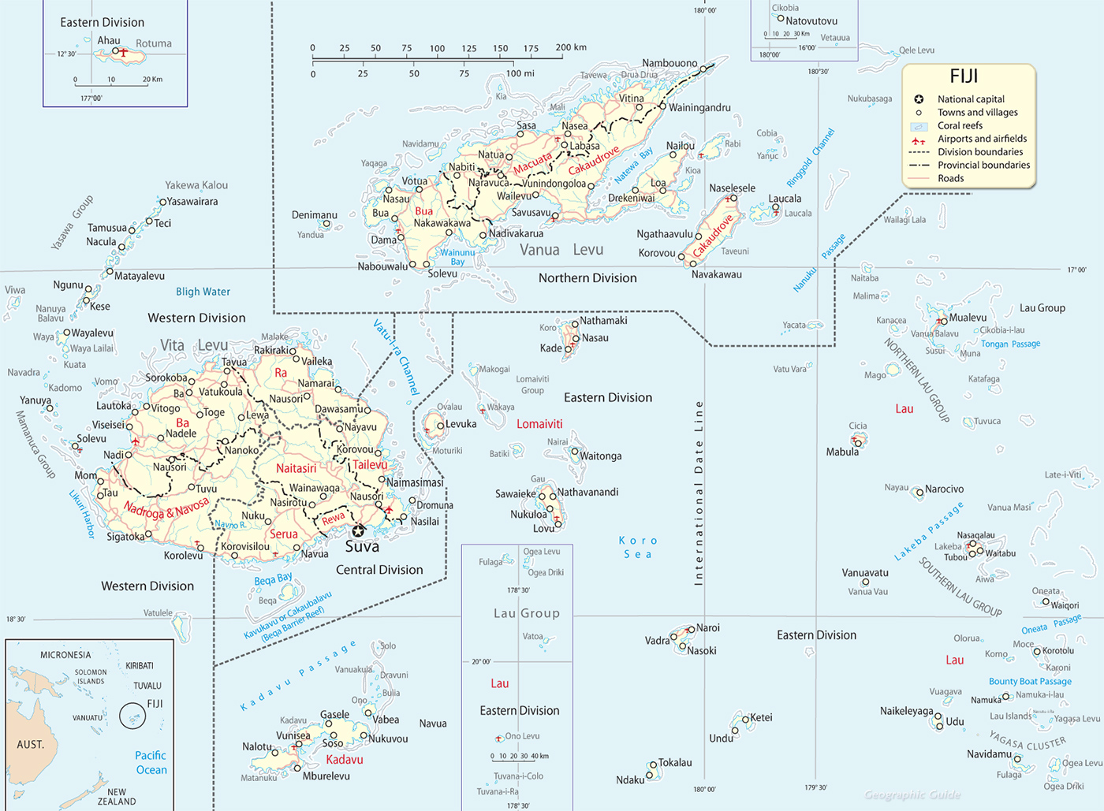

[**http://www.geographicguide.com/oceania-maps/fiji-islands.htm**](http://www.geographicguide.com/oceania-maps/fiji-islands.htm)

**LESSON 32**

**STRAND:PLACES AND ENVIRONMENT**

**SUB-STRAND:RELIEF**

**Learning Outcome: Identify the relief features in Fiji and its location.**

**PHYSICAL GEOGRAPHY**

**WHAT IS RELIEF?**

* Relief is the difference in slope and height of any area of land. The main types of relief features found in Fiji are Mountains, Rolling hill country, Plains, Plateaus, and Rivers.

**WHAT IS FIJI’S TOTAL AREA?**

* Fiji has a total land area of 18,274 square kilometers.
* Nadi is the hub of the Pacific air routes while Suva is a regional centre.
* The 180th Meridian cuts through Fiji but the International Dateline swings east so that the entire group can share the same day.
* Fiji has up to 350 islands.100 islands are permanently inhabited.

**ACTIVITY**

1. Define relief.

2. Describe Fijis location?

3. Identify the total number of islands in Fiji.

4. Explain what you understand by the International Date Line.

**LESSON 33**

**STRAND:PLACES AND ENVIRONMENT**

**SUB-STRAND:TYPES OF ISLANDS**

**LEARNING OUTCOME :Differentiate the types of islands in Fiji and how they were formed.**

**WHAT ARE PLATE TECTONICS**

* The large scale movement of tectonic plates that contributes towards continent drift.
* Fiji is located at the Indo Australian and Pacific plate boundary between two opposite facing sub-duction zones.

.

* The stress created by the opposing plate movements has resulted in the formation of transform faults such as the Fiji **Fracture Zone** to the North and the **Hunter Fracture Zone** to the South**.**

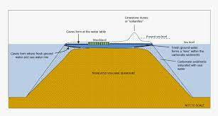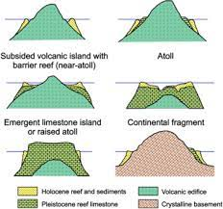

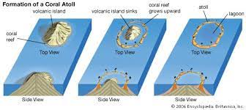

**TYPES OF ISLANDS AND THEIR CHARACTERISTICS**

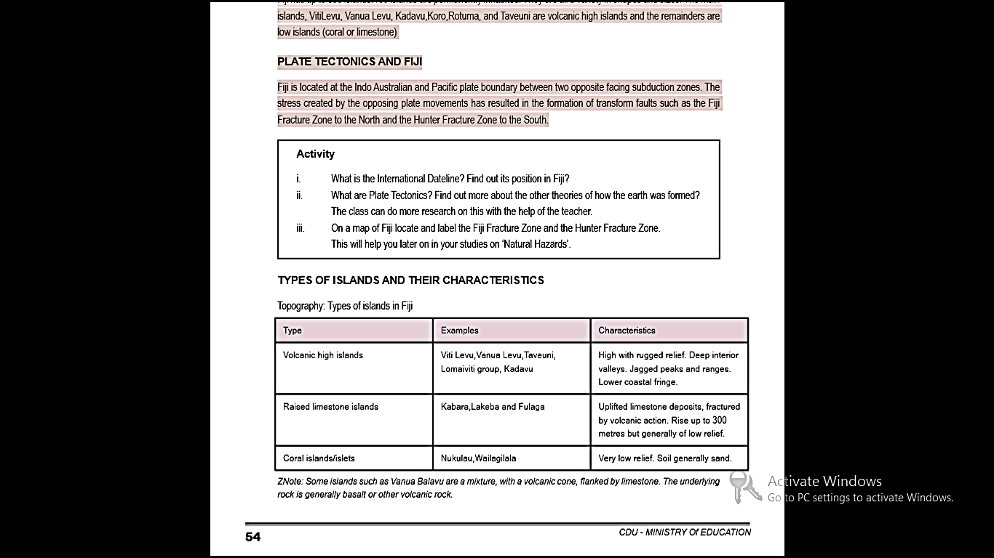

**ACTIVITY**

1. Define plate tectonics?

2.Name the three types of islands and state its features.

**LESSON 34**

**STRAND: PLACES AND ENVIRONMENT**

**SUB-STRAND: REEFS**

**LEARNING OUTCOME: Appreciate the roles played by reefs**

**WHAT ARE REEFS?**

* Is a chain of rocks sand or coral lying near the surface of the water.
* Fringing reefs are common along most of the coastlines and Fiji is outstanding for its many barrier reefs.
* The Great Sea Reef off the north coast of Vanua is the fourth longest in the world and the Astrolabe reef north of Kadavu is one of the most colorful.
* Reefs surround all islands except the Southern half of Taveuni.

The two types of reefs are:

**a) Fringing Reefs**: cover the off-shore plate forms and has little water on them. The area dries up at low tide.

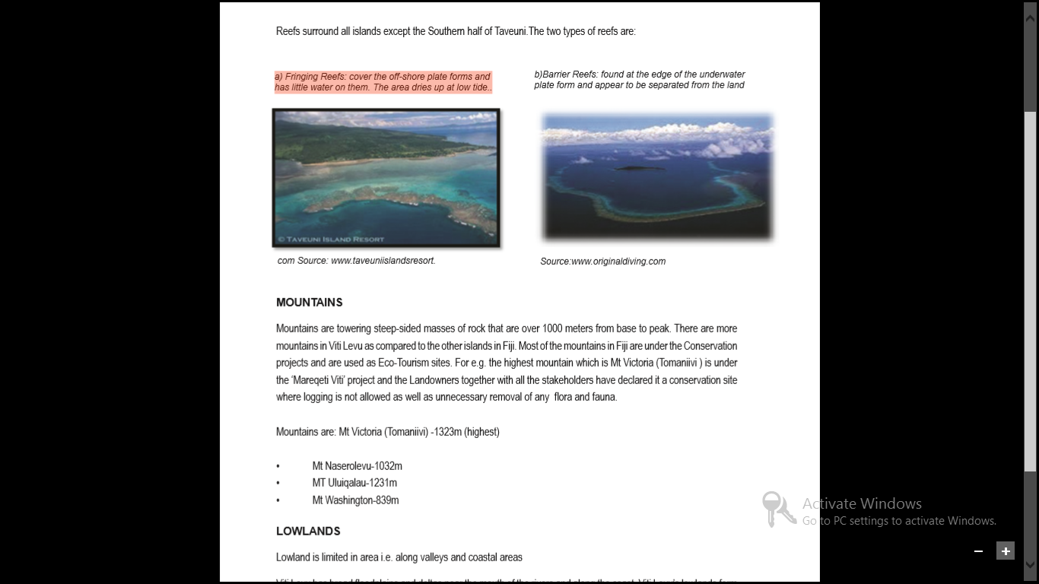

b)**Barrier Reefs**: found at the edge of the underwater plate form and appear to be separated from the land



**ACTIVITY**

1.Define reefs.

2.Name the two well known reefs in the world that is in Fiji.

3.Differentiate between fringing and barrier reefs.

**LESSON 35**

**STRAND:PLACES AND ENVIRONMENT**

**SUB-STRAND:MOUNTAINS**

**LEARNING OUTCOME:APPRECIATE MOUNTAINS BEING ECO-TOURISM SITES IN FIJI**

**WHAT ARE MOUNTAINS?**

* Mountains are towering steep-sided masses of rock that are over 1000 meters from base to peak.
* . Most of the mountains in Fiji are under the Conservation projects and are used as Eco-Tourism sites. For e.g. the highest mountain which is Mt Victoria (Tomaniivi ) is under the ‘Mareqeti Viti’ project.

Some Mountains in Fiji are:

* Mt Victoria (Tomaniivi) -1323m (highest)
* Mt Naserolevu-1032m
* MT Uluiqalau-1231m
* Mt Washington-839m

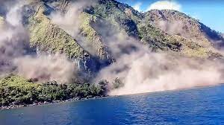 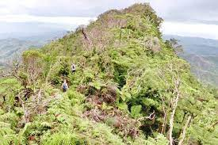

Mt Washington,Kadavu Mt Tomaniivi

ACTIVITY

1.Explain how mountains act as eco-tourism sites.

2.Name the highest peak in Fiji and in the world.