YEAR 10
SOCIAL SCIENCE
HOME LEARNING KIT
WEEK 2

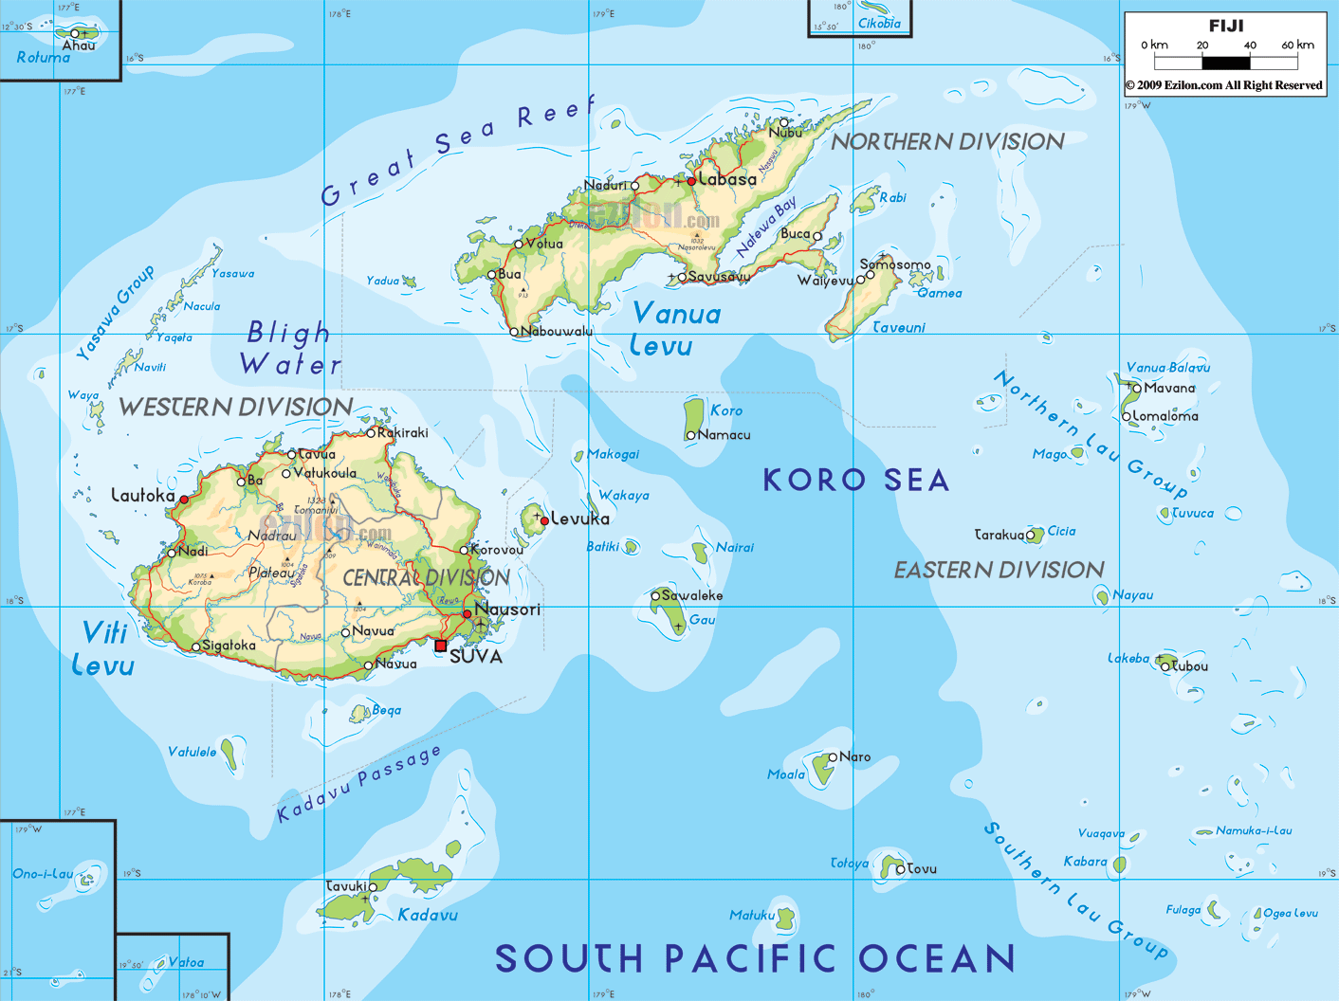 | 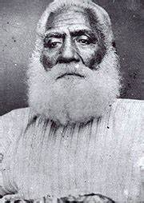
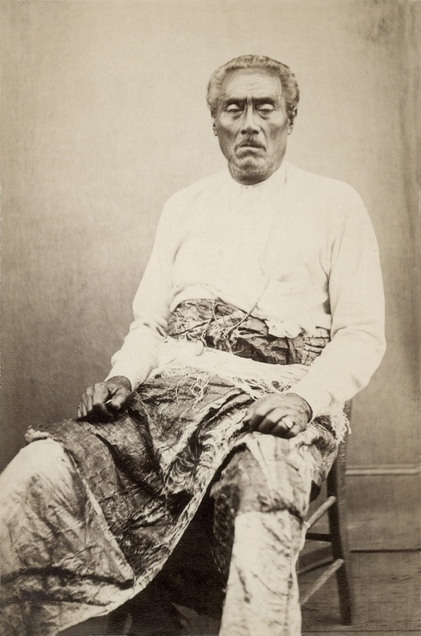 | 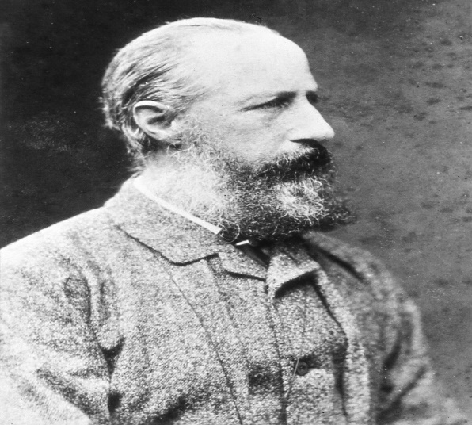

NAME
LEVEL
S/ID
LESSON 24
Strand: Time Continuity and Change
Sub Strand: Sir Author Gordon
Learning Outcome: Identify and Appreciate the work carried out by Sir Author Gordon
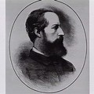
Sir Arthur Gordon
.He arrived in Fiji in June, 1875
.He came to Fiji to be the new/first governor
.He was a strong champion/supporter of native rights
.He was the first person to set up a permanent colonial government

Situation in Fiji
- When Sir Arthur Gordon arrived, he found out that the Fijians and Europeans were in poor spirit.
- Epidemic of measles had killed approximately ¼ of the whole population.
Why Fijians and Europeans were in poor spirit?
- Because many tribes thought that the diseases were introduced by the Europeans in order to destroy them that is why there was ill feeling amongst the tribes.
Problems faced by Sir Author Gordon
Problems | Solutions
- The uprising of mountain people in Sigatoka Valley.  - They had attacked Christian Fijian villagers, murdering and eating inhabitants | - Gordon maintains and controlled them  - Gordon successfully defeated and punished several leaders
- Issue of Land  - There were problems in ownership of land and land that were unfairly bought. | - A Land Claims Commission was set up in 1875 to examine claims.  - Purpose – to investigate that all the land was fairly bought and sold.  - Europeans were required to prove that the land that was bought by them was fairly bought.  - All land became Crown Land (owned by the state or government) unless occupied by a chief or tribe.  - “Gordon believed that if you separate them from their land, the race will die out”.
- Tax Problem  - People were against the old poll tax set by Cakobau. | - It was replaced by a new form of tax.  - Roko collected produce from the people and sold it to pay the government the amount of tax due.  - The balance was returned to the people.
- Labour Problem  - After cession, labour traffic was stopped which led to labour shortage. | - Sir Author Gordon decided to bring Labourers from other countries  - When sugarcane planting started, Labourers were bought from India under the Indentured labour System.
Governor Gordon’s Two Main Views on Native Policy
1. Fijians (now known as I-taukei) should be treated according to their ancient traditions and customs.
2. Fijians (now known as I-taukei) should be encouraged to take part in their own government.
Activities
1. State the year Sir Author Gordon arrived in Fiji?
2. State two problems faced by Sir Arthur Gordon.

LESSON 25
Strand: Time Continuity and Change
Sub Strand: Fijian Administration After Cession (1876)
Learning Outcome: Identify the purpose of the Administration
Native Affairs Ordinance on 1876
The following work was carried out under this body;
- District and Provinces had Councils
- The Council of Chiefs represented the whole colony.
Official Appointed
- Village – Turag-ni-koro
- District – Buli
- Province – Roko
Set Up
Governor

Council of Chiefs

Native Regulation Board

Province (Roko)

```
Village (Turaga-ni-koro)
District (Buli)

ACTIVITIES
1. Who established the 1876 Native Affairs Ordinance?
2. Who looks after the following: (I) Province (ii) District (iii) Village
LESSON 26
STRAND: SOCIAL ORGANISATION AND PROCESS
SUB-STRAND: INDENTURE SYSTEM
LEARNING OUTCOME: Appreciate the work carried out by indentured labourers
INDENTURE SYSTEM
INDENTURED LABOURERS IN FIJI
- Governor Gordon faced the problem of shortage of labourers and imported Indian labourers to come and work in Fiji
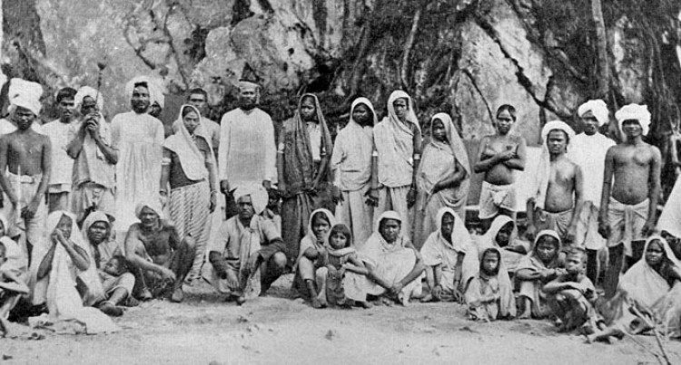
Source: http://girmitiya.girmit.org/new/index.php/dt_gallery
TERMS OF THE INDENTURE SYSTEM
- The Indians had to sign a contract from 5 years to work in Fiji
- After 5 years they were free to return to India at their own expense.
- If they wanted to stay for another 5 years then the government would pay for their return fare
RECRUITMENT
- Many Indians signed up signed up the contract for this reasons:
1. They thought Fiji was in India.
2. They wanted to escape poverty, the law and family problems.
3. Others were kidnapped and fooled to sign the contract (60,500 signed up the contract)
4. May 14th, 1879,498 Indians boarded the ship, Leonidas. About 17 died on the ship due to diseases.
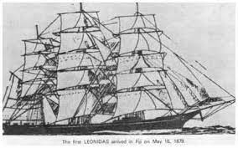
Source: http://girmitiya.girmit.org/new/index.php/dt_gallery
The system in practice
- Once in Fiji the Indians lived in barracks
PROBLEMS FACED BY INDIANS
- All eating, sleeping and cooking was done in one room
- There was no privacy and rooms were overcrowded
- High crime rate
- Rumors, accusations, jealousy and fighting was common
- The children were not educated
- Lack of medical care led to high death rate
- The pressure of life resulted in suicide
CLASS ACTIVITY
1. Define the term indenture system
2. List down two reasons why most Indians accepted the offer to come to Fiji.
3. Identify the person that brought Indians from India.

LESSON 27
STRAND: SOCIAL ORGANISATION AND PROCESS
SUB-STRAND: INDENTURE SYSTEM
LEARNING OUTCOME: Identify how work was carried out during the system
TASK SYSTEM
- Was where certain task was assigned to the workers before nightfall? Failure to complete the task meant no wages for the day’s work.
EFFECTS OF THE INDENTURE SYSTEM
1. BREAKDOWN OF THE TASK SYSTEM
- People mixed around with each other and worked together in farms. Inter-marriages (marriage with other cast members led to the breakdown of the system)
2. PROSPERITY
- THE Indians labourers were given regular wages and food and shelter. Many farmers became prosperous and used their money to invest in Fiji.
THE END OF INDENTURE SYSTEM
- In 1912 a missionary J. S. Burton wrote a book outlining the abuses of Indenture system and made a plea for better treatment
- 1915,C.F. Andrews and W.W. Pearson were sent to Fiji to investigate the situation. In their report they wrote about the SOCIAL EVILS OF THE SYSTEM which made the Indian government to stop all recruitments by 1916
- 1920-all indenture contracts were cancelled
CLASS ACTIVITY
1. Explain the task system
2. Name the two officers sent to investigate Fiji’s situation regarding the indenture system.
3. Identify one effect of the system

