YEAR 10
SOCIAL SCIENCE
HOME LEARNING KIT
WEEK 1

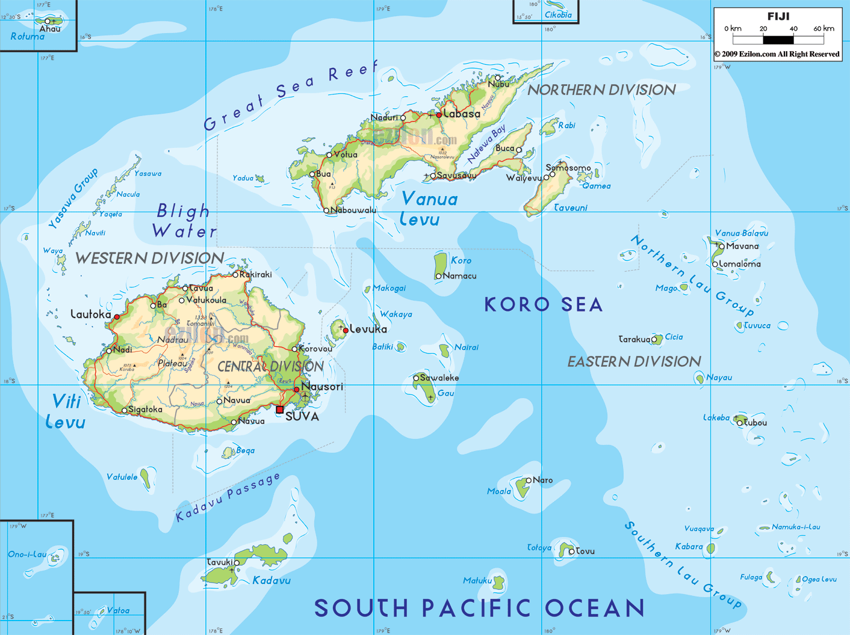 | 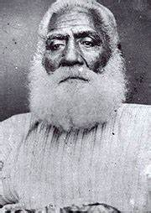
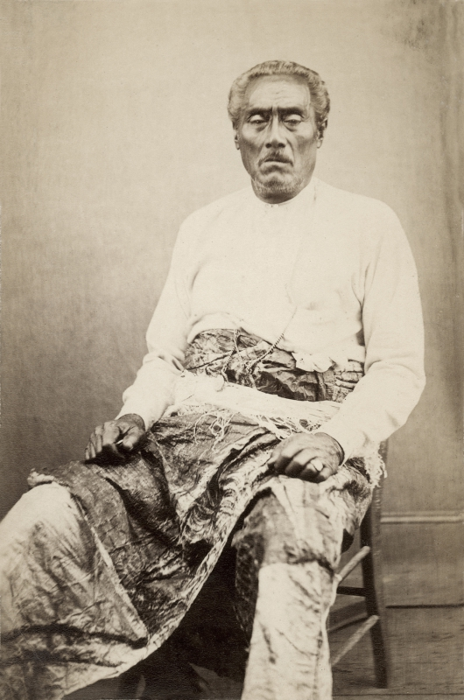 | 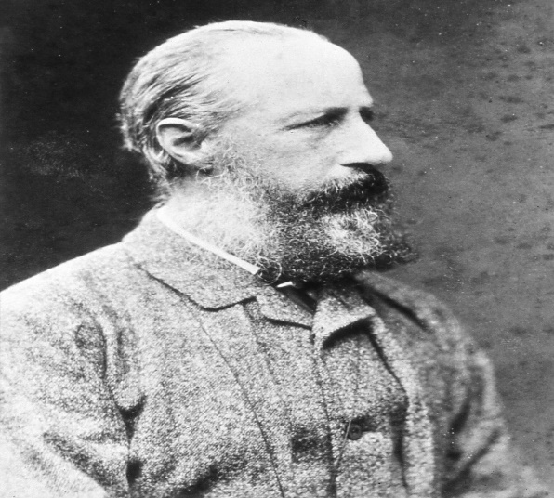

NAME
LEVEL
S/ID
STRAND 2-TIME, CONTINUITY AND CHANGE
LESSON: 20
Strand: TIME, CONTINUITY AND CHANGE
Sub-Strand: From Cession to Independence (History of Fiji)
Learning Outcome: Identify the reasons why Fiji was ceded to Great Britain
What led to Cession in 1874?
The first offer
- it was made in 1875 by Cakobau
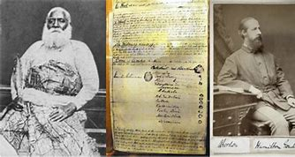
Reasons for the first offer
- Because of Cakobau’s inability to pay American debt of $45000.
- Because of Cakobau’s fear about Ma’afu’s growing power.
Note
In the first offer Cakobau laid two conditions:
- He be allowed to keep the title as “Tui Viti”.
- British Government to pay the American debt of $45000.
W. J. Smythe’s
- Was send to Fiji by the British government.
Why was he sent to Fiji?
- To investigate whether Fiji should be ceded to Great Britain or not.
Note
- The first offer of cession was rejected
Why was the first offer of cession rejected?
- Because of Smythe’s negative or unfavorable report.
What was included in the report?
- Cakobau has no claim to be the king of Fiji
- Fijians (now known as i-taukei) were hard to control
- Fiji has no better port as there was rugged reefs
- Cotton price was falling
Second offer of Cession
- Was made and rejected.
Third offer of Cession
- Third offer was made due to certain reasons.
What are the reasons?
- Labor traffic (black birding) and ill – treatment of laborers had increased
- Bad situation of the government. The political situation in Fiji was getting worse as a civil war was likely to break out at any time.
Why the political situation in Fiji was getting worse?
Reasons
- The white settlers did not support the Cakobau government.
- The government was badly in debt and the price of cotton had fallen.
- There was little trade and the rate of crime had increased. 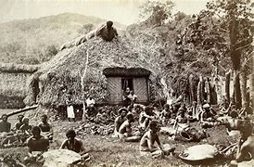
- The government could not control the hill tribes and protect the Europeans.
Activity
1. When was Fiji ceded to Great Britain?
2. Explain 2 reasons for the above
3. Who was sent to investigate Fijis situation?
4. How many offer of Cession was made with Great Britain?
LESSON 21
Strand: Time, Continuity and Change
Sub-strand: Further offer of Cession
Learning Outcome: Identify reasons why the offer was not accepted.
What is black birding?
- Trading in indigenous population for labor.
Who was the Prime Minister of Great Britain?
- William Gladstone
William Gladstone
- At that time, he (Prime Minister) was not in favor of expanding the British Empire.
- He set two officers in Fiji.
Who were these two officers?
- Commodore Goodenough - Senior Naval Officer in the South Pacific
- E. L. Lavard – New British Consul in Fiji
Why these two officers were send to Fiji?
- To investigate the situation in Fiji.
Note
- After investigating these two officers filed a report
- In their report, they advised the British government to accept the offer.
- They said as British Crown colony, Fiji would prosper
- Australia also supported Fiji
Activity
1. Define black birding.
2. Name the two officers sent to investigate Fijis situation

LESSON:22
STRAND: Time, Continuity and Change
Sub-Strand: Deed of Cession
Learning Outcome: Appreciate the events that led to Cession
Fiji as a British Colony
- Fiji was ceded to Great Britain on 10th October, 1874
- The Deed of cession was signed at Navosa, Levuka.
- Sir Hercules Robinson accepts the offer of cession on behalf of the British government.
- The offer was unconditional (without limits and conditions).
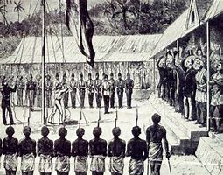
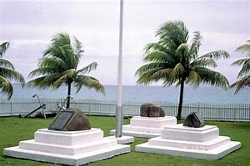

Cakobau’s Benefit After Cession
- His power was recognized as the “Vunivalu”
- He was granted a pension of 1500 pound per year
- He was given a yacht

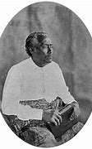
Ma’afus Benefit After Cession
- His position was recognized as Roko TuI Lau

- He continued to control all affairs of his work in the Lau group

Note
- Cakobau died in 1883 Ma’afu died in 1881
Activity
1. When was Fiji ceded to Great Britain and where?
2. What benefits did Cakobau and Ma’afu receive?

LESSON 23
Strand: Time Continuity and Change
Sub Strand: The Temporary Government
Learning Outcome: Identify the role played by the Temporary government
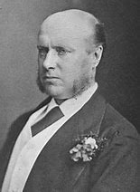
- was set up by Sir Hercules Robinson.

- established after Deed of Cession

- Sir Hercules Robinson was the governor of New South Wales who was sent to Fiji to set up a Provincial (temporary) government.

Structure of the Temporary Government
Governor
Deputy Governor
Secretary for Native Affairs
Colonial Secretary

Positions held in the Temporary Government
Position | Name
Governor | Sir Hercules Robinson
Deputy Governor | E.L. Layard
Colonial Secretary | J.B. Thurston
Secretary for Native Affairs | R.S. Swanston
Whole Colony – Fiji
- The whole colony Fiji was divided into four regions.
- Each region was under the control of the Magistrate.
- The four regions were then divided into twelve provinces in each of which the existing rulers were appointed as the provincial chiefs (Roko).
- Under the Roko were 80 district chiefs (Buli).
SET UP
Whole Colony

4 Regions
4 Regions

12 Provinces
80 District

Why Fiji was divided into four Regions?
- British divided Fiji up into four regions so that i-taukei could not unite against themselves.
- British had a policy of Divide and rule.
Laws made in the Temporary Government
- Laws were made in the temporary government to maintain order until a permanent government was formed.
Rules
- All taxes levied by the former Cakobau Government were stopped and new government tax was levied.
- All land sales were stopped until previous sales could be investigated.
- The Queensland Act was introduced to stop ill-treatment of labourers.

Why were the laws made?
- To maintain order for almost a year until a new Governor, Sir Arthur Gordon arrived.
Activities
1. Name the four positions in the temporary government.
2. List two laws made in the temporary government
3. Identify who looked after the following :(i) Governor (ii)Colonial Secretary (iii)Secretary of Native Affairs

