HOME LEARNING KIT SOCIAL SCIENCE – YEAR 10
WORKSHEET 9

MULTIPLE CHOICE
Circle the answer of your best choice
1. Urban areas can be best defined as
A. villages B. highlands and the interior
C. towns and cities D. islands and villages

2. Residential areas include which of the following
A. Food processing, marine engineering, ship building
B. Includes both formal and informal housing (squatter)
C. warehouse, customs sheds, bulk stores, office of shipping companies
D. banks, insurance companies, travel agencies, hotels

3. The main administrative city in Fiji is
A. Nadi B. Suva C. Lautoka D. Labasa

4. The number of people living in a given area is referred to as
A population distribution B. population density
C. natural increase D.urbanisation

SHORT ANSWERS
1. Define the terms (i) Demography (ii) Demographic Transition model
2. Which zone in an urban area would contain commercial offices?
3. Name the Minister for Housing in Fiji’s parliament.

RESOURCE INTERPRETATION
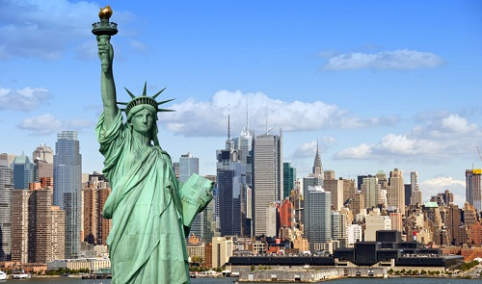
(i)List some of the different zones in a city.
(ii)Name a major city in Fiji.
(iii)Identify two features of the CBD area.
(iv)Write down two problems faced in towns and cities.

PARAGRAPH WRITING
In a paragraph discuss three pull factors and three push factors in an urban area.

