HOME LEARNING KIT SOCIAL SCIENCE – YEAR 10
WORKSHEET 7

MULTIPLE CHOICE
Circle the answer of your best choice.

1.Sugarcane is mostly grown on which parts of Fiji?
A.dry areas of Fiji B.Navua to Korovou
C.wet areas D.Labasa area only

2.Physical factors in a farming system can include
A.trucks and farm equipments B.water,land and relief
C.capital and machinery D.farmers experience and knowledge

3.One of the major problems faced by pig farmers is
A.market demand B.lack of capital
C.lack of expertise and skills D.feed is too expensive

4.Shifting cultivation is the process whereby
A.land is cleared for pig farming B.land is left fallow to regain fertility
C.land ploughed for building purposes D.land prepared for seaweed farming

B)SHORT ANSWERS
Write down your answers to the above questions.

1.Explin why Sigatoka is called the salad bowl of Fiji.

2.Where in Fiji would you find a beef cattle estate?

3.Write down 2 importance of the yaqona industry.

C)RESOURCE INTERPRETATION
Use the resource given below to answer the questions that follow.

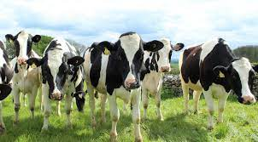

(i)Identify the farming system shown above

(ii)List down two challenges faced by the above farmers

(iii)Where in Fiji would you find the above

PARAGRAPH WRITING

Choose one farming system from the list given below and write a paragraph on the headings that follow:1.Sugarcane farming 2.Rice farming 3.Dalo farming
-areas grown
-two importance of the farming system
-two problems faced

