HOME LEARNING KIT SOCIAL SCIENCE – YEAR 10
WORKSHEET 6

MULTIPLE CHOICE
1. Aquatic freshwater vegetation include
A. Reed swamps, floating plant,otakarisi and aquatic weeds
B. dense/thick undergrowth of grass and shrubs.
C. Sea weeds (lumi), algae, sea grasses
D. Tahitian chestnut ivi and palms forbs

2. Identify one type of soil in Fiji
A. woodland B. rainforest
C. Regolith D. Tropical lowlands

3. The winter season season in Fiji is from
A. June to September B. November to April
C. May to November D. January to July

4. The letter H on weather maps shows?

A. good weather conditions
B. floods
C. rainy and stormy weather
D. cyclone

SHORT ANSWERS
Answer the following questions with reference to your notes
1. Define the following: (i) Depression (ii) Anti-cyclones (iii)Isobars
(iv)endemic plants
2. Explain how cyclonic and convectional rainfall occur.
3. Identify an importance of mangrove plants.
4. Name one of Fijis endemic plants.

RESOURCE INTERPRETATION
Study the diagram given below to answer the questions that follow.
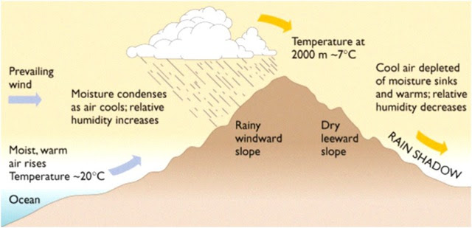
1) Identify the type of wind system shown above
2.) Briefly explain how the above occurs
3) Where in Fiji would you mostly find this type of wind system.
4) Name Fijis prevailing wind system

PARAGRAPH WRITING
In a paragraph discuss four factors affecting soil formation.

