HOME LEARNING KIT SOCIAL SCIENCE – YEAR 10
WORKSHEET 5
MULTIPLE CHOICE
1. Taveuni is also known as the
A. island of the red prawns B. Garden Island of Fiji
C. Garden of the sleeping giant D. Turtle Island
2. The deepest river in Fiji is called
A. Sigatoka river B.Navua river
C. Rewa river D. Dreketi river
3. The cyclone season in Fiji is from
A. October to March B. November to April
C. May to November D. January to July
4. Sugarcane is mostly grown in which parts of Viti Levu?
A. All throughout Viti levu
B. Sigatoka to Rakiraki
C. Korovou to Navua
D. Suva to Lautoka
SHORT ANSWERS
1. Name two plateaus in Fiji
2. Identify the three types of climates experienced in Fiji
3. Name Fijis longest river
4. Briefly explain the difference between climate and weather
RESOURCE INTERPRETATION
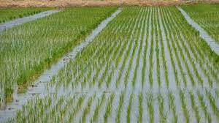
1) Identify the type of farming system shown above
2.) Outline two importance of the system
3.) State one important feature required by this farming system
PARAGRAPH WRITING
In a paragraph discuss four factors that influence the climate of an area.

