STRAND OT 10. 2: COMPUTER CONCEPTS AND SKILLS
SUB- STRAND 10. 2. 3: WORD PROCESSING
Lesson 27:
CLO: Use prior knowledge to recap on word processing

- Word Processing is an application program that allows you to create letters, memo, reports, news letter.
- Use this application program you can add graphics, tables and charts to our documents
- You can also check spelling and grammar.
- A paragraph refers to having breaks (blank lines) between texts, it is achieved by pressing Enter key, also use of the Tab key to place an indent at the beginning of the first line.
- The Tab key works by lining up text with invisible tab stops, pressing the tab keys is the putting in a group of blank spaces and we use tab key to line up a list of names or numbers to make it easier to read.
- Show/ hide to show special text marks where line breaks and tabs have been a text that can be justified, right aligned, left aligned or centered.
- Margins are marked on the ruler which appears at the top of the working area.

STRAND OT 10. 2: COMPUTER CONCEPTS AND SKILLS
SUB- STRAND 10. 2. 3: WORD PROCESSING
Lesson 28
CLO: Discuss the uses of graphics

Integration of Text and Graphics
- Integrated software: all in one application program
- It is a single program that provides functionality of a word processor, graphic and many more programs.
- It allows the user to use the same toolbar and switch between programs.
- You can open several packages and swap between them.
Graphics
- It can add impact to your word document like lines, shapes, colours, text and patterns are called graphics.
- There are 2 reasons to use graphics: to give information and to make impression.
- Graphics convey information by: using common conventions understood by the audience, leaving out unnecessary details and using realistic pictures.
- Graphics produce an impression by: use of colours, use pictures with emotional contents and distorting or altering pictures.
- Insert clip arts to your document is a way to illustrate ideas.
- You can use wrapping styles to modify the layout of the text in relation to the graphic.

STRAND OT 10. 2: COMPUTER CONCEPTS AND SKILLS
SUB- STRAND 10. 2. 3: WORD PROCESSING
Lesson 29

CLO: Discuss the different features of the wrapping styles
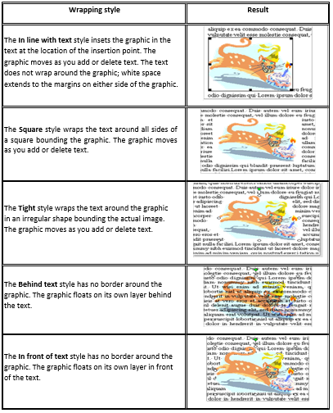

- You can always position your graphic by using the layout tab.
- You can also use Horizontal alignment or you can drag the graphic where you want.
- You can also insert photographs or images from your files using the same process.

STRAND OT 10. 2: COMPUTER CONCEPTS AND SKILLS
SUB- STRAND 10. 2. 3: WORD PROCESSING
Lesson 30
CLO: Discuss the steps to insert WordArt and using graphic package.

Insert Word Art
Step 1: click insert menu, click picture and then click Word Art
Step 2: select a word style format and then click on OK button
Step 3: enter your own text

Open Graphic Package
- Click on the start button, you will see the start menu.
- Pick the All Programs option.
- See a list of all programs available, some are arranged into folders which is in alphabetical order. Find the accessories folder and click on it to open.
- The final menu opens up, it shows the content of the accessories folder. Click on the paint icon to open up.

Using the tools
- Find the tool bar on the screen, the icon on this bar stands for the different things you can do.
- Can experiment by clicking on the different tools and drawing in the working area of the screen.

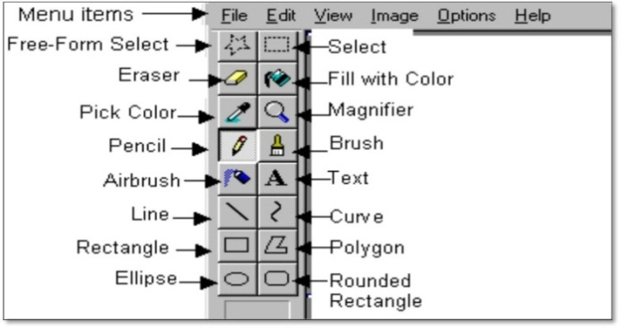
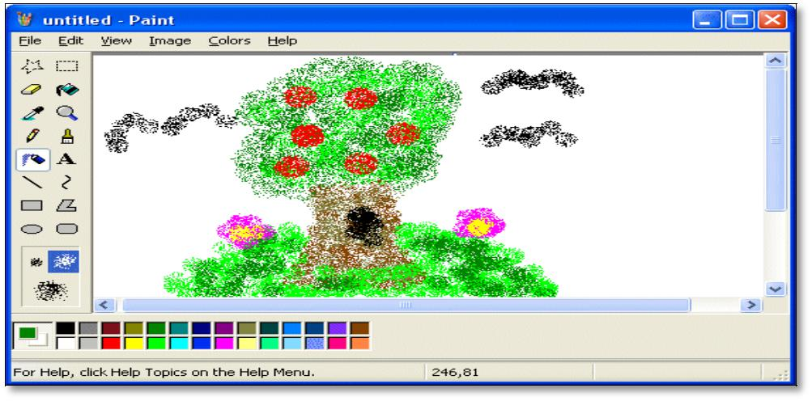

Use the mouse to:
- Move the pointer across the screen
- Click on icons
- Drag lines across the screen

Exercise:
- Explain the need for Graphics and Word Art in Word Processing.

What type of brush?
- Click on the brush tool and picking the shape and size of the brush.
- Practise with different brush shapes.

Line Styles.
- Select the line tool also pick the width of the line.
Filled shapes
- Select the shape tool such as a rectangle, it is also outlined by solid lines.
Foreground and background
- Graphic packages allow you to select two colours.
- The background is used for all lines and outlines that make up the drawing.
- The background colour is used when you draw a filled shape.
- Click on the colour palette with the left mouse button foreground colour.
- Click the right mouse button for the background colour.
Undo
- Most software packages have Undo command.
- It is a useful feature.
- Allows you to reverse the effect of the most recently changes you made.
Adding texts to graphics
- Most graphics need words as well as images.
- Letters and numbers can be added using the keyboard.

STRAND OT 10. 2: COMPUTER CONCEPTS AND SKILLS
SUB- STRAND 10. 2. 3: WORD PROCESSING
Lesson 31
CLO: Discuss the additional features of graphic package.
Text can be used:
- Titles, headings, labels, instructions and design elements.
- Can also add information such as your name and the date.
- Learn how to alter the size and style of the text.
- Learn how to make changes to the font, it will improve appearance of the text when you add to your graphics.

Text tool
- Find the text tool then create a box on the screen then add letters or other characters in the text box.
- Need to check your typing carefully, when text box is open you can type a new text, delete any mistake and change the size of the text box.
Changing the size of the textbox
- The larger dots on the text box are called re- sizing handles, drag the handles to change the size.
Choosing Fonts
- There are different font style and size you can choose from.
- To open the dropdown menu, click on the little arrow head, then pick out the font style and size.
There are 2 types of graphic package, one is called bitmap and vector, they work in different ways
- Bitmap package – the computer stores the position and colour of all the dots that makeup the image
- Vector package – the computer stores all the lines and shapes that make up the image, when you select a part of a vector image you select a complete line or shape.
Deleting a selected item.
- When you have selected an area of the screen(bitmap) or a shape(vector) you can delete it.
- Otherwise, press the Delete key on your keyboard to remove the item you have selected.

Exercise:
- Differentiate between Bitmap and Vector Packages

- Explain the feature of a Text Box

STRAND OT 10. 3: OFFICE ADMINISTRATION
SUB- STRAND 10. 3. 1: OFFICE ROLES AND FUNCTION
Lesson 32
CLO: Define the term business environment.
- A business is an economic unit which is engaged in the production of distribution or the production and the distribution of goods and services for the purpose of earning profit.
- Business environment is the relationship between a business action and its environment.
- Environment is a surrounding of a business by which business influence directly or indirectly.
- The term business environment implies those external forces, factors and institution that are beyond the control of individual business organisation and their management and affect the business enterprise.
- These forces are customers, creditors, competitors, government, socio- cultural organisations and etc.

STRAND OT 10. 3: OFFICE ADMINISTRATION
SUB- STRAND 10. 3. 1: OFFICE ROLES AND FUNCTION
Lesson 33
CLO: Discuss the features of business environment.
- Business environment includes both specific and general forces.
- Special forces affect enterprise in their day to day working.
- General have impact on all enterprises and affect an individual firm only indirectly.
- Business environment is dynamic in that it keeps on changing whether in terms of technological environment, shifts in consumer preferences or entry of new competition in the market.
- Business environment is largely uncertain as it is very difficult to predict future happenings, especially when environment changes are taking place too frequently as in the case of information technology or fashion industries.
Exercise:
- List two features of a business environment and discuss how these features help make the business better

