YEAR 10 MATHEMATICS-WEEK 1 WORKSHEETS
]NUMBERS
LESSON 30
Sub strand: Expressing numbers into Index
Note: Please read the notes and examples given below
NOTES
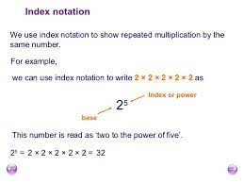 | 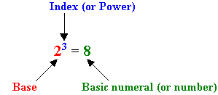
EXAMPLES
Write the number in base index form  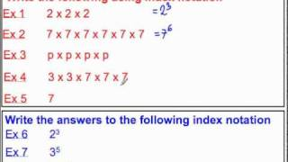 | Answers:  E.g. 1  2³  E.g. 2  7⁶  E.g. 3  P⁴  E.g. 4  3² x7³  E.g. 5  7¹  E.g. 6  2 x 2 x 2  E.g. 7  3 x 3 x 3 x 3 x 3

LESSON 31
Sub strand: Index Rules/Laws
Note: Please read the notes and examples given below
NOTES/EXAMPLES
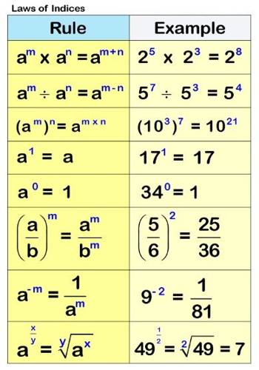 | 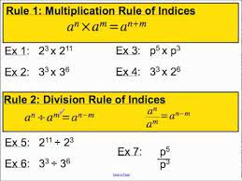

GEOMETRY
LESSON 32
Sub strand: Squares
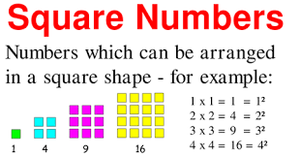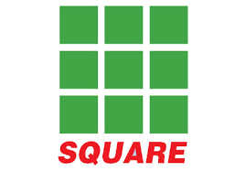
The length of the each are the same. So, 3 x 3 which is 3²
NOTES/EXAMPLES
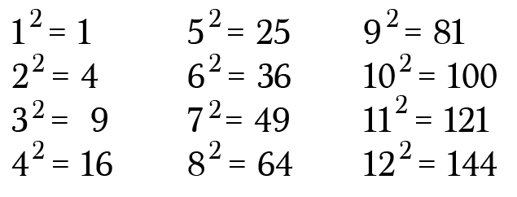 | 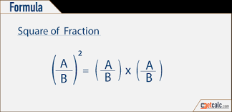
 | 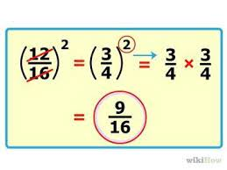

LESSON 33
Sub strand: SQUARE ROOTS
Square root, in mathematics, a factor of a number that, when multiplied by itself, gives the original number. For example, both 3 and –3 are square roots of 9.
NOTES/EXAMPLES
Finding square of a perfect squares  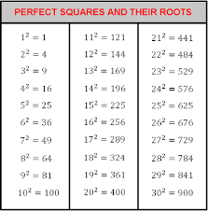 | Finding square roots of perfect squares  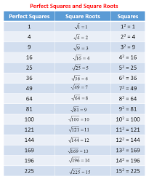
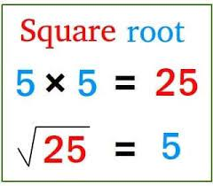 | 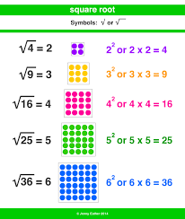

LESSON 30 WORKSHEET
1.

Write $a×a×a×b×b$ in base index form

2.

Simplify 3x⁰

3.

Write 6⁴as expanded form

4.

Write 8 in Base index form

5.
6.

LESSON 31 WORKSHEET

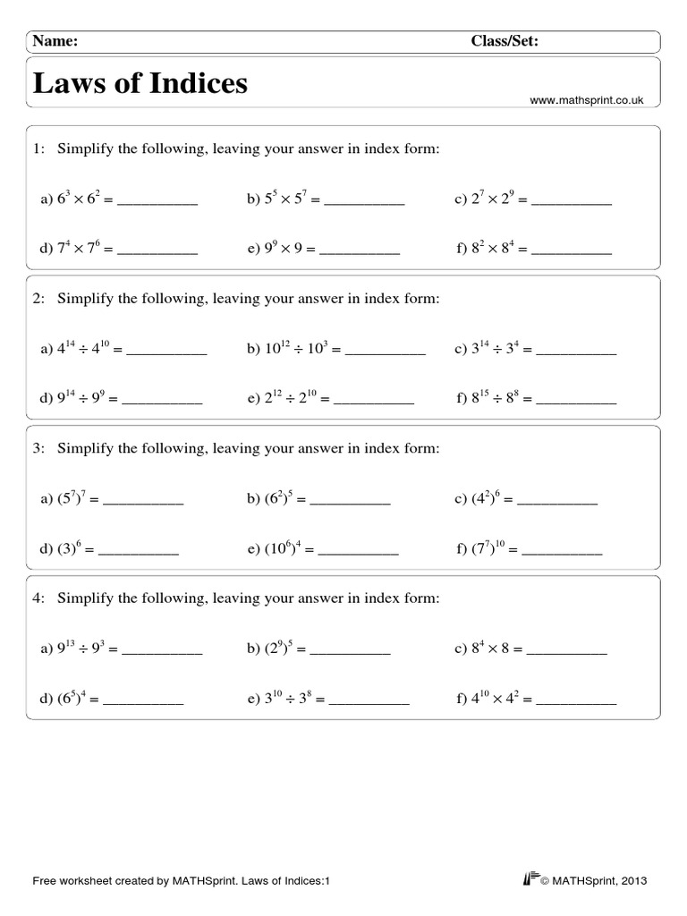

LESSON 32/33 WORKSHEET
