RATU NAVULA COLLEGE
WORKSHEET 4 [ lesson 42 – 44 ]
MATHEMATICS
YEAR 10
LESSON 42
SUB STRAND: Application of SOH CAH TOA I
AIM: Finding the unknown Side of a right angled triangle using SOHCAHTOA
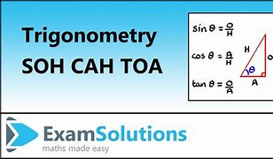
NOTES/ EXAMPLES:
Since there are two sides and one angle involve in this .So given would be 1side and 1angle.
EXAMPLE 1
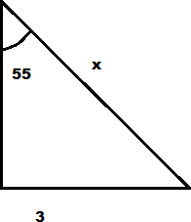  Find the length of x  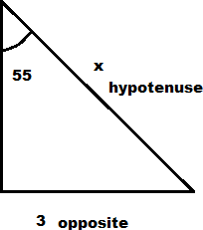  STEP 1  Identify the two sides  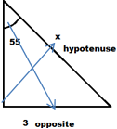 | STEP 2  Determine the trig function to be used  SOH CAH or TOA  Since O and H are given we use SOH  STEP 3  Use SOH to find length of x  $$\sin{{55}^{0}}=\frac{3}{x}$$  $$x sin{{55}^{0}}=3$$  $$x=\frac{3}{\sin{{55}^{0}}}$$  $$use calculator$$  x = 3.66m (2 dp)

EXAMPLE 2
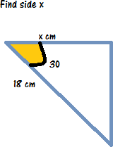  STEP 1  $$x=adjacent$$  $${18}^{}=Hypotenuse$$ | STEP 2  Determine the trig function used.  Given are $AH so CAH$  STEP 3  Use CAH to find the side $x$  $$\cos{{30}^{0}}=\frac{x}{18}$$  $$18\cos{{30}^{0}}=x$$  $$x=15.59cm$$

EXERCISE
Find the side $x$ using SOHCAHTOA  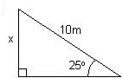 | Find the value of z using SOHCAHTOA  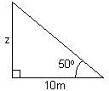
LESSON 43
SUB STRAND: Application of SOH CAH TOA II
AIM: Finding the unknown Angle of a right angled triangle using SOHCAHTOA
NOTES/ EXAMPLES
Since there are two sides and one angle involve in this. To find the angle only 2 sides given
EXAMPLE 1
For the right – angled triangle given,  find angle x  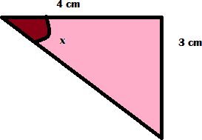  STEP 1  $$opposite=3cm$$  $$adjacent=4cm$$ | STEP 2  Since O and A we will use TAN  STEP 3  $$\tan{x}{=\frac{3}{4}}$$  $$x=\tan^{-1}{\frac{3}{4}}$$  Use the calculator  $$x={36.87}^{0}$$

EXAMPLE 2
Find the value of angle x

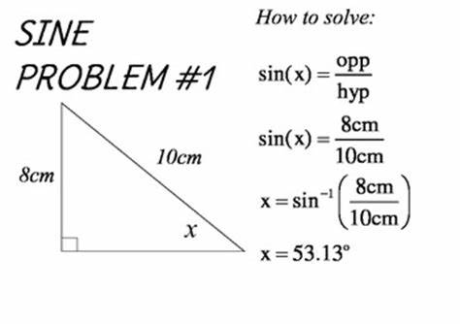

Use calculator to find the angle in two decimal places

EXERCISE
Find the angle x?  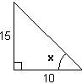 | Find the angle Z?  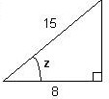

LESSON 44
SUB STRAND: Word problem using SOHCAHTOA
AIM: Finding the unknown Side and Angle of a right angled triangle using SOHCAHTOA
NOTES/ EXAMPLES
Read the word problem carefully; sketch its diagram to guide your calculation
A ladder leaning against a wall makes 75 ⁰ angle with the ground. If the ladder is 5m tall, how far is the base of the ladder from the wall of the house?  Diagram  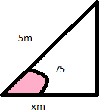 | Step 1  Identify the sides and angles given  $$θ={75}^{0}, H=5m and A=xm$$  Step 2  Which Trig function used  $$AH so it CAH$$  Step 3  Substitute values into CAH  $$\cos{{75}^{0}}=\frac{x}{5}$$  $$5\cos{{75}^{0}}0=x$$  Use calculator to find the value of x  $$x=1.29m$$  So the length of the ladder is 1.29m.

EXAMPLE 2
An aeroplane flies 250 km west, but the wind blows it 60 km north  What is the compass bearing of the plane from the starting point?  Diagram  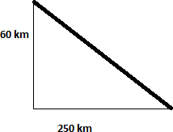 | $$O=60km and A=250km$$  $$So use TOA find the angle$$  $$\tan{θ}=\frac{60}{250}$$  $$θ=\tan^{-1}{\frac{6}{25}}$$  $$θ={13.5}^{0}$$  Note:  Bearing is in Angle.

EXERCISE
1. A man is walking along a straight road. He notices the top of a tower subtending an angle A = 60º with the ground at the point where he is standing. If the height of the tower is h = 35 m, then what is the distance (in meters) of the man from the tower?
$${ 60}^{0}$$
35m

Distance

LESSON 42 – 44 WORKSHEET

1.
2.
Find the length of letter x?

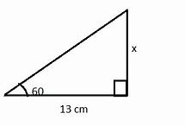

3.
Find the height of the building given on the diagram below
