RATU NAVULA COLLEGE

MATHS YEAR 10

HOME STUDY KIT

WEEK 2

GEOMETRY
LESSON 34: PYTHAGORAS THEOREM I
Finding a SIDE, when two other sides given.
Sub strand: PYTHAGORAS THEOREM
Outcome: Finding hypotenuse side using Pythagoras theorem
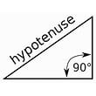 | 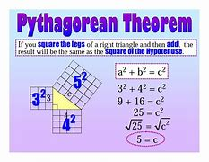

Hypotenuse

In geometry, a hypotenuse is the longest side of a right-angled triangle, the side opposite the right angle. The length of the hypotenuse can be found using the Pythagorean theorem, which states that the square of the length of the hypotenuse equals the sum of the squares of the lengths of the …
Note: Please read the notes and examples given below
NOTES
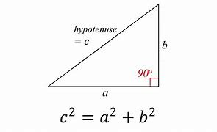
EXAMPLES
Find the value of C  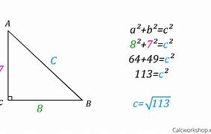 | Find the value of C
EXERCISE
Find the value of $x$ in the following
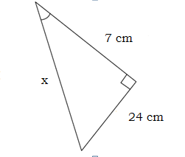

LESSON 35: PYTHAGORAS THEOREM II
Sub strand: PYTHAGORAS THEOREM
Outcome: Finding any of other two sides (a and b) using Pythagoras theorem
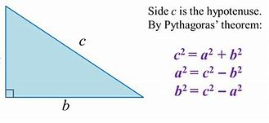
Examples:
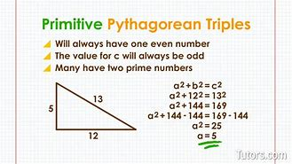 | How tall is the building?  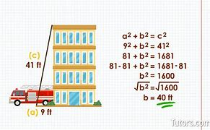
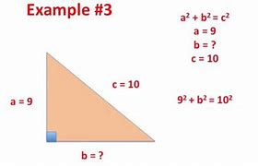 | 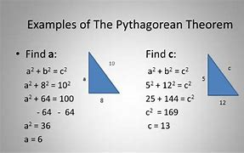
EXERCISE
Find the length of AB  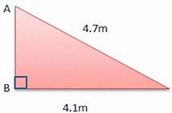 | Find the length of AC  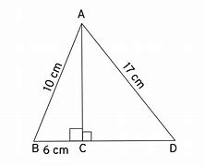
LESSON 36:
Sub strand: APPLICATION OF PYTHAGORAS THEOREM
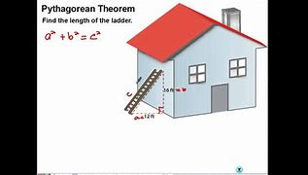
Outcome: Finding any side using Pythagoras theorem

EXAMPLES
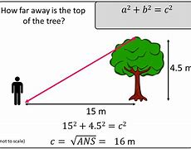 | 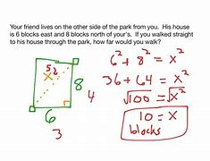

EXERCISE

LESSON 37
Sub strand: Finding the unknown side of a Isosceles right angle triangle
EXAMPLES
Find the value of the hypotenuse?  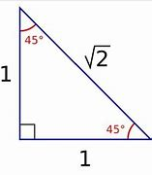 | SOLUTION  $$1^{2}+1^{2}=x^{2}$$  $$1+1=x^{2}$$  $$2=x^{2}$$  $$\sqrt{2}=x$$

EXERCISE
Find the value of its hypotenuse?
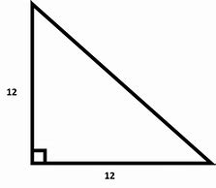

WORKSHEET
Find the length of the following unknown sides
Find the length of BC  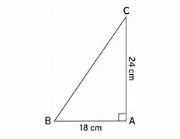 | Find the value of X  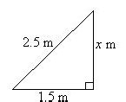
Find the value of each x?  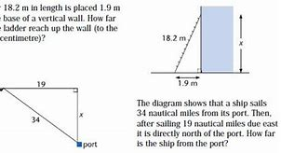 | Find the length of the hypotenuse?  