RATU NAVULA COLLEGE
WORKSHEET 3 [lesson 38 -41]
MATHEMATICS
YEAR 10

LESSON 38
SUB STRAND: PYTHAGOREAN TRIAD
AIM: To find the three numbers those satisfy (follow) the Pythagoras theorem.
NOTES/ EXAMPLES:
The three numbers and all its multiples
a. 3, 4, 5 and all its multiples ( $×2 , ×3, ×4$ …..e.tc.)
i.e. $3^{2}+4^{2}=5^{2}$
b. 5 , 12, 13 and all its multiples($×2 , ×3, ×4……$e.t.c)
i.e. $5^{2}+{12}^{2}={13}^{2}$
c. [ 7, 24, 25] [8, 15, 17] and [ 9, 40, 41]
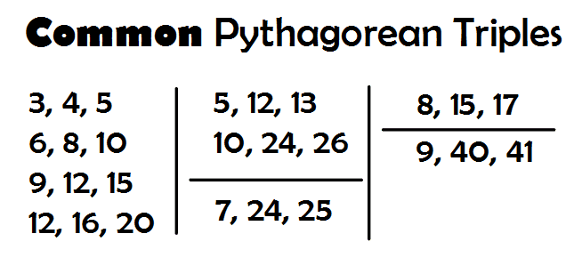

EXERCISE
Is 3, 5, 6 a Pythagorean triad. Prove it | Which of the following triangle is a Right angled and which is not a right angled  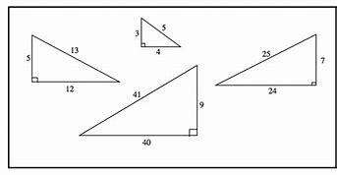

LESSON 39
SUB STRAND: PYTHAGORAS THEOREM ON RIGHT AND NON RIGHT ANGLED TRIANGLE
AIM: To use Pythagoras theorem in order to prove that it is a right angle
L/O: To determine whether a triangle is aright or non-right angled
NOTE
Right angled triangle: Its follow the Pythagoras Theorem
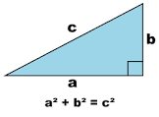
Non right angled Triangle: DOES NOT FOLLOW PYTHAGORAS THEOREM

EXAMPLE
Show that this triangle shown below is a right angled triangle  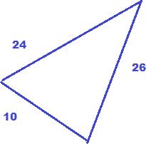 | Solution  a=10 , b=24 and c=26  Remember c (hypotenuse)= the longest side  $${10}^{2}+{24}^{2}={26}^{2}$$  $$100+576=676$$  $$676=676$$  Since RHS = LHS , it is a Right angled triangle
EXERCISE:
Find out whether this triangle shown below is a right or Non right angled triangle
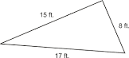

LESSON 40
SUB STRAND: Trigonometric Functions
AIM: Naming sides and Angle of a Right angled triangle
NOTE
Now we are dealing with
i) Right angled triangle
ii) Sides and angle
Naming sides and angle
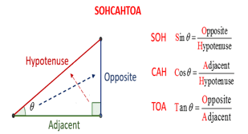 | Hypotenuse(H)- the side directly opposite to the right angled side  Opposite(O) - the side directly opposite to given angle or indicated angle Theta($θ)$  Adjacent side(A)- The side beside the given angle  SOHCAHTOA

Using Trigonometry Ratio
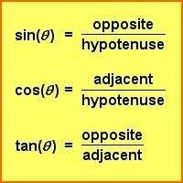 | 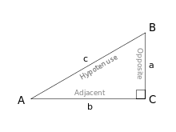

EXAMPLES

1.  Label the given sides of this triangle shown below  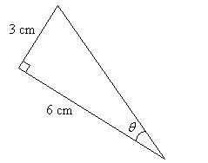 | O=3cm  A = 6cm
2.  Use trigonometric ratio to fill SINE,COSINE and TANGENT  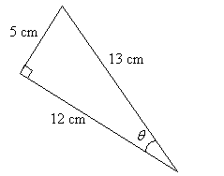 | $\sin{θ=\frac{5}{13}}$ [SOH]  $\cos{θ}=\frac{12}{13}$ [CAH]  $\tan{θ}=\frac{5}{12}$ [TOA]

EXERCISE
1.  a) Identify the two given sides of the triangle below.  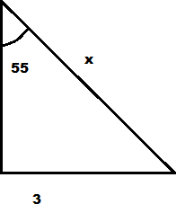  b) Determine which Trig ratio to use  c) To find the value of x complete these box  $55= \frac{}{}$ | 2.  a) Identify the two given sides of the triangle below.  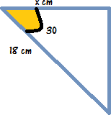  b)Determine which Trig ratio to use  c) To find the value of x complete these box  $30 = \frac{}{}$

LESSON 41
SUB STRAND: Using Calculator to Find the value Sine, Cos and Tangent and its unknown ($θ)$
AIM: The find the proper way of calculating trigonometry values
NOTE:
A calculator can be used to find the values of the trigonometric ratios sin, cos and tan for the given angle where the angle is measured in degrees.
EXAMPLES
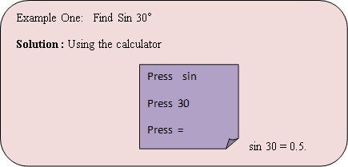 | Example Two  Find sin Ѳ = 0.66  Solution  Press shift Sin  Press 0.66 =(equal to)  $\sin^{-1}{0.66}=41.30(2 dp)$

EXERCISE
1. Evaluate the following. 2 decimal places  (a) Sin 60˚  (b) $\tan{{45}^{0}}$ | 2. Find the value of . 2 decimal places  (a) $\cos^{-1}{θ}=0.50$  (a) $\sin^{-1}{θ}=24.5$

WORKSHEET
1. Evaluate the following. 2 decimal places  (a) Sin 350˚  (b) $\tan{{65}^{0}}$ | 2. Find the value of . 2 decimal places  (a) $\cos^{-1}{θ}=23.50$  (a) $\sin^{-1}{θ}=8.56$

