YEAR 10 HOME ECONOMICS
WEEK 10

LESSON 53
STRAND : HEC 10.2 FOOD AND NUTRITION
Sub Strands: HEC10. 2.6 Food Planning and product development
CLO: HEC 10.2.6.1 Recognise and demonstrate planning and cooking skills for special needs.
Managing money
The financial record keeping of how money is managed is important in a small business. The business may have an excellent product that has a lot of marketable potential. However, if there is no proper record of financial management, the business is likely to fail.
All businesses should keep daily records of money coming in and money going out. These records can help the entrepreneur to keep control of cash, know how well the business is doing, show others e.g. the bank how well the business is doing and also plan for the future.
Importance of record keeping (Why keep records)
- It is mandatory by law that all businesses whether small or big to keep business records.
- Adequate records can answer the following questions:
- How much profit is the business making?
- How much is the business worth?
- How much credit is owed to the business by customers?
- How much credit does the business owe to its creditors?
- How much tax should the business pay?
What kind of record should be kept by a small business?
For a small business it is important to start small. The most important record is the Cash Book record.
Who should be responsible for keeping the financial record?
For a small business it is practical for the owner to keep the record himself.
An important point to consider is that business money and private (household) money should be kept separately. If kept together then money will leak and be spent for private expenses. At the end of the month, the entrepreneur will not be able to calculate whether the business has made any profit or not.
Cash book record (sample)
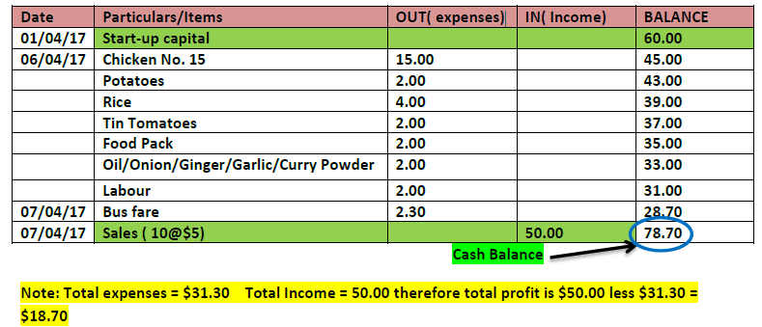
ACTIVITY:
- Given below is a Cash Book Record for Sandra’s small home enterprising
activity.
Use the information given to answer the questions that follow.
Date | Particulars | out(Expenses) | IN (income) | BALANCE
01/01 | Startup capital |  |  | $10.00
02/01 | A big bag of mixed  peas (which includes20 small packets) | $ 7.50 |  | $ 2.50
05/01 | Sold all 20 packs for  80 cents per packet |  | $16.00 | $18.50
05/01 | Bus fare to  supermarket and  return | $2.20 |  | $16.30
 |  | AVAILABLE BALANCE |  | $16.30
(i) How much was Sandra’s startup capital?
(ii) Calculate the profit that Sandra made.
(iii) Explain one importance of keeping a cash book record.

LESSON 54
STRAND: HEC 10.2 Food and Nutrition
SUB-STRAND: HEC 10. 2.4 Food Supply
CLO: HEC 10. 2.4.1 Demonstrate understanding of other food sources available in the home.

Convenience Foods - Convenience foods are processed foods that require little or no preparation.
TYPES OF CONVENIENCE FOODS
Bottled and canned | Frozen | Dehydrated food | Ready to eat | Ready to cook
-Canning and bottling food is a method of preserving food in either brine or syrup where the food contents are processed and sealed in an airtight container.  -During processing  Vitamin B and C may be destroyed.  -Examples canned foods, vinegar and Fiji water | -Food is kept in the freezer below the  freezing point of  0◦C.  -For example,  Ice cream, chicken, mix vegetables | -Dehydrated  foods have water  removed from it  through evaporation (air  drying, sun drying,  smoking or wind drying).  -Removal of water prevents  growth of microorganisms  and extends shelf life.  -Example dried fish, lentils, peas | -Ready-to-eat  food are foods  that can be  eaten without  any additional  preparation  -For example yogurt, tomato sauce, breakfast crackers | -Ready- to- cook food is commercially  prepared and  requires some cooking before consumption.  -For example noodles, cake mix,

Advantages of convenience foods
- Sometimes not as expensive as fresh food e.g when buying food out of season, such as canned tomatoes.
- A wide variety is available.
- Little or no wastage.
- Often have either extra nutrients added or lost nutrients are replaced.
- Saves energy: [human energy for preparation Fuel energy for cooking.]
- Useful in times of emergency.
- Easy to store and have long shelf life.
- Nutritional information is provided.
- Saves time in preparation and cooking.

DISADVANTAGES OF CONVENIENCE FOODS
- Usually more expensive than fresh food.
- Contain preservatives like fats, sugar, salt which can be harmful to our health when taken excessively.
- Contains less dietary fibre compared to fresh food.
- Nutrients may be lost during processing and not replaced.
- Servings may not be enough, making it necessary to buy extra, which defeats the purpose.
- Cans and bottles are heavy to carry.
- Disposal of packaging becomes a problem.
- Dependency makes people less bothered to prepare fresh and nutritious meals.

May contain additives e.g artificial colouring and flavouring which may not be as natural as fresh food.

LESSON 55
STRAND: HEC 10.2 Food and Nutrition
SUB-STRAND: HEC 10. 2.4 Food Supply
CLO: HEC 10. 2.4.1 Demonstrate understanding of other food sources available in the home.

NUTRITIVE VALUE OF CONVENIENCE FOODS
- The nutritive value of convenience food is as high as that of the fresh ingredients that go into them.
- Some vitamins are lost due to the heat treatment during food processing.
USES OF CONVENIENCE FOOD
- Convenience food may be as nutritious as fresh foods.
- Nutrients and flavors’ may be lost during the process of bottling; canning and drying
- Use convenience food with fresh food to make a dish or meal more nutritious.
EXAMPLES OF HOW TO USE CONVENIENCE FOOD WITH FRESH FOOD
- Make omelets’ using diced luncheon meat, long beans, carrots, onion and chilies.
- Tuna sandwich can be made using canned tuna, tomatoes, cucumber, onion, carrot, chilies and dhaniya.
FOOD ADDIVTIES IN CONVENIENCE FOOD
- To preserve the food
- To improve taste
- To make food look attractive
- To enhance its nutrient content
POPULARITY OF CONVENIENCE FOOD
- More women are working fulltime now and have very little time to prepare the family meal.
- Advances in technology have made it possible for processed foods to be just as nutritious as fresh foods.
STORAGE OF CONVENIENCE FOODS
Convenience foods last longer if they are stored properly.

TYPES OF CONVENIENCE FOODS | METHOD OF STORAGE
Canned Foods | Should be stored in a cool, dry and dark place. Moisture will cause cans to rust.
Bottled Foods | Should be kept in a cool , dark place as light may affect the food.
Dehydrated Foods | Should be stored in clean, dry, air tight containers.
Frozen Foods | Should be stored frozen at -180C.Do not refreeze frozen food once it has been thawed. There is no danger to health if you keep frozen foods longer than the recommended time, but you may notice slight changes in flavor, colour or texture.
Packet mixes and ready – to – eat cooked foods | Best to be kept in the refrigerator and used as quickly as possible

BUYING CONVENIENCE FOOD WISELY
- Always check the packaging and expiry date.
- Read the nutritional information on the packet.
- Make sure can is not bulging, dented or rusty. Food in such cans may be contaminated and may cause food poisoning when consumed.
- Make sure packets of dried foods are properly sealed.
- Do not buy in bulk as you may not get around to using it before expiry date.

WORKSHEET
1.Define convenience food.
2.State two disadvantages of using convenience food?
3.What is food additives?
4.Differentiate between ready to cook and ready to eat food.
5.Explain why convenience foods have become popular in many homes.
6.Explain the reason for consuming fresh foods with convenience foods.
7.Define thawing.
8.How would you store the following:
(i)packet of ice cream
(ii) fresh fish

